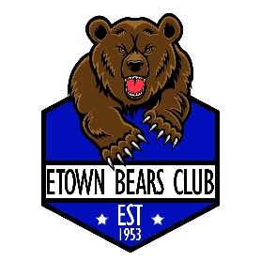
2026 Elizabethtown Bears Club
10U1 Baseball Tournament Information

Format: All teams will be guaranteed 3 games (weather permitting). Each team will play 2 seeding games chosen randomly. Then the teams will be seeded based upon wins, run differential, runs against and total runs scored. Following the seeding round, teams will play single elimination, top teams will receive a first-round bye.

Tournament Max of 8 teams

When: March 28-29 (Saturday, and Sunday)
Where: All games will be played at Wenger and New Minor Field on Poplar Street in Elizabethtown PA. GPS Address: 110 Peace Alley, Elizabethtown PA 17022

Entry Fee: $425.00 (payable to EBC Bears Club) per team
Send check to: EBC Bears Club
PO Box 42
Elizabethtown, PA 17022
Phone: 717-435-3286 Call/text with any questions
Rules:
All Lancaster County PA Youth League rules will be followed.
Rules can be found at: https://lancoyouthbaseball.org/
Insurance: Each team is responsible for its own medical and liability insurance coverage. The Elizabethtown Bears Club sponsors this tournament but does not assume any responsibility for injuries or damage to or by players, coaches, spectators, etc. or their equipment or property.

Food: A concession stand will be open during the tournament.

NOTE: No open flames (grills) allowed. No pets allowed per park rules except for service dogs.
Contact information: Please complete the EBC Tournament Entry form and submit with payment and copy of insurance coverage prior to start of tournament.
ATTENTION: Must provide proof of birth certificates upon checking in at tournaments

