**Creating a Gang Sheet in Canva**

1. Go to Canva.com
2. Go to “Create a design” and select “custom size”

1. Once you get a small box, you will enter the width (12 in) and height desired for your document. Make sure the “IN” (inches) box is selected. Click on “Create Design”
2. Now is time to put in your designs!
   1. - If you are inserting designs of your own, on the left sidebar you will find an “Uploads” section, click on it and then on “upload files”, select your files and drag them into the document.
3. Check that all the designs are sized the way you need, you can check the exact size by clicking on “Position” which is at the bar on the top, it will give you the exact length and width.

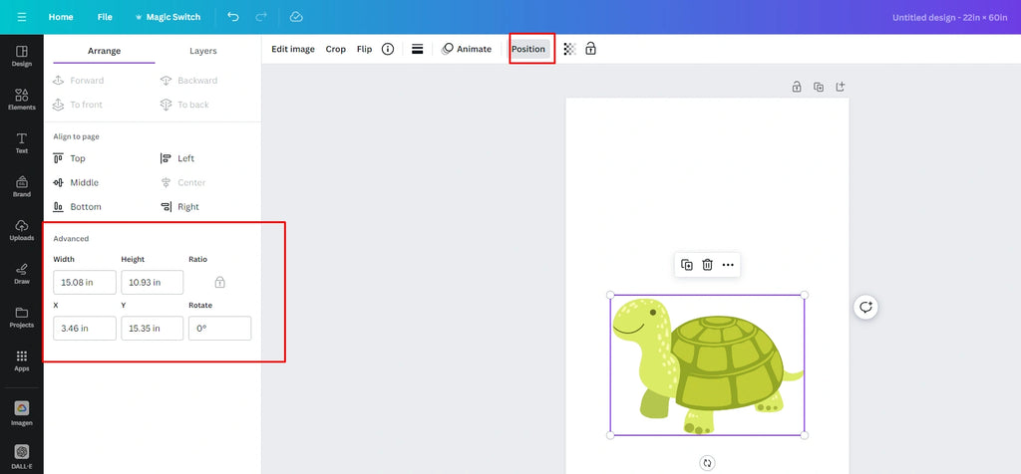

1. Spread all your designs on the gang sheet, you can add as many designs and text as you want, make sure you leave a space between 0.25 and 0.5 so you can have enough space to cut your designs without cutting another one.

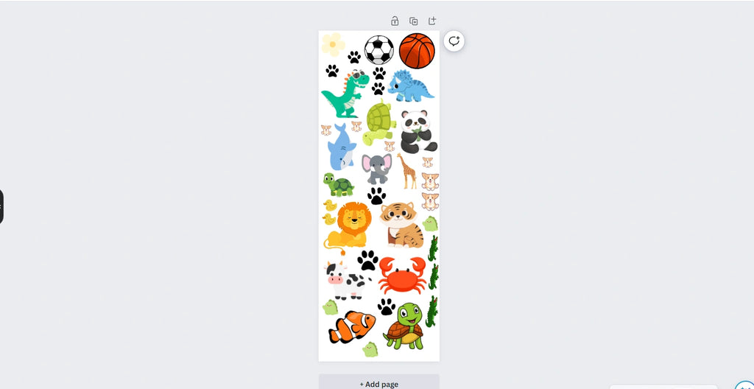

1. Once your gang sheet is ready, it is time to download it, to do so please follow these important instructions:
   1. - Go to the “Share” button located in the top-right corner and click on “Download”
   2. A screenshot of a computer

      AI-generated content may be incorrect.
2. Make sure PNG file is selected, the slide the size bar all the way until 3.125 and mark the “transparent background box”

1. - Click on “Download” and wait for it to download.
2. Great job! You have your gang sheet ready to be printed out, once your order is placed, email us that gang sheet to kustomkreations.lisa@gmail.com, and I will take care of the rest!