Assignment: Information Report on Camels in Australia
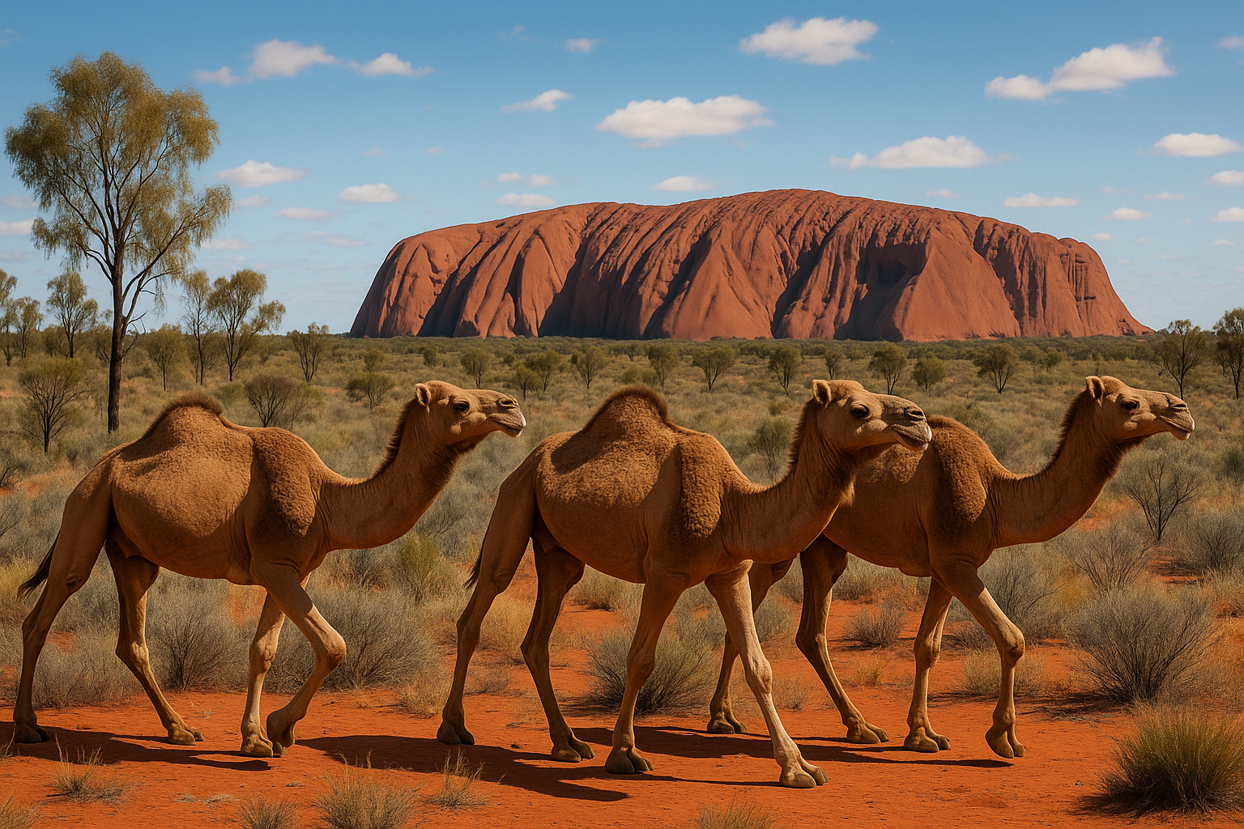

Task
You are to research and write an information report about camels in Australia.
Your report must:
- Use present tense and third person (no “I” or “you”).
- Be factual and include technical vocabulary.
- Be well-structured with headings, subheadings, diagrams, and a fact box.

Structure and Subheadings with Guiding Questions
Introduction
- What are camels?
- Why are camels an important animal to study in Australia?
- Why are they unique compared to other animals in Australia?
Image suggestion: A photo of a camel in the Australian desert.

1. History
- How did camels arrive in Australia?
- Who brought them and from where?
- What were camels used for in the 1800s and early 1900s?
- Why were they useful for explorers and settlers?
- What happened to camels when they were no longer needed for transport?
Image suggestion: Old drawing/photo of explorers with camels in the desert.

2. Camels in the Qur’an and Sunnah
- Where are camels mentioned in the Qur’an?
- What lessons does Allah tell us to reflect on when looking at camels?
- How did Prophet Muhammad ﷺ speak about camels?
- How were camels used in Islamic history?
Image suggestion: A decorative Qur’anic verse about camels (e.g., Surah Al-Ghashiyah 88:17 – “Do they not look at the camels, how they are created?”).

3. Types of Camels
- What type(s) of camels are in Australia?
- What are their physical features (size, humps, colour, strength)?
- How do these features help them survive in hot, dry places?
- How are camels different from other animals (e.g., horses, kangaroos) in Australia?
Diagram suggestion: A labelled diagram of a camel showing hump, long eyelashes, thick lips, wide feet.

4. Diet
- What do camels eat?
- What do camels drink?
- How long can camels survive without water?
- What special adaptations help camels live in deserts?
- Do camels harm plants when they eat?
Image suggestion: A camel eating dry shrubs or drinking at a waterhole.

5. Habitats
- Where do camels live in Australia today?
- What states or regions have the largest camel populations?
- What kind of environments do they survive in (deserts, bushland, outback)?
- How do they cope with extreme temperatures?
- Do camels travel in groups or alone?
Map suggestion: A map of Australia showing camel habitats (desert regions in NT, WA, SA, QLD).

6. Today
- How many camels live in Australia today?
- What are camels used for today (e.g., tourism, meat, milk, exports)?
- Do camels cause problems for farmers or the environment?
- How do governments and communities manage wild camel populations?
Image suggestion: A photo of tourists riding camels in Alice Springs.

Conclusion
- What makes camels an interesting and unique part of Australia’s history?
- Are camels more helpful or harmful today?
- Why is it important to learn about camels in Australia?
Fact Box suggestion: Did you know…
- Camels can drink up to 200 litres of water in one day.
- Australia has the largest wild camel population in the world.
- A camel’s hump stores fat, not water.

Success Criteria
Your report will be assessed on how well you:
✅ Use the correct information report structure (introduction, subheadings, conclusion).
✅ Write in formal, factual language (present tense, third person, technical words).
✅ Answer the guiding research questions under each subheading.
✅ Include visual features (photos, diagrams, maps, fact box).
✅ Present information neatly, logically, and in paragraphs.

🐪 Information Report Scaffold and Plan: Camels in Australia

Title:
Camels in Australia

Introduction
👉 Write 3–4 sentences introducing camels in Australia.
- What are camels?
- Why are camels important or interesting in Australia?
- Why should we learn about them?
Sentence Starters:
- Camels are…
- In Australia, camels are…
- They are important because…
✍️ ____________________________________________________________________
_______________________________________________________________________
_______________________________________________________________________
_______________________________________________________________________
_______________________________________________________________________
_______________________________________________________________________
Image suggestion: Draw or paste a picture of a camel in the Australian desert.

1. Camels in the Qur’an and Sunnah
👉 Answer the questions.
- Where are camels mentioned in the Qur’an?
- What lessons does Allah tell us to reflect on when looking at camels?
- How did Prophet Muhammad ﷺ speak about camels?
- How were camels used in Islamic history?
Sentence Starters:
- In the Qur’an, camels are mentioned in…
- Allah tells us to reflect on camels because…
- The Prophet Muhammad ﷺ said…
- Camels were important in Islamic history because…
✍️ ____________________________________________________________________
_______________________________________________________________________
_______________________________________________________________________
_______________________________________________________________________
_______________________________________________________________________
_______________________________________________________________________
Image suggestion: A decorative Qur’anic verse about camels (e.g., Surah Al-Ghashiyah 88:17 – “Do they not look at the camels, how they are created?”).

2. History
👉 Answer the questions using full sentences.
- How did camels arrive in Australia?
- Who brought them, and from where?
- Why were they useful in the 1800s and 1900s?
- What happened when they were no longer needed?
Sentence Starters:
- Camels first came to Australia in…
- They were brought from…
- Camels were used for…
- When cars and trains arrived…
✍️ ____________________________________________________________________
_______________________________________________________________________
_______________________________________________________________________
_______________________________________________________________________
_______________________________________________________________________
_______________________________________________________________________
Image suggestion: Old photo of explorers with camels.

3. Types of Camels
👉 Answer the questions.
- What types of camels are in Australia?
- What do they look like (size, humps, colour)?
- How do their features help them survive?
Sentence Starters:
- The type of camel in Australia is…
- Camels have…
- These features help them to…

✍️ ____________________________________________________________________
_______________________________________________________________________
_______________________________________________________________________
_______________________________________________________________________
_______________________________________________________________________
_______________________________________________________________________
Diagram task: Draw and label a camel with arrows to: hump, eyelashes, lips, feet, coat.

4. Diet
👉 Answer the questions.
- What do camels eat?
- What do they drink?
- How long can they survive without water?
Sentence Starters:
- Camels eat…
- They drink…
- Camels can survive without water for…
✍️ ____________________________________________________________________
_______________________________________________________________________
_______________________________________________________________________
_______________________________________________________________________
_______________________________________________________________________
_______________________________________________________________________
Image suggestion: Camel eating dry shrubs.

5. Habitats
👉 Answer the questions.
- Where do camels live in Australia today?
- What kind of environments do they live in?
- Do they live alone or in groups?
Sentence Starters:
- Camels in Australia live in…
- The environment is…
- Camels often…
✍️ ____________________________________________________________________
_______________________________________________________________________
_______________________________________________________________________
_______________________________________________________________________
_______________________________________________________________________
_______________________________________________________________________
Map task: Shade or label the areas of Australia where camels live (NT, WA, SA, QLD).

6. Today
👉 Answer the questions.
- What are camels used for today?
- Do they cause problems for people or the environment?
- How are wild camel numbers controlled?
Sentence Starters:
- Today, camels are used for…
- Sometimes camels cause problems because…
- Wild camels are managed by…
✍️ ____________________________________________________________________
_______________________________________________________________________
_______________________________________________________________________
_______________________________________________________________________
_______________________________________________________________________
_______________________________________________________________________
Image suggestion: Camels carrying tourists in Alice Springs.

Conclusion
👉 Write 2–3 sentences summarising your report.
- Why are camels an interesting part of Australia’s history?
- Are they more helpful or harmful today?
Sentence Starters:
- Camels are an important part of Australia because…
- Today, camels are mostly…
- Learning about camels helps us to…
✍️ ____________________________________________________________________
_______________________________________________________________________
_______________________________________________________________________
_______________________________________________________________________
_______________________________________________________________________
_______________________________________________________________________

Fact Box task: Add 3 fun facts about camels.

✅ Checklist before handing in:
- Title
- Introduction
- 5 Subheadings with full sentences
- Conclusion
- Diagram and map
- Fact box with 3 fun facts

