📝 Learning to Write Information Reports

Activity 1 – What is an Information Report?
Goal: Understand what an information report is.
Explanation
There are different types of texts. Some are made up (fiction) and some are true (non-fiction).
- Stories (fiction): These are created from imagination. For example, Harry Potter is about wizards – it is not real.
- Information reports (non-fiction): These give facts about real things. For example, a report about penguins will tell us where they live, what they eat, and how they look.
So the big difference is:
- Stories entertain us.
- Reports inform us.
Model Example (Story vs Report)
Story (fiction):
“Once upon a time, a penguin lived in the desert. He wore a golden crown and loved to eat chocolate ice cream.”
Information Report (non-fiction):
“Penguins are birds that live in cold places like Antarctica. They have black and white feathers and eat fish.”
👉 Activity: Read these two examples. Which one is true? Which one is made up? How do you know?

📖 Model Story (Fiction)
The Penguin Who Wanted to Fly
Once upon a time in Antarctica, there was a curious little penguin named Pippa. Unlike the other penguins in her colony, Pippa dreamed of soaring through the sky like the albatrosses that circled above. Every day she would stretch her wings and flap as hard as she could, but she never lifted off the ground.
One morning, Pippa decided to climb the tallest iceberg she could find. With all her strength, she jumped into the air. “I’m flying!” she cried—until she landed with a splash in the icy ocean. The other penguins laughed, but Pippa didn’t give up.
Then, something magical happened. A wise old puffin gave Pippa a golden feather. “This feather holds the power of flight,” the puffin whispered. Pippa tucked the feather under her wing, leapt again, and this time she soared high above the sea. From then on, she flew with the albatrosses, becoming the first flying penguin in history.
And at night, when she returned to her colony, the penguins listened wide-eyed to her stories of the sky.
The End.

📘 Model Information Report (Non-Fiction)
Penguins
Penguins are birds that live mainly in the Southern Hemisphere. The largest number of penguins are found in Antarctica, but some species live in warmer areas such as South Africa and South America.
Appearance
Penguins are easily recognised by their black and white feathers. They have flippers instead of wings, which help them swim powerfully through the water. Their bodies are covered with a thick layer of feathers to keep them warm, and they have webbed feet for swimming.
Habitat
Most penguins live in very cold places like Antarctica, but some species live on rocky coastlines and islands closer to the equator. Penguins spend much of their time in the ocean but return to land to breed and raise their chicks.
Diet
Penguins eat mainly fish, squid, and krill. They catch their food while swimming underwater. Some penguins can hold their breath for several minutes while diving deep to chase prey.
Behaviour
Penguins are social animals and live in large groups called colonies. They huddle together to stay warm during the freezing Antarctic winters. Parents take turns protecting their eggs and feeding their chicks.
Conclusion
Penguins are unique birds that cannot fly but are expert swimmers. Their special features help them survive in some of the world’s coldest and harshest environments.

Activity 2 – Features of an Information Report

🎯 Goal
Learn the special language features that make information reports different from stories and other text types.

🗣 Explanation
Information reports are factual texts, so the language must be clear, formal, and precise. There are three main language features you will always find in a report:
1. Present Tense
- Reports describe facts, and facts are true now.
- That is why writers use the present tense (verbs like is, are, live, have, eat).
- Examples:
  - ❌ Wrong (past tense): “Penguins lived in Antarctica.”
  - ✅ Correct (present tense): “Penguins live in Antarctica.”
  - ❌ Wrong (future tense): “Penguins will live in Antarctica.”
  - ✅ Correct (present tense): “Penguins are found in icy environments.”
👉 Remember: Even if something has been true for a long time, we still write about it as if it is happening right now.

2. Third Person
- In reports, we don’t use “I” or “you.”
- Instead, we use third person pronouns (they, it) or the name of the subject (penguins, kangaroos, volcanoes).
- Examples:
  - ❌ Wrong: “I saw a penguin. You can see them in Antarctica.”
  - ✅ Correct: “Penguins are found in Antarctica. They are flightless birds.”
👉 Remember: The focus is on the subject (the animal, place, or object), not on the writer or reader.

3. Technical Words
- Reports often use topic-specific vocabulary (sometimes called jargon).
- These are words that belong to a certain subject area.
- Examples:
  - Science topic: mammal, marsupial, ecosystem, habitat
  - Animal topic: flightless, carnivore, nocturnal, colony
  - Geography topic: eruption, lava, tectonic plates, landscape
👉 Remember: Technical words show that the writer knows the subject well. They make the report sound expert and factual.

📘 Model Example
Title: Penguins
Penguins are flightless birds that live mainly in the Southern Hemisphere. The largest colonies are found in Antarctica, but some species also live in South America, Africa, and New Zealand.
Appearance
Penguins are easy to recognise because of their black and white feathers. Their wings are shaped like flippers, which they use to move quickly through the water. Penguins also have webbed feet that make them strong swimmers.
Diet
Penguins eat fish, krill, and squid. They catch their prey while swimming underwater, using their sharp beaks to grab food. Some penguins can dive hundreds of metres to find food in the deep ocean.
Behaviour
Penguins are social animals that live in large groups called colonies. During the cold winter months, they huddle closely together to keep warm. Parent penguins take turns protecting the eggs and feeding the chicks.
Conclusion
In conclusion, penguins are fascinating birds that have adapted to life in icy environments. Their unique features, such as their flippers and ability to live in colonies, help them survive some of the coldest places on Earth.

📝 Activity
- Circle all the technical words in the report (flightless, Southern Hemisphere, Antarctica, feathers, flippers, webbed feet, krill, squid, beaks, colonies, eggs, chicks).
- Underline all the present tense verbs (are, live, recognise, use, eat, catch, dive, huddle, take).
- Highlight all the examples of third person pronouns (they, their, them).
- Discuss: How do these language features make the report sound different from a story?
________________________________________________________________
________________________________________________________________
________________________________________________________________
________________________________________________________________
________________________________________________________________
________________________________________________________________
________________________________________________________________
________________________________________________________________
________________________________________________________________
________________________________________________________________

Activity 3 – Collecting Facts (Using the Library)

Goal: Learn how to gather information from books.
Explanation
When we research in the library, we don’t copy whole sentences from the book. Instead, we read carefully, then write down short notes. Books often have contents pages and indexes to help us find information quickly.
- Contents page → at the front of the book. Shows chapters/topics. Example: “Chapter 4: Habitats.”
- Index → at the back of the book. Alphabetical list of key words. Example: “Penguins – page 23.”
- Glossary → sometimes at the back. Explains technical words.
Step-by-Step Research with Books
- Choose a non-fiction book from the library.
- Look at the contents page or index to find the pages about your topic.
- Read the section carefully.
- Write short notes (not sentences) under simple headings:
  - Appearance
  - Habitat
  - Diet
  - Behaviour
Model Notes from a Book on Penguins
- Appearance: black and white feathers, flippers, webbed feet
- Habitat: Antarctica, cold oceans
- Diet: fish, krill, squid
- Behaviour: live in colonies, huddle, care for chicks
👉 Activity: Go to the school or local library. Each student chooses one book about animals. Practise using the contents and index to find information. Write 3–4 dot points under each heading.

Activity 4 – Planning Your Report

Goal: Organise your facts into a plan.
Scaffold
- Title
- Introduction: What is the animal? Where is it found?
- Paragraph 1 – Appearance
- Paragraph 2 – Habitat
- Paragraph 3 – Diet/behaviour
- Conclusion
Model Plan (Penguins)
- Title: Penguins
- Introduction: Penguins are flightless birds that live in the Southern Hemisphere.
- Appearance: Black and white feathers, wings for swimming, strong beaks.
- Habitat: Antarctica, ice and ocean, cold climate.
- Diet/behaviour: Eat fish, krill, squid; live in colonies; huddle together for warmth.
- Conclusion: Penguins are fascinating animals adapted to icy places.
👉 Activity: Pick your own animal and fill in a plan like this one.

Activity 5 – Writing the Report

Goal: Turn your notes into full sentences.
Explanation
Each paragraph should have one main idea. Use linking words like also, because, another, in addition.
Model Draft (Penguins – Appearance Paragraph)
“Penguins have black and white feathers. They have wings, but they cannot fly. Instead, they use their wings like flippers to swim quickly through the water.”
👉 Activity: Write the “Habitat” paragraph from your notes. Swap with a partner (or show your teacher/parent). Check: Is it in present tense? Are the facts grouped together?
________________________________________________________________
________________________________________________________________
________________________________________________________________
________________________________________________________________
________________________________________________________________
________________________________________________________________
________________________________________________________________
________________________________________________________________
________________________________________________________________
________________________________________________________________
________________________________________________________________

Activity 6 – Editing and Publishing

Goal: Make your report ready to share.
Editing Checklist
- Title
- Clear introduction
- Paragraphs with headings or grouped ideas
- Written in present tense
- Technical words included
👉 Activity: Fix any mistakes. Then write or type a neat final copy. Add:
- Pictures or diagrams with labels
- Coloured headings
- A “Did you know…?” fun fact box

🌟 Bonus Fun
- Make a fact book: each student contributes one report.
- Present your report like a TV presenter.
- Create a “Guess the Animal” game: hide the title, read the facts, and let others guess.

📘 Information Report
Title: Penguins
Introduction
Penguins are a group of flightless birds that live mainly in the Southern Hemisphere. The largest populations are found in Antarctica, but penguins also live in South America, Africa, Australia, and New Zealand. Unlike most birds, penguins cannot fly. Instead, they are expert swimmers that spend much of their lives in the ocean.
Appearance
Penguins have black and white feathers, which help them blend into their surroundings. This is called camouflage: from above, their black backs look like the dark ocean water; from below, their white bellies look like the bright sky. Penguins have short wings that are shaped like flippers, which allow them to move quickly through the water. They also have strong webbed feet and streamlined bodies, which make them excellent divers.
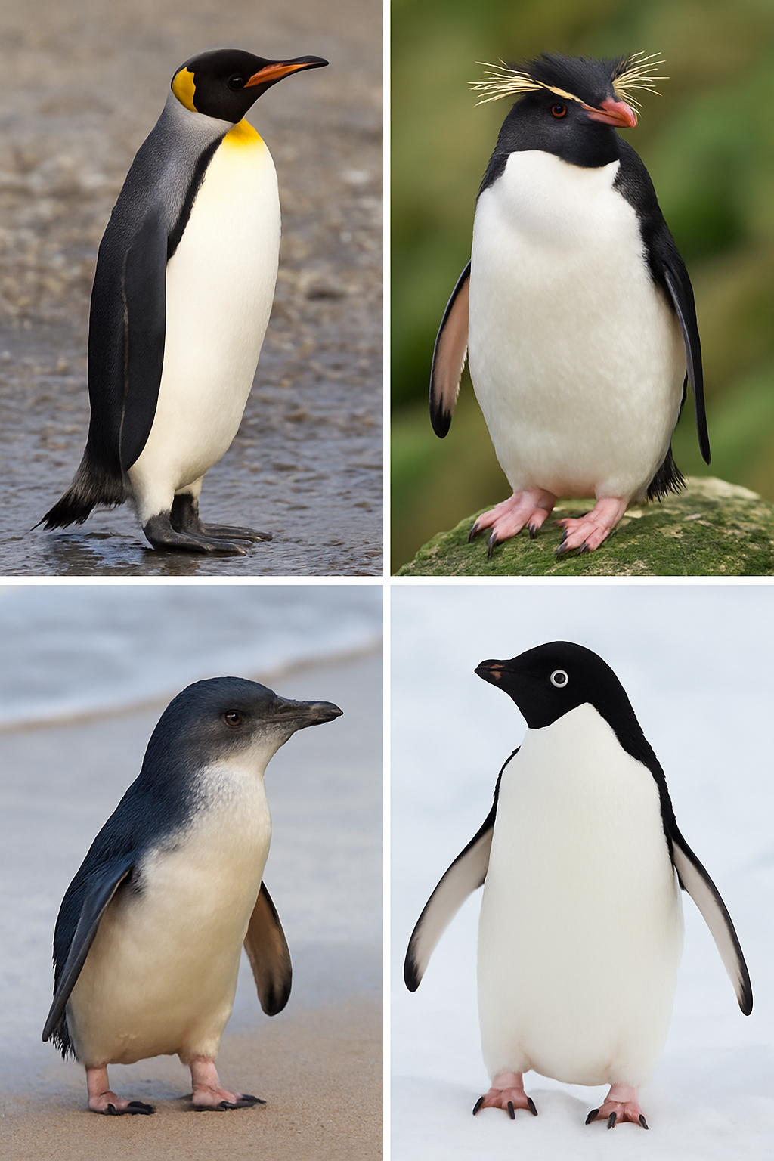

Image 1: Different types of Penguin.

Habitat
Most penguins live in very cold environments, such as the icy coasts of Antarctica. They build their nests on rocky shores or on the ice. Some species, like the African penguin, live in warmer places, such as the beaches of South Africa. Penguins spend much of their time in the ocean, where they hunt for food, but they return to land to breed and raise their young.
Diet
Penguins are carnivores, which means they eat meat. Their diet mostly includes fish, squid, and tiny shrimp-like creatures called krill. Penguins catch their food while swimming underwater, using their sharp beaks to snap up prey. Some penguins can dive as deep as 500 metres and hold their breath for up to 20 minutes.
Fact Box:
📌 Penguin Diet Facts
- Penguins eat up to 2 kilograms of food per day.
- Emperor penguins can dive deeper than 500 metres.
- Some penguins travel hundreds of kilometres in search of food.
Behaviour
Penguins are social animals and live in large groups called colonies. These colonies can include thousands of birds. During the freezing Antarctic winters, penguins huddle closely together to keep warm, taking turns moving into the centre of the group. Parent penguins care for their chicks by keeping them safe and warm. Both the mother and father share the job of feeding the chicks by regurgitating food.
Life Cycle
Penguins begin life as eggs. The largest species, the Emperor penguin, lays a single egg, which the father keeps warm by balancing it on his feet under a flap of skin called a brood pouch. After the chick hatches, both parents take turns feeding it until it is old enough to swim and find food on its own.
Conclusion
In conclusion, penguins are fascinating birds that have adapted to life both in the ocean and on land. Their flippers, webbed feet, and social behaviour help them survive in icy environments. Although they cannot fly, penguins are among the best swimmers in the animal kingdom, making them one of the most remarkable birds in the world.

✅ Elements included:
- Title
- Introduction
- Structured sections (Appearance, Habitat, Diet, Behaviour, Life Cycle)
- Diagrams (body features, life cycle)
- Images (map, colony photo – described for you to add)
- Captions under diagrams/images
- Fact box with quick information
- Conclusion

