FOR IMMEDIATE RELEASE
1/17/2023
Contact: Jane Rubini, jrubini@christchurchde.org; 302-655-3379; 610-806-2611 (cell)
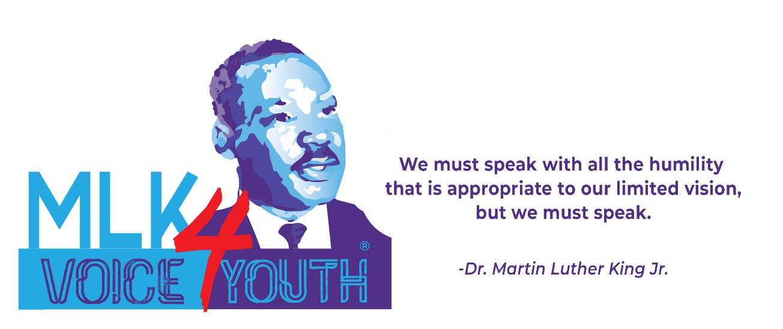
YOUTH SPEAKING THEIR TRUTH, THEIR WAY

CONGRATULATIONS AYOMIKUN ADEOJO $2,000 FIRST PRIZE WINNER!

MLK VOICE 4 YOUTH 2023 a statewide, spoken word contest for Delaware youth, celebrated 8 years providing a platform for youth voices. On Sunday, January 15 at the baby grand in Wilmington, seven finalists shared their powerful and passionate messages impressing judges, audience members as well as a virtual audience that included viewers in the US, Ghana, Nigeria, Canada, the UK, Guyana, Panama, Sweden, South Korea, and New Zealand!

This was the first year the contest was open to junior high students, in addition to high school students, and for the first time, a grade 8 student from Newark Charter Junior High School, Ayomikun Adeojo, cleaned up winning the $2,000 first prize plus $250 for junior high student with the highest score! Ayomikun was also the youngest to ever win MLK VOICE 4 YOUTH with his inspiring piece titled, “Keep Moving.” He began his prize winning performance,
“You can’t do this, you can’t do that. Oh, you’ll never be able to do this, and it’s impossible to do that. That’s just a fraction of what we hear from some of the people we love, or hate and even the people we know or don’t know because there will always be people wishing for your downfall.”

“You see, I like to think that me and Martin Luther King are some-what alike. We are both strong black men; we stand for what’s right, we are headstrong and we don’t stop until we get what we desire. This means Dr. King and I never give up and never let the oppressors and bullies puncture and tear through our skin like flesh eating lions feasting on their prey. In other words, as a young black man I've learned to stand up for what I believe in no matter what the consequence is. Even if my voice starts out as just a whisper.”

On behalf Chemours, this year’s first prize sponsor, was presented to Ayomikun Adeojo by 2022 MLK VOICE 4 YOUTH winner Srijay Chenna, currently a junior at the Charter School of Wilmington, and Jane Rubini, Founder of MLK VOICE 4 YOUTH. WSFS Bank sponsored second prize of $1,000 presented by Vernita Dorsey and Herb

- 2 -
Broadwater to Boluwatife Aminu, a senior at MOT Charter High School. Kathryn Jakabcin presented third prize of $500 sponsored by the Rotary Club of Wilmington to Iveena Mukherjee a junior at The Charter School of Wilmington. The four other finalists were:
Ayotomiwa Anawo, Millsboro Middle School, Grade 8
Obaapa Asante, Christiana High School, Grade 10
Skyy Kelly, William Penn High School, Grade 12
Julia Nowaczyk, Padua Academy, Grade 11

New Castle County Executive Matt Meyer, in addition to presenting the seven finalists with $50 gift cards, also presented $250 to the junior high student with the top score, Ayomikun Adeojo.

Sunday’s judges were:

Doneene Damon, Immediate Past President & Chief Diversity Director Richards, Layton & Finger, P.A.
Vernita Dorsey, Senior Vice-President, Director of Community Strategy, WSFS Bank
Dr. Guillermina Gonzalez, Professor, College of Business, Wilmington University
Paul Herdman, President & CEO, Rodel
Joseph P. Lawson, Southern Delaware Alliance for Racial Justice, Steering Committee
Dr. Kevin McAllister, Gamma Theta Lambda Education Foundation, Inc. & Alpha Phi Alpha Fraternity, Inc.
Deborah Olatunji, 2019 MLK VOICE 4 YOUTH Winner, University of Pennsylvania

Tim Hurtt, a past contestant now studying music at Rowan University, did an amazing job as Master of Ceremonies as did the members of the YMCA Essence Legacy Performance Arts who performed during the intermission while this year’s winners were determined.

To view the MLK VOICE 4 YOUTH finals visit: MLK Voice 4 Youth - 2023 MLK Voice 4 Youth Finals Livestream | Facebook The winner, Ayomikun Adeojo, is contestant number 4 at 54:27.

Photo (l.-rt.): 2nd Boluwatife Aminu, Ayotomiwa Anawo, Finalist; 3rd Iveena Mukherjee; Jane Rubini, Founder;
1st Ayomikun Adeojo; Julia Nowaczyk, Finalist; Skyy Kelly Finalist; Obaapa Asante, Finalist

MLK VOICE 4 YOUTH is generously supported by:

Chemours
The Grand Opera House, Inc.
Christ Church Christiana Hundred
Tom & Betsy Scott
AZTEC Printing & Design
New Castle County, Matt Meyer Executive
The Osbun Family
WSFS Bank
Alpha Phi Alpha Fraternity, Inc. & Gamma Theta Lambda Education Foundation, Inc.
Alpha Kappa Alpha Sorority, Inc. Zeta Omega Chapter
The Rotary Club of Wilmington
Southern Delaware Alliance for Racial Justice

Registration for MLK VOICE 4 YOUTH 2024 opens International Peace Day, September 21st.
For more information, visit: www.mlkvoice4youth.org

###

