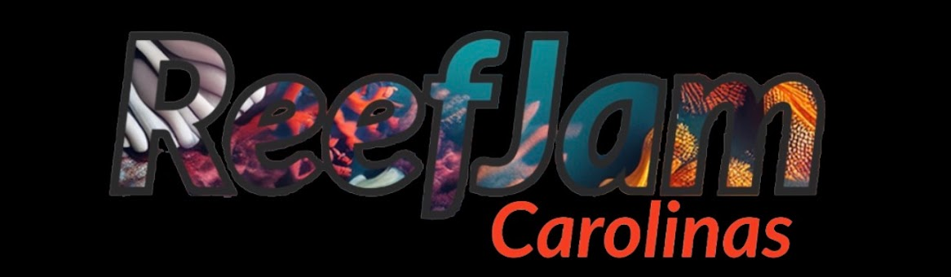

Want to be a vendor at Reefjam in Wilmington, NC on November 7, 2026? Simply Fill out the below or use the link on the website.

https://docs.google.com/forms/d/e/1FAIpQLSfkJE1r5jKzUAC-9nIxBt2uKVJdm52fK3o-fuOSTbao3Q6-0Q/viewform?usp=header

Company Name:

First and Last Name:

Phone Number:

Address:

Tax EIN Number (required):

Do you need a table?

**Payments must be made by September 1, 2026. You get choice of table selection once payment is made.
Once form is submitted we will send a link for payment.Table fee is $300

