Raindrop Technique and its many Benefits

Raindrop Technique is a truly remarkable procedure. that combines a variety of energy medicine and natural medicine modalities.
To receive a Raindrop treatment is to stimulate every organ, muscle and bone of the body at the cellular level.
Developed by D. Gary Young in the 1980’s it includes the use of several anti-bacterial therapeutic grade essential oils. Aromatics, direct topical application, effleurage, massage and moist heat are all employed in this unique procedure.
Since its development over 20 years ago it has brought relief to thousands suffering chronic back pain and has saved many expensive surgical procedures.
As research accumulates, it is becoming clear that the elements of the raindrop technique not only help heal the spine, but also benefit significantly other body systems, including the mental and emotional function of the brain.

SEVEN POWERFUL BENEFITS OF RAINDROP TECHNIQUE

#1 It helps reduce pain Massage is significant part of a raindrop treatment with particular focus on the spinal muscles. Aromatherapy, heat and massage are combined to give relief and raise dopamine and serotonin levels.
#2 It helps reduce inflammation Many studies have identified several essential oils as being powerful anti-inflammatory agents, some having the same active ingredient as aspirin. Three of these oils are used in the raindrop technique.
#3 It helps improve circulation. A 2004 study tested 100 patients with known circulation problems and found that massaging the back of the neck with essential oils resulted in a significant improvement of cerebral circulation and functional state of the brain.
#4 It can help prevent the bacterial and viral causes of spinal misalignment Researchers in Germany at the university of Bonn have found that virus like particles can lodge in the spinal ganglia through life and when activated can lead to scoliosis.
#5 It helps relieve stress Japanese studies show that the primary ingredient in cypress essential oil, also used in Raindrop technique was effective in reducing stress in lab rats. The technique of effleurage, has been beneficial to premature infants. Massage itself has been shown to boost immune health.
#6 It helps improve immune function. A recent study at the University of Miami School of Medicine, examined the effects of massage therapy on women with breast cancer over a 5 week period and found that those who received massage had more vigor Dopamine levels natural killer cells and lymphocytes increased from the first to the last day of the study.
#7 Raindrop Technique can facilitate the release of negative emotions. In a paper on the psychobiology of post-traumatic stress, Bessal A van der Kolk, MD of Harvard Medical School points out that severe emotional stresses can produce subconscious neuroses which are indelibly stored in the subconscious parts of the brain through the limbic system, Stimulation of these parts of the brain which occurs through inhaling of essential oil aromas through the nose, can help activate and release subconscious emotional stress.
It is a complex biochemical process, but even the most informed biochemists are now beginning to recognize the importance of this process in achieving emotional release and a return to normal emotional response.

_________________________________________
In short, the benefits of Raindrop technique go well beyond the physical benefits of massage. Indeed they can help improve every aspect of life, physically, mentally and emotionally, often relieving a variety of issues in a single treatment.
Raindrop technique can help not only to relieve pain and restore immediate physical wellbeing, but it can set in motion healing processes that will last for weeks or even months.
Only Young Living Essential Oils are used in the Raindrop Technique

For More Information:
Valda Pike
R.H.N
Certified Live/Layered Blood Analysis
506-229-0455

What
is
  - Raindrop Technique?

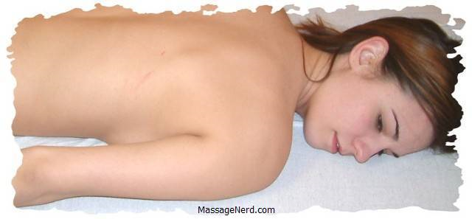

Holistic Choices
Support
Body, Mind, Spirit

