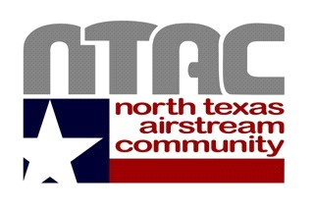
MEMBERSHIP AGREEMENT
By-Laws Article IV: The purposes for which the corporation is organized are to acquire, develop and operate a private park for the enjoyment of its members.

Preamble
NORTH TEXAS AIRSTREAM COMMUNITY, INC (“Corporation”) was conceived with the intent to provide a place where members who enjoy “Airstreaming” can be together in fellowship and participate in social activities. It was founded with the goal to establish and maintain the finest possible Airstream Park.

I affirm that I have received a copy of the North Texas Airstream Community By-Laws, Rules & Regulations which form a framework for the high purposes and goals of the community.
I accept the premise that NTAC is a place for Wally Byam Caravan Club International members to enjoy being together as friendly neighbors for fellowship and travel.

I agree to abide by the NTAC Constitution and By-Laws and to work toward maintaining the finest Airstream Park standards.
Signed
Applicant________________________Date__________________

Printed Name _________________________________________________

Signed
Spouse/Partner__________________________Date__________________

Printed Name_________________________________________________

(Rev 3/16/2021)

