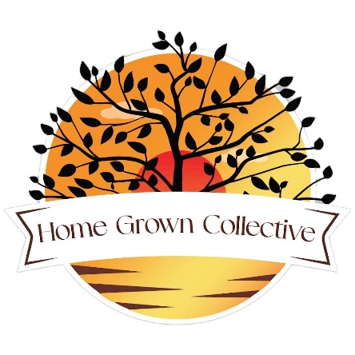

Board of Advisors & Affiliate Information SHeeT for

north carolina
Leave message @ 252-402-1373 or email us at support@homegrowncollective.org
Board of Advisors:
- Should meet every 3 months to discuss following topics:
  - Strategic planning
  - Public Relations
  - Operations quality
- Should be able to contribute constructively and knowledgeably without prejudice of politics, religion and ethnicity.
- Should have some prior experience regarding Agriculture, Local food sourcing & production and/ or Applicable business knowledge.
- The Non-profit is operated remotely to minimize overhead, Advisors must be able to utilize web meetings, email communications and organizational apps.
- Advisors time must be considered volunteer, unless professional service and consultation is rendered.
Affiliates:
- Should advocate weekly online and in-person at events, markets, gatherings along preferably their regular schedule as they are already passionate and hopefully involved in current efforts.
- Should be able to contribute constructively and help grow the platform without prejudice of politics, religion and ethnicity.
- Should be involved or very passionate about the goals of our non-profit detailed at: https://homegrowncollective.org/about .
- Affiliates that are employed by the non-profit on the Events Team or other departments will be paid an agreed amount by the hour for time and labor depending on specific task.
- Understand that if their behavior becomes damaging to the Non-profit they can be relinquished from their duties as an affiliate and employee, if applicable.

