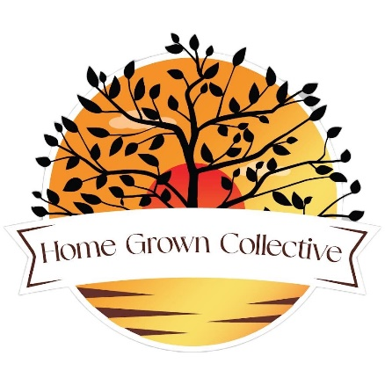 | Board of Advisors & Affiliates Application for New State  support@homegrowncollective.org  (Subject to change at New State’s Discretion)

Full Name Printed:
State, City & County:
Contact Number:
Email Address:
What knowledge and experience do you have with local food production?

How will you be able to help us grow this platform to benefit communities in your state?

Are you able to contribute constructively while focused on our goals and without prejudice of politics, religion, and ethnicity?

The Non-profit is operated remotely to minimize overhead, Advisors and affiliates must be able to utilize web meetings, email communications and organizational apps.

By signing you are confirming this information is correct and we have permission to contact you:

Board of Advisors or Affiliate?

Signature:____________________________________Date:_________________

