How do honey bees use chemical communication to manage reproduction and resources to promote colony success?

Target audience: presentation to advanced beekeeping class of Norfolk County Beekeeping Association

To understand the workings of their colonies beekeepers need an understanding of the ways that bees as individuals communicate with each other to facilitate the success of the colony itself. Colonies are complicated organisms with needs ranging from where is our next food source, to is the queen making enough offspring to provide a work force to assure our immediate and overwintering survival. It would seem that bees are presented with a difficult task of determining the state of their environment and disseminating information rapidly and accurately among anywhere from 500 – 50,000 members of the colony. One of the most important avenues of communication is the use of pheromones to transmit information.

What are the key areas of colony management?

In an over simplified view the key things that a colony of honey bees need to attend to can be summarized into three broad areas:

- Reproduction
- Nutrition
- Thermal control of the hive environment

Reproduction
Making more individual bees
Making new colonies - Swarming

Nutrition can be considered in two broad areas.
Foraged food - food brought into the hive from the outside environment
Nectar – carbohydrates
Pollen (protein)
Bee made food - food that bees process or manipulate from it’s raw form
Royal Jelly
Bee bread

Thermal Control
Surplus heat- cooling the hive
Deficit heat -warming parts of the hive that are too cold

In order to meet the demands of regulating their nutritional, thermal and reproductive needs bees have developed a wide range of chemical messengers called pheromones that enable them to effectively regulate different behavioral, metabolic or physiological outcomes. The sources of these pheromones are various glands throughout the bee’s bodies. All castes of bees are capable of producing pheromones but each caste produces different pheromones.

What are pheromones?

These are chemicals secreted by an organism’s exocrine glands that trigger a physiological or behavioral response by another member of the same species.
Pheromones and the responses to them are influenced by many factors such as: age, genetics and health status of the effected organisms. Environmental conditions and the simultaneous exposure to other pheromones can also modifiy an organism’s response to a given pheromone.
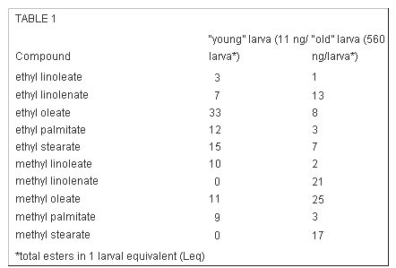
This table shows the distribution of components of the brood pheromone from two different-aged larvae. Note how greatly the proportions of some components differ. All the compounds are esters—formed by combining an alcohol (in these cases ethyl or methyl alcohols) and an organic acid. These particular esters are all formed from long-chain fatty acids typically found in vegetable oils (linoleic, oleic, and palmitic acids)-thus they are not very volatile. From United States Patent US6595828.

Primer pheromones – These pheromones act at a physiological level and trigger of a cascade of long lasting complex changes in the recipient. These are compounds are chemically less volatile in nature and cause relatively slow acting changes. Examples are Vitellogenin, Brood Pheromone, Queen Pheromone

Releaser pheromones – These are more chemically volatile and trigger immediate temporary changes in behavior in the effected organism. Examples are: alarm pheromones, sex pheromones, aggregation pheromones, egg laying pheromones, brood-tending pheromones, recruitment pheromones, trail following pheromones and territory marking pheromones.

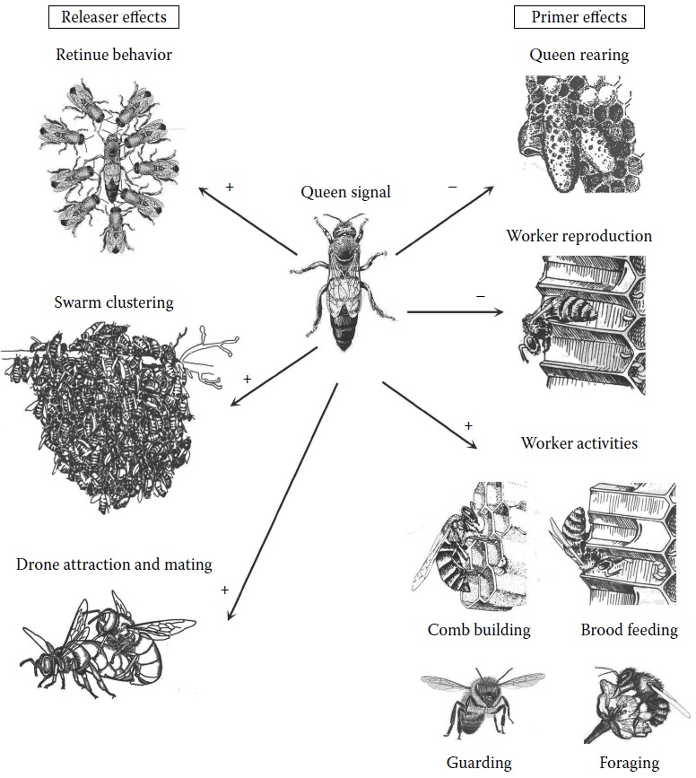
Releaser and primer effects of the queen signal, which regulates colony functions and development. Stimulating effects are indicated as “+” and inhibiting effects as “–.” (Adapted from Winston, M.L. (1987)

Some pheromones can operate as both slow acting Primer pheromones and fast acting Releaser pheromones. An example of this is Queen Pheromone which is a blend of as many as 17 different compounds. Queen Pheromone can operate as a Releaser pheromone to control retinue behavior, drone attraction and mating and also in swarm clustering. While it’s effects as a Primer pheromone are seen in queen rearing, worker reproduction, and in the control of worker activities like comb building brood feeding, foraging, and guarding.

How do bees transmit the information from one bee to the next?
Pheromones differ greatly in their degree of volatility—some, such as alarm pheromone, evaporate quickly, waft through the air, and then dissipate. Others are more “oily” and need to be physically transferred from bee to bee. In general, the more volatile act as “releaser” pheromones that elicit short-term behavioral responses (such as homing toward orientation pheromone). The less volatile function as “primer” pheromones, which cause longer-term physiological changes, such as ovary suppression in workers, change in brain function, or vitellogenin production in nurse bees. In some cases (such as with brood or alarm pheromones) a single pheromone can elicit both behavioral and physiological effects (Alaux 2007, LeConte 2001).

Trophallaxis:
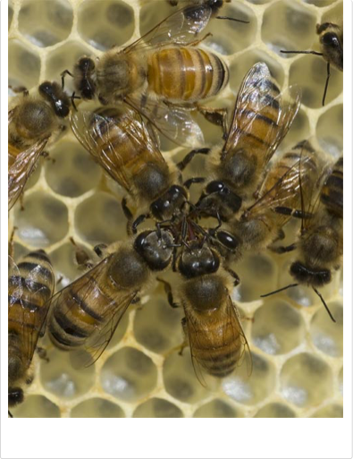
Bees engaged in trophallaxis. Note the touching of antennae, which serves to transfer pheromones from bee to bee. The group at the bottom appear to be sharing food; the pair at the upper left are sharing only information. Photo courtesy Dr. Zachary Huang.

Antenation:

Bees use antennation or the touching of their antennae to other bees to pass molecules of various pheromones from bee to bee in order to keep track of different metabolic states and processes. The picture below shows worker bees antennating a queen bee to determine her pheromonal milleu.

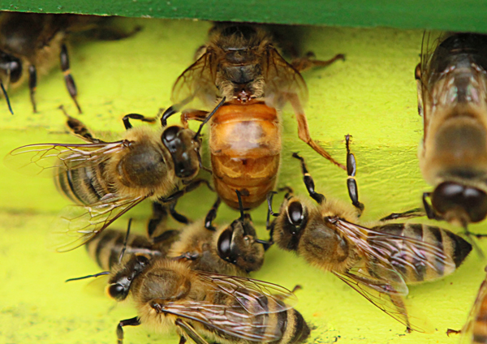

Where are pheromones produced?
Pheromones are produced in glands located in different places on bee’s bodies.

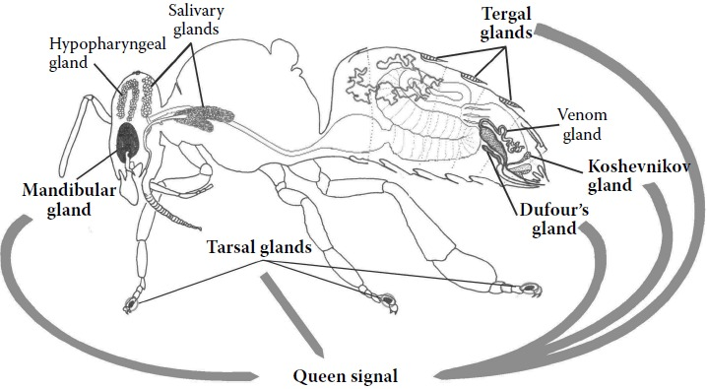
Exocrine glands of the honey bee queen. The pheromone-producing glands that concur to the formation of the queen signal are highlighted in bold. (Adapted from Goodman, L. (2003) Form and Function in the Honey Bee. Cardiff, UK: IBRA.)

Key pheromone producing glands are:

Queen mandibular glands produce Queen Mandibular Pheromone (QMP). These glands are a pair of small glands located in the queen’s head just above the base of their mandibles. QMP is the most widely studied pheromone and is involved in the control of many different aspects of life in the colony.

Tergal Glands produce a series of pheromones that assist or cooperate in the functioning of QMP. These tergal glands are sometimes referred to as Renner and Bumann glands. They are located interior to the abdominal tergites or body segment plates in both workers and queens. The Renner and Bumann glands are more developed in the queens relative to the workers.

Tarsal Glands are found in all castes and produce footprint pheromones. This pheromone when produced by a queen serves to inhibit the formation of queen cups.

Dufor’s Gland is a tubular gland found in association with the sting apparatus. Because of it’s location the secretions of the Dufor’s gland are linked to defense / sting related functions in workers and egg coating and egg marking functions in queens

Koschevnikov Gland is also located near the sting shaft and produces pheromones associated with sting / defense functions.

Nasonov Gland is located beneath the sixth and seventh tergites produce pheromones associated with the orientation of bees to the location of their hive and also for recruitment of bees to move to high quality forage sites and also to promote swarm clustering.

The cuticle of the bees body is the source of a mix of compounds that serve to form an identifying signal among the bees from a given colony. In a manner of speaking this is the smell of hive mates and allows bees to identify each other as part of the group or as outsiders.

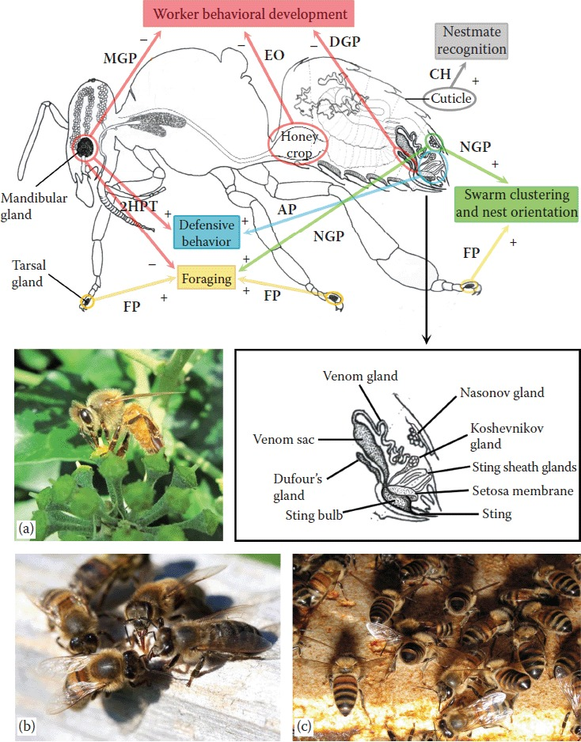

Pheromone-producing glands and organs and their main products in the honey bee worker, and their effect in the different worker activities. Stimulating effects are indicated as “+” and inhibiting effects as “–.” (a) Honey bee worker foraging on Hedera helix; during foraging workers mark flowers with the secrete of their tarsal and mandibular glands. (b) Nestmate recognition among workers in front of the hive entrance; workers use chemical cues like cuticular hydrocarbons perceived through mouth and body part contact. (c) Honey bee workers exposing the Nasonov gland in front of the hive to release the orientation pheromone. 2HPT = 2-heptanone; AP = Alarm pheromone; CH = cuticular hydrocarbons; DGP = Dufour’s gland pheromone; EO = ethyl oleate; FP = Footprint pheromone; MGP = mandibular gland pheromone; NGP = Nasonov gland pheromone. (Adapted from Goodman, L. (2003)

What are the key pheromones and what are the control functions that they are linked to?

Queen Mandibular Pheromone (QMP) is the most widely studied of the chemical signals bees employ. It’s primary source is the mandibular glands in the queen’s head and is a key player in many aspects of hive activity organization. It can function in primer or releaser roles and is involved in the control of mating behavior, restriction of ovary development in worker bees, swarming behavior and in the formation and maintenance of the retinue of bees attending the queen. QMP is a complex chemical signal comprised of numerous organics compounds. Prominent among the constituents of QMP are:
(E)-9-Oxodec-2-enoic acid (9-ODA)
(R,E)-(−)-9-Hydroxy-2-enoic acid (9-HDA)
(S,E)-(+)-9-HAD
Methylparaben (HOB)
4-Hydroxy-3-methoxy phenylethanol (HVA)

Examples of the impact of QMP’s constituents are:
9-HDA helps to keep swarms of bees cohesive and calm during the move from the former colony site to the “new “ site for the swarm.
9-ODA has a wide number of effects it helps workers know if the queen is in the hive, it serves to restrict ovary development in worker bees and is a powerful attractant for drones during mating flights.

Queen retinue pheromone (QRP)
The combination of the 5 QMP compounds and the methyl oleate, coniferyl alcohol, certyl alcohol, and α-Linolenic acid is called the queen retinue pheromone (QRP). The combination of QMP and QRP attract bees to attend to the queen.

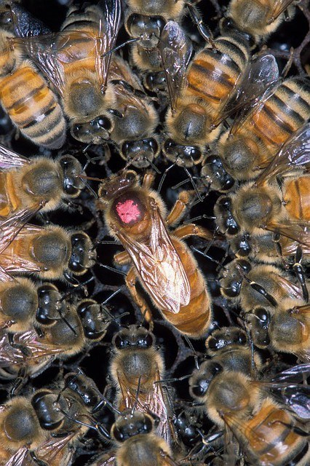Queen retinue formation is one of many honey bee behaviors controlled by pheromones. Pixabay photo.

Brood Pheromone (BP) is a blend of 10 fatty-acid esters: methyl palmitate, methyl oleate, methyl stearate, methyl linoleate, methyl linolenate, ethyl palmitate, ethyl oleate, ethyl stearate, ethyl linoleate, and ethyl linolenate . When taken as a whole these compounds act a primer pheromone that regulates worker development and colony growth. Independently these compounds show different releaser effects on adult bees.
Alarm pheromone, produced by workers, is a releaser pheromone that calls nest mates to help defend the colony from intruders. A sting, which also releases alarm pheromone, causes other bees to sting as well.
I observed the effect of this pheromone one day when I had been working in my apiary during autumn and was working a particularly defensive hive. My gloves got stung numerous times loading them with alarm pheromone. By exposing my gloves to smoke I was able to mask the alarm pheromone and the level of defensive behavior dropped markedly.
Brood ester pheromone (BEP), produced by larvae, is a primer pheromone that, among other things, inhibits ovarian development in worker bees.

Drone pheromone is released by drones and allows them to find each other and form a drone congregation area (DCA).

Dufour’s gland pheromone is not clearly understood except that it has something to do with interactions between queens and workers, and between laying workers and non-laying workers. The composition of the pheromone changes as a worker evolves into a laying worker.

Egg marking pheromone allows worker bees to distinguish between queen-laid eggs and worker-laid eggs. At one time, scientists believed that the Dufour’s gland pheromone marked a queen’s eggs, but now egg-marking pheromone appears to be separate.

Fecal pheromone is produced by virgin queens. In-hive squabbles between virgin queens, or virgin queens and workers, are sometimes resolved when virgins squirt feces on the aggressive bees. Workers covered in the pheromone-laced feces back off in order to groom, and virgin queens covered in feces are ignored by the workers.

Footprint pheromone, also known as trail pheromone, is found in many social insects. Worker honey bees secrete the pheromone from their feet as they go about their daily business, and the odor is attractive to other honey bees. In theory, footprint pheromone is used for orientation and may aid the workers in finding the hive entrance or in locating a good food source, but the specifics are unclear.

Nasonov pheromone, sometimes called the “come hither” scent, is produced by worker bees to attract nest mates to the colony entrance, a clustering swarm, or a food source. If you move a hive a short distance from its original location, you can see workers exposing their Nasonov gland (it lies between the sixth and seventh abdominal tergites) and fanning the scent into the air. Nasonov can also be used to attract swarms to nest boxes.

Tarsal pheromone is similar to footprint pheromone but it is secreted by the queen. The pheromone is deposited on the surface of the comb and is believed to delay or prevent queen cell construction.

Tergite pheromone is produced by all bees in the hive but the composition and amount varies with the type of bee. Virgin queen tergite pheromone is believed to be related to fighting among virgin queens.
Queen mandibular pheromone (QMP) plays many roles in the hive, including regulating social behavior, swarming, mating, and suppressing laying workers. Often known as “queen substance” the pheromone is spread throughout the hive by the worker bees, thereby alerting colony members that the hive is “queen-right” and operating normally.

Queen retinue pheromone (QRP) entices worker bees to groom and feed the queen, and causes a circle of attendants to surround and care for her.

Worker pheromone (Ethyl oleate) is a primer pheromone produced by foraging bees that slows the maturation of nurse bees into forager bees. It is believed this pheromone helps to maintain a proper balance of nurse bees to forager bees in the colony.

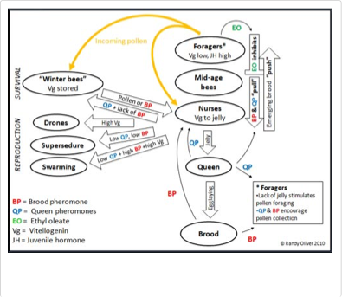
This diagram shows the interplay of BP, QP, EO, vitellogenin and JH with respect to reproduction and nutrition.

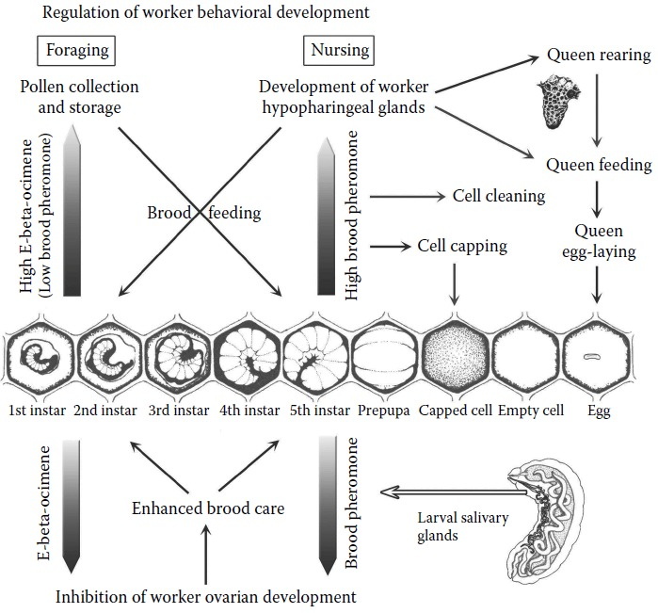
Effect of brood pheromones on the regulation of worker behavioral and sexual development. Large arrows indicate effect of the pheromones on development; small black arrows indicate effect of the pheromones on activities. In the lower part of the figure: both E-beta-ocimene and brood pheromone (secreted by larval salivary glands) inhibit ovarian development in workers, which in turn enhances their brood care commitment. In the upper part of the figure: high levels of E-beta-ocimene and low levels of brood pheromone, secreted by young larvae, boost worker behavioral development toward the foraging phase, stimulating pollen collection and thus supporting larval nutrition; high levels of brood pheromone, secreted by older larvae, enhance the nursing phase through the development of worker hypopharyngeal glands, which produce the royal jelly used for nutrition of young brood and the queen; in addition, brood pheromone stimulates cell capping and cell cleaning, the rearing of new queens, and queen egg-laying. (Adapted from Winston, M.L. (1987) and Crane, E. (1990)

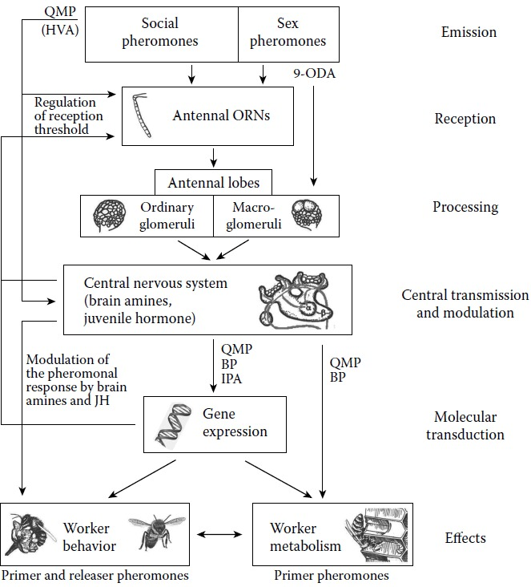
Schematic representation of the pheromone processing pathway from its reception to its behavioral and physiological effects. Pheromones are transduced by the antennal odorant reception neurons (ORNs) and processed in the antennal lobes, respectively, in the ordinary glomeruli for social pheromones and in the macroglomeruli for sexual pheromones (9-ODA). The signal is transmitted to the central nervous system, mainly to the mushroom bodies and the lateral horns, where it influences the level of brain amines (especially octopamine [OA]) and juvenile hormone (JH). In turn, the levels of brain amines and JH modulate pheromonal response by regulating the reception threshold at peripheral and central level. Homovanillyl alcohol (HVA), one of the components of QMP, is able to mimic dopamine and thus acts directly on the dopaminergic pathways in the central nervous system, but also at the peripheral level on DA and OA antennal receptors. At the molecular level some pheromones were found to act on gene expression (QMP, BP, and IPA), others on worker metabolism (primer pheromones like QMP and BP), while for all of them the final effect is the regulation of worker behavior. (Bortoloti and Costa 2014)

Anticipated questions from the audience:
- What is a practical way I can use this information in daily interactions with my hives.
  - By learning to use smoke or other odors to mask alarm pheromone when working bees that are being defensive and stinging.
- Are there opportunities to actually observe bees using pheromones to communicate?
  - Probably the most obvious opportunity is when beekeepers are installing a new package of bees. After you have installed the bees there are almost always some bees that didn’t make it into the hive. Bees will often mass at the front entrance of the hive with their buts in the air fanning to spread Nasanov pheromone to attract the bees that didn’t make it into the hive.

REFERENCES:

Bortolotti L., Costa C, Chemical Communication in the Honey Bee Society. In: Mucignat-Caretta C, editor. Neurobiology of Chemical Communication. Boca Raton (FL): CRC Press/Taylor & Francis; 2014.

Burlew, Rusty, https://honeybeesuite.com/honey-bee-pheromones-common-scents/

Crane E. Bees and Beekeeping: Science, Practice and World Resources. Ithaca, NY: Cornell, University Press; 1990.
Goodman L. Form and Function in the Honey Bee. Cardiff, UK: IBRA; 2003.
Oliver, Randy. scientificbeekeeping.com/the-primer-pheromones-and-managing-the-labor-pool-part-1/
Oliver, Randy, scientificbeekeeping.com/the-primer-pheromones-and-managing-the-labor-pool-part-2/
Oliver, Randy, scientificbeekeeping.com/the-primer-pheromones-and-managing-the-labor-pool-part-3/
Winston M.L. The Biology of the Honey Bee. Cambridge, MA: Harvard University Press; 1987.

