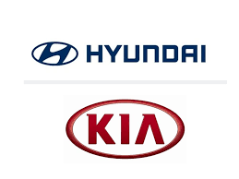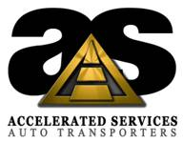

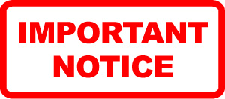

**Montgomery/West Point Loading Instructions**

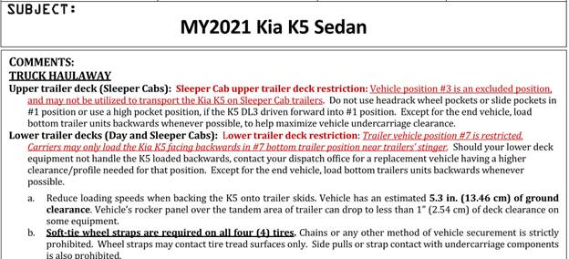

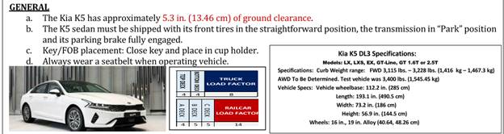

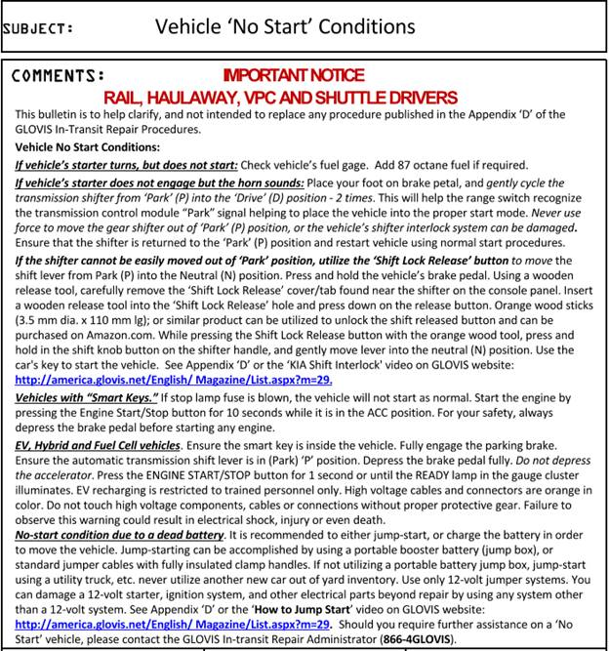

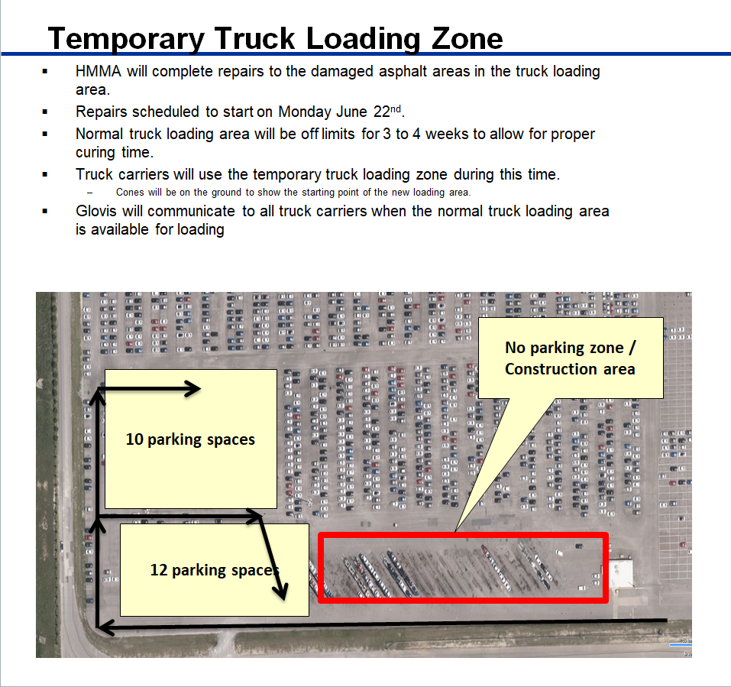

1. **Confirm that the VIN# on load sheet matches the VIN# on the unit**
2. **Thoroughly inspect the unit for cosmetic damages**
3. **ALL DAMAGES FOUND ON VEHICLES MUST BE SIGNED OFF OR REPAIRD BY YARD. DO NOT SHIP ANY VEHICLES WITH DAMAGES!!!**
4. **Confirm that the VIN# on the bay tag matches the VIN# of the unit**
5. **Bay tags are the full sheets of paper with VIN# and barcode—found in each unit**
6. **If the bay tag is missing from the unit or has the wrong VIN#, the correct bay tag must be printed by an authorized GLOVIS representative**
7. **Drive the unit to the truck—no faster than 15 mph**
8. **4-strap the unit down when loaded using a wheel strap for each tire**
9. **Company BOL / load sheet with Load# , VIN#s, and company info is required to exit the gate**
10. **Organize all bay tags in the exact order they appear on load sheet**
11. **A driver is prepared to exit the gate once all bay tags have been organized in the exact order the VINs appear on the load sheet**
12. **If bay tags are not in the exact order they appear on the load sheet, the security guard will hand them back to the driver and will not accept them until they are properly organized.**
13. **Failing to properly organize bay tags will result in lost time for the driver at the gate, as well as, the other driver behind him waiting to exit.**
14. **A driver should never arrive to the guard shack with the wrong bay tag**
15. **When a driver arrives to the guard shack with the wrong bay tag, that means he/she failed to confirm that the VINs match their load sheet**
16. **If a driver finds that a bay tag does not match the VIN # on the unit or his/her load sheet, the driver must notify his/her terminal manager/supervisor**
17. **The correct bay tag must be supplied before the driver can exit the premises**