**MBUSA procedures and special instructions**

**OPEN 24/7 FOR LOADING.**

**YOU MUST HAVE YOUR YARD SHEET AVAILABLE WHEN ENTERING MERCEDES. GUARD WILL ASK FOR IT ALONG WITH YOUR DRIVERS LICENSE.**

**ALL UNITS HAVE A RELEASE FORM (GATE PASS)ON DASH BOARD. YOU MUST HAND TO GUARD WHEN EXITING THE YARD. IF YOU DO NOT HAVE THE GATE PASSES, YOU WILL NOT BE ABLE TO LEAVE THE YARD.**

**\*REPORTING DAMAGES TO MERCEDES BENZ\***

**DRIVER’S ARE TO REPORT DAMAGES TO THEIR RESPECTIVE DISPATCH OFFICE.**

***NOT TO THE MERCEDES EXPEDITOR’S OFFICE.***

***Mercedes will conduct audits of drivers loading abilities. Please make sure you are not loading with frayed or torn straps. Make sure the 3 cleats on straps are in the 10-12-2 position on each tire. You are required to have a vest or shirt of high visibility.***

**\*\*\*\*UPDATE\*\*\*\***

**Carriers, please be advised with factory roof spoilers, load the vehicles in the forward position.  CANNOT BE BACKED ON!**

**Vehicles with roof spoilers may only be loaded in the direction of travel.**

**G63 models are to be loaded on top decks except #1 position. And loaded on last position on bottom deck. No Exceptions!!!**

**AMG BODY STYLING UNITS**

**\*\*For loading restrictions/requirements please see below\*\***

**Under no circumstance should an AMG body styling A-Class AMG/C-Class AMG/E- CLASS AMG be loaded on the top deck. LOAD ON BOTTOM DECKS ONLY!!!!**

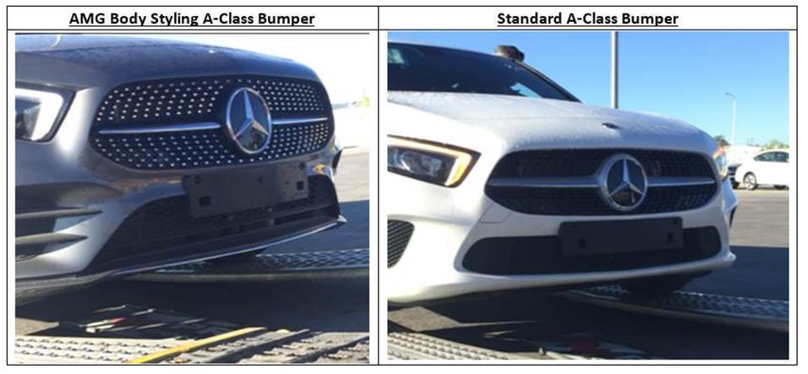



**MAYBACH IS 6 INCHES LONGER**

**TO OPEN S-CLASS DOOR(WITH FLUSH HANDLES), PRESS THE LEFT SIDE OF THE HANDLE AND IT SHOULD POP OPEN.**



Mercedes-Benz USA, LLC A Daimler Company

NOVEMBER 30th, 2018

Subject: ADS/ Adaptive Suspension Handling Requirements

In 2016, MBUSA implemented several loading restrictions related to the transportation of vehicles equipped with the ADS+ system. During this time, tests were performed and observations were made regarding the necessity of these restrictions. Based on these results, MBUSA is hereby modifying the restrictions as follows:

**Loading of ADS Vehicles:**

* May be loaded on any deck of the trailer
* No restriction on maximum number of ADS+ units per load
* Increased space minimums remain (toward the ground: 4in., to the front/back: 4in., above roof: 8in.)

Note: If loaded on top deck, total trailer height must be under 12’8” for the increased space minimums.

* Ensure tie-down straps show no signs of structural integrity being compromised (e.g. frayed, torn, etc.)

**Transportation of ADS Vehicles:**

* Check and adjust the straps after the first 50 miles of travel.
* Afterwards, check the straps in regular intervals, especially after extraordinary driving situations: (emergency braking, swerving, etc. Straps may become loose or break)

**Identification of ADS Vehicles:**

A notification will be provided through our normal manifest process to identify vehicles equipped with ADS+. Additionally, vehicles may have a broadcast sheet in the windshield which will identify the suspension code.

ADS vehicles should have special label (below) applied by the factory to the driver side door frame (B pillar), adjacent to the tire and loading information label, which addresses the increased distance.

B Pillar Label Export Shipping Label Domestic Shipping Label

