
Factory Works Ten4 upgrade for 4wd RC10
If you get lost, the RC10 4WD manual is useful for reference! If you need to zoom in on the pics, see the online manual on our website

1- Rear transmission: Install the aluminum pulley using the included setscrew. Trim the small plug for the topshaft for pulley clearance.
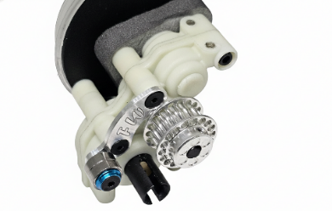
2-Rear shock tower: Replace your existing rear shock tower with the provided tower. You can keep the stock rear braces, or remove them as we have done here. If you remove them, use some 2mm spacers to take up the space. The stock braces do very little for support.
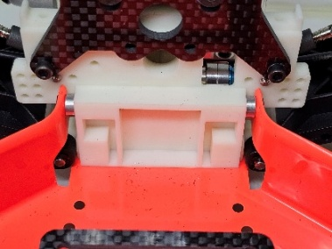
3- Front transmission: Install the aluminum pulley using the included setscrew. Trim off the two nubs for the shock tower from the transmission. We do not use them. Install the front belt separator using the instructions with the set. Install the new belt around the front pulley, over the idler bearings, and to the rear. Swap out the front shock tower. You will also want to trim down the post on the bellcrank to clear the separator. About 2mm should be fine!
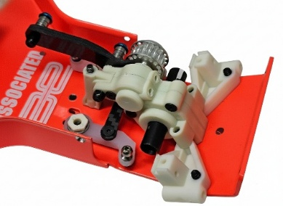
7- Install your ball joint onto the caster block as shown. Note: If you are using 3mm ball joints you MUST tap the caster block to 3mm first! Install the caster blocks onto the front arms. Assemble the front cva joints making sure the clip is seated in the groove. Install a shim onto the cva shaft, then install it into the steering knuckle using the 5x10mm bearings. Install the 12mm wheel hex. Install a caster hat bushing into the top and bottom of the caster block, and slide the steering block into place. Install the steering block to the caster hat bushings using the 3x10mm screws and lockwashers. Make sure the steering moves freely (if not, run a 4.5mm drill bit BY HAND through the large holes in the caster blocks). Transfer over your turnbuckles. Lastly, assemble the aluminum chassis brace using the provided instructions. You can now install the shocks and wheels.
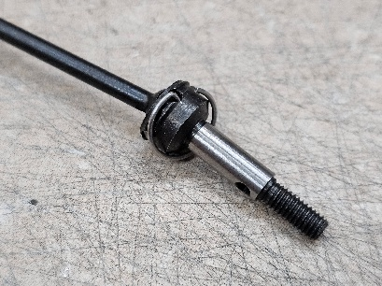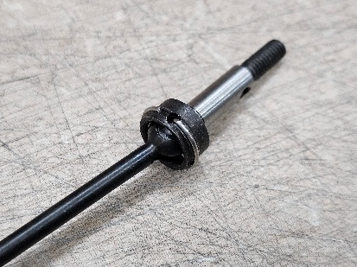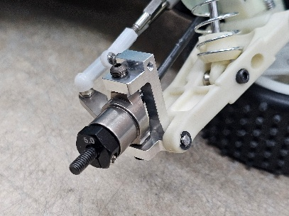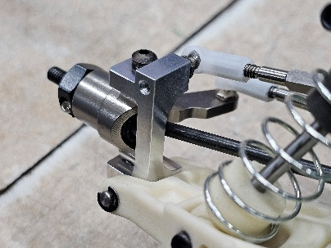

This completes assembly! Happy Racing!

Please feel free to reach out at:
sales@factoryworks.com



