
Factory Works Ten4 upgrade for 2wd RC10 tub chassis buggies with Stealth transmission
If you get lost, the RC10 4WD manual is useful for reference! If you need to zoom in on the pics, see the online manual on our website

1-Let’s start with the chassis prep. Depending on your existing chassis, you may not need to complete all these steps. The 4wd chassis are already prepped and you can skip this. Attach the template to the chassis temporarily using all 3 screws. Drill through the chassis using the template as your guide. These 5 new holes will need to be countersunk to match the other chassis holes. Use a 100° countersink for the large holes and 82° for the small ones. Once finished, make certain all 6 of the noseplate holes are tapped to 8-32. Now bolt the nose to the chassis using the front most outer holes with 3/16” screws. The rear most outer screws will be 1/2". The rearmost center will be another 3/16” screw. The remaining front center hole will be the special screw. We will install it later. This completes the chassis mods.
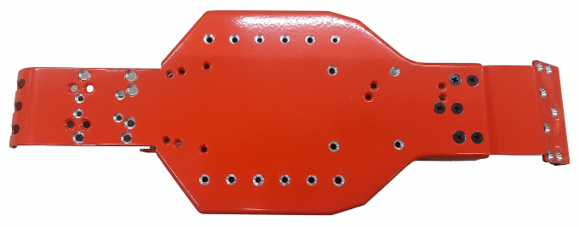
2-On to the rear stealth transmission. Disassemble and discard the idler gear. With the bearing still in the case for the idler on the left side, use a 3/16” drill bit and run it through the bearing drilling through the case. Now remove the bearing and drill the hole out to 7mm or 9/32”. This will allow some space for the pulley. The small plug for the topshaft on the same case half will need to be trimmed for clearance. Reassemble the transmission with the 4wd idler and you will want to use a little of your favorite grease (JConcepts RM2, Valvoline Crimson, Lucas Red and Tacky, AE diff lube, etc.) on the gears since it is now metal to metal. Instead of the two forward bolts, you will be installing the new belt idler bracket using the included flat head screws. Install the 2 unflanged bearings onto the idler bracket using a 3x8mm screw and washer. We highly recommend using Loctite but keep it away from plastic! Install the aluminum pulley using the included setscrew.
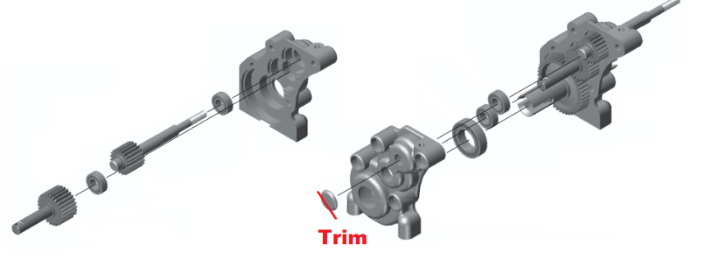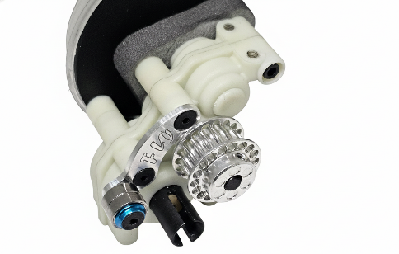
3-Replace your existing rear bulkhead and shock tower with the 4wd bulkhead and new shock tower. Use the included spacers between the chassis and bulkhead to take up the space. Note: we do not use the AE braces as they do almost nothing but take up space. Leave out the two upper, inner screws to the shock tower as we will install the brace later. You can now transfer your ball joints to the new bulkhead. Reattach your transmission and install the trans brace. Reassemble your rear suspension if you have removed it. The rear should now be complete.
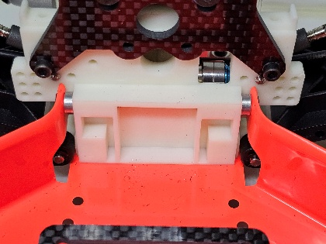

4-Install the steering link between the bellcranks, you will want a single shim between the link and the bellcranks with the flat head screw lightly tightened and then backed off to allow free movement without slop. Install your steering ball ends. Install the flanged bearings, and add a washer to the screws on the chassis. Now lay the steering in place and attach using a steering post from the top side down, snug up until everything moves freely and without slop.
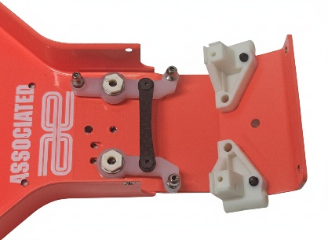
5-Assemble the front diff using the instructions for your existing rear stealth diff. Trim off the two posts at the front of the 4wd case. We do not use those for our shock towers. We have included shims; you may need a couple per side- AE has made many running changes there. When bolting the case together, make sure you have the rear brace post in place as it is captured by the trans halves. Use 4 of the ½” long screws to hold the case together. Install the aluminum pulley using the included setscrew. Install the front belt separator using the instructions with the set. This completes the front transmission.
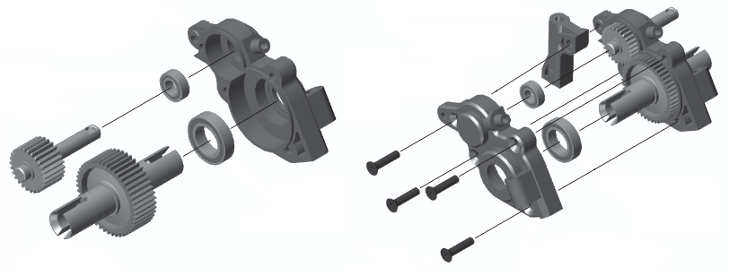

6-Now reinstall your front suspension to the nose plate using the outer 4 holes. The inner 2 holes will be drilled out with a 4.4mm, #16, or 11/64” drill. Install the front transmission using the holes that were just drilled out with 7/8” screws. Now install the special screw into the chassis/noseplate and through the rear brace post. I like to drill out the post for the screw to pass easier, it will help with future maintenance. Do not install a nut at this time. Route the belt as shown around the front pulley, over the idler bearings, and to the rear. You can still flex the chassis a bit if needed. Install your ball joints onto the front shock tower and attach it to the mounts using the ½” flat head screws. Reinstall the nose brace tubes.
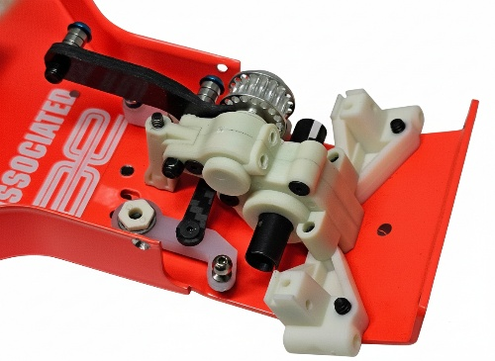
7- Install your ball joint onto the caster block as shown. Note: If you are using 3mm ball joints you MUST tap the caster block to 3mm first! Install the caster blocks onto the front arms. Assemble the front cva joints as shown. Install a shim onto the cva shaft, then install it into the steering knuckle using the 5x10mm bearings (note! If you feel drag, make sure the cva clip is fully seated. I will sometimes grind out the inside of the steering knuckle a little with a Dremel). Install the 12mm wheel hex. Install a caster hat bushing into the top and bottom of the caster block, and slide the steering block into place. Install the steering block to the caster hat bushings using the 3x10mm screws and lockwashers. Make sure the steering moves freely (if not, run a 4.5mm drill bit BY HAND through the large holes in the caster blocks). Transfer over your turnbuckles. Lastly, assemble the aluminum chassis brace using the provided instructions. You can now install the shocks and wheels if you haven’t already.
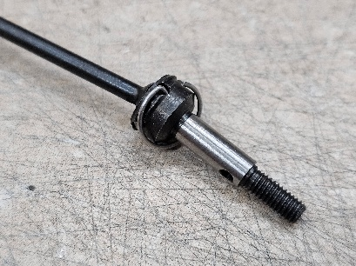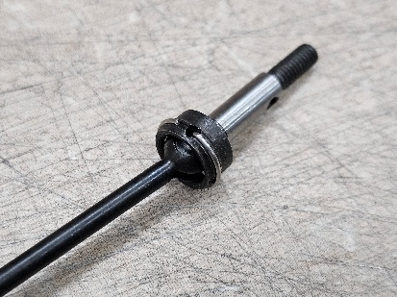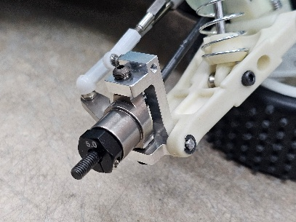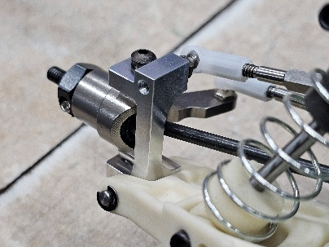

This completes assembly! Happy Racing!

Please feel free to reach out at:
sales@factoryworks.com



