
How to assemble your JC Racing/Factory Works case for modern internals

This transmission case was designed to fit ANY RC10 utilizing either 6 gear mounting holes OR stealth mounting holes on both the chassis and trans brace. Reuse your stock screws for whichever mounting you prefer.

Start with assembling the ball diff or gear diff using the AE instructions. If you are using a B6.4 series diff as recommended you wont need shims. If you are using a B5 series diff or a SR10/DR10/RB10 diff, you will need to purchase Team Associated 92139 shims or equivalent. Use the ¼” socket head screws to attach the motor plate to the right side case half. Then press the 5x10 and 10x15 bearings into the trans case.
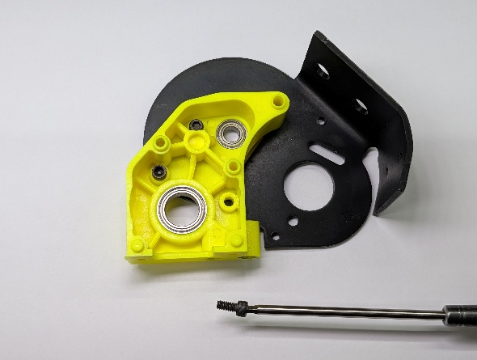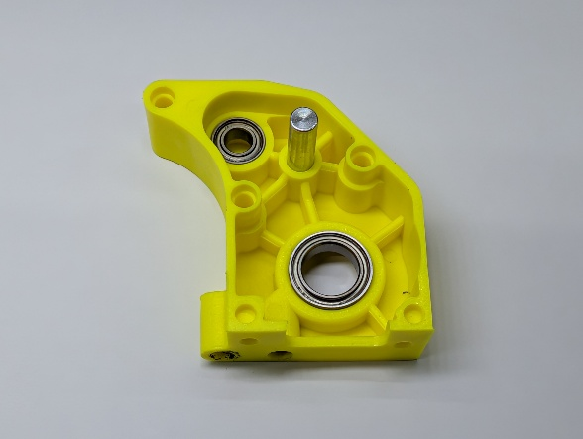
Now install the top shaft, idler with bearings, and diff. On the ball diff, the adjustment should be on the same side as the topshaft. Install the left case half using the 2 short and 1 long screw (uppermost hole). Do not overtighten.
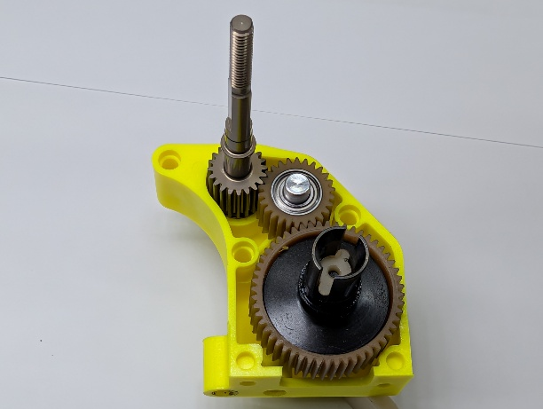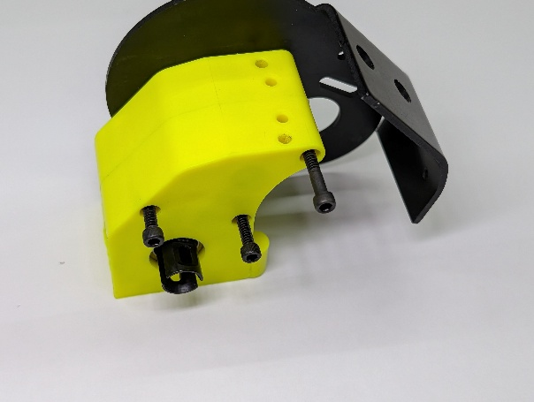
For the slipper, chose the instructions for the style you will be using.
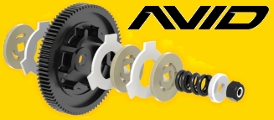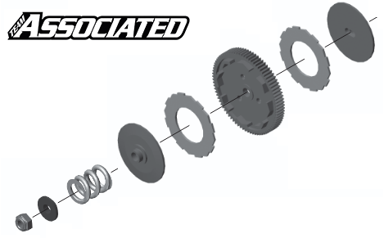

Finally, mount the trans using existing screws. The gear cover uses the remaining 4-40 x ¼” screws.
Enjoy!

