To the Friends of the Alpena Farmers’ Market:
”Pull up a chair. Take a taste. Come join us. Life is so endlessly delicious!”
Ruth Reichi, Chef, Author
The Friends of the Alpena Farmers’ Market supports the health and nutrition of our local community. This is accomplished by sponsoring activities at the market organized by volunteers and supported through donations and grants, guest chefs, kids’ day, cultural demonstrations, and tasting events. Our goal is also to assist the market to adapt and expand to meet the changing needs of vendors, customers, and community.

Adaptation and expansion can be related to facilities but also to increased awareness of how a farmers’ market strengthens a community. The following list itemizes what is being done in cooperation with the Alpena Farmers’ Market with assistance from the Community Foundation of Northeast Michigan, Alpena County Youth and Recreation Committee, community organizations, and donations from individuals and sponsors.

- Annual Locavore Dinner.
- Scholarship established for youth involved in agriculture.
- Community Antiques and Rummage Sale Day
- Save-A-Life Saturday
- Spring Plant Sale Fundraiser to support market activities
- Market Sprouts Programs teaching kids about a healthier lifestyle
- Sponsoring kids to sell items they have produced or grown themselves
- SNAP/EBT cards, Double Up Food Bucks, WIC vouchers, and Senior Project Fresh coupons.
- Music at the Market
- Fall Mum Sale to support market activities
- “Ban The Bag”reusable bag program to eliminate the use of single use plastic bags
- “Save A Life Saturday” which helps us maintain an Automatic Electrical Defibrillator(AED) at the market and provide Basic Life Support(BLS) training at the market.
- Guest chef programs teaching us how to prepare local, season, healthy meals
- Annual Kid’s Day with Alpena Future Farmers of America and the City of Alpena Fire Department.
- Spring Fun Day with the Alpena Optimist Club.
- Enhance and support Mich-E-Ke-Wis Park by hold our summer and winter market here.
Join the Friends of the Alpena Farmers’ Market in promoting consumption of locally grown produce, good nutrition, and engagement in the community. Donations may be tax deductible.

Thank you for your support,
SANDY SANTAMOUR, PRESIDENT J.B. COOK, PRESIDENT
Friends of the Alpena Farmers’ Market Alpena Farmers’ Market
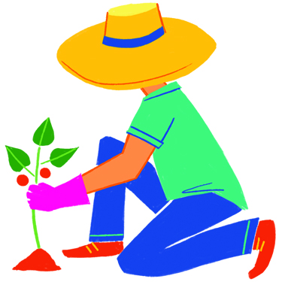
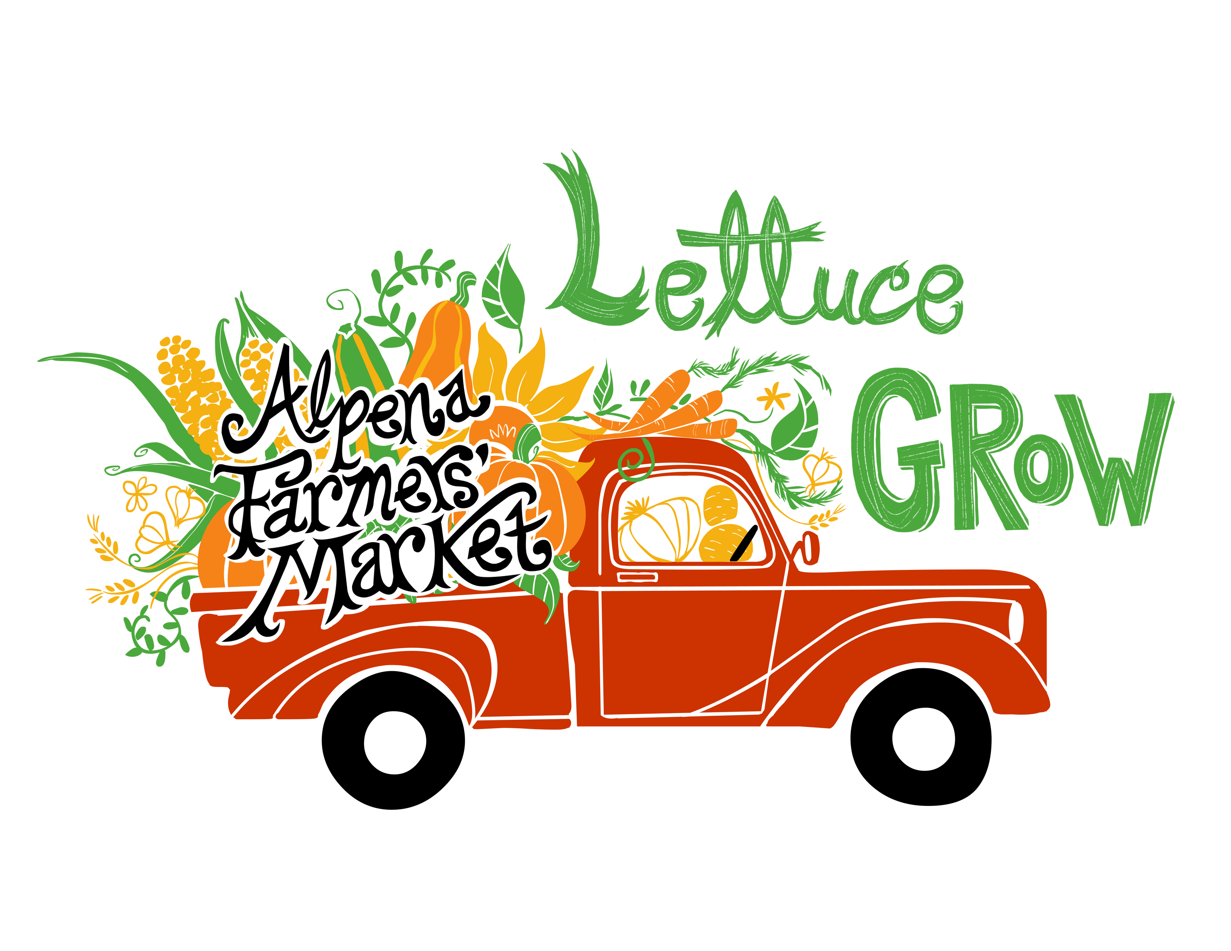
Friends of the Alpena Farmers’ Market Sponsorship Levels

Gardener Level ($1000 and above)

- With this sponsorship level, we will use at least $500 of this money to go directly toward purchase of an item/activity in the sponsor’s name.
- You will receive 2 tickets to the annual market dinner
- Money will be used to help fund Friends of the Alpena Farmers’ Market activities.
- You or your business will be recognized with Kids’ Day advertisement.
- You or your business will be listed as one of the main sponsors of the market in the next brochure and/or reusable bag that will be printed for next season.
- You or your business will be listed on the donor board at the Locavore Dinner and at the Farmers’ Market. You will also receive a market button and reusable bag

Sunshine Level ($500-$999)

- With this sponsorship level, we will use at least $250 of this money to go directly toward the purchase of an item/activity in the sponsor’s name.
- You will receive 2 tickets to the annual market dinner
- Money will be used to help fund Friends of the Alpena Farmers’ Market activities.
- You or your business will be recognized with Kids’ Day advertisement.
- You or your business will be listed in the next brochure and/or reusable bag that will be printed for next season.
- You or your business will be listed on the donor board at the Locavore Dinner and at the Farmers’ Market. You will also receive a raffle button and reusable bag.

Cultivator Level ($150-$499)

- You or your business will be listed in the next brochure and/or reusable bag that will be printed for next season.
- You or your business will be listed on the donor board at the Locavore Dinner and at the Farmers’ Market. You will also receive a raffle button and reusable bag.

Seedling ($50-$149)

- You or your business will be listed on the donor board at the Locavore Dinner and at the Farmers’ Market. You will also receive a raffle button and reusable bag.

Friend Level ($10-$49)

- You will receive a market raffle button and reusable bag

