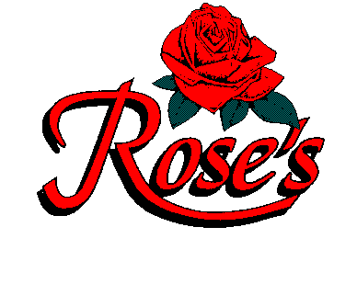
SAMPLE FROM DINNER PRICE MENU
FOR LARGER GROUPS
WELCOME TO ROSE’S
IN HONOR OF (PERSON OR BUSINESS NAME)

LASAGNA
Mama Rose’s homemade lasagna, stacked high with homemade noodles $13.95

FETTUCCINE ALFREDO
plain 12.95 with chicken or shrimp $17.20
Romano and Parmesan cheeses blended in a light cream sauce, served over fettuccine

ANGEL HAIR PROVENCALE
plain 12.95 with chicken or shrimp $17.20
A light sauce of diced tomatoes, wine and herbs
with artichokes over angel hair

MAMA PASTA BOAT
Two jumbo meatballs over a bed of spaghetti topped with rose’s homemade marinara sauce $13.95

CHICKEN MILANO
Sautéed chicken breast with mushrooms and garlic
in a sherry cream sauce Served W/Rice & Vegetable $16.50

SALMON WITH DILL CREAM SAUCE
Broiled salmon smothered in chef’s dill cream sauce
Served With Rice & Vegetable $17.95

ABOVE SERVED W/ ROSE’S BREAD & STRACCIATELLA SOUP COFFEE –TEA – SODA $2.59 PLUS 6% TAX 20% GRATUITY
Room Rental $50 Call for more information (734)981-9904

