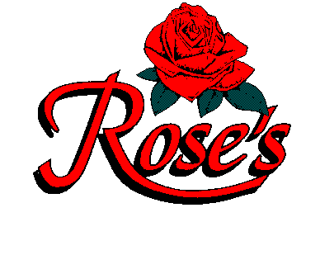
WELCOME TO ROSE’S
IN CELEBRATION OF
BOB’S 80TH BIRTHDAY

DPM MENU

LASAGNA
Mama Rose’s homemade lasagna, stacked high with homemade noodles $14.95

FETTUCCINE ALFREDO
plain 13.95 with chicken or shrimp $18.20
Romano and Parmesan cheeses blended in a light cream sauce, served over fettuccine

ANGEL HAIR PROVENCALE
plain 13.95 with chicken or shrimp $18.20
A light sauce of diced tomatoes, wine and herbs
with artichokes over angel hair

MAMA PASTA BOAT
Two jumbo meatballs over a bed of spaghetti topped with rose’s homemade marinara sauce $13.95

CHICKEN MILANO
Sautéed chicken breast with mushrooms and garlic
in a sherry cream sauce Served W/Rice & Vegetable $16.95

SALMON WITH DILL CREAM SAUCE
Broiled salmon smothered in chef’s dill cream sauce
Served With Rice & Vegetable $18.95

ABOVE SERVED W/ ROSE’S BREAD & STRACCIATELLA SOUP COFFEE –TEA – SODA ADD $2.89 PLUS 6% TAX 20% GRATUITY
ROOM RENTAL $50.00 DPM MENU

