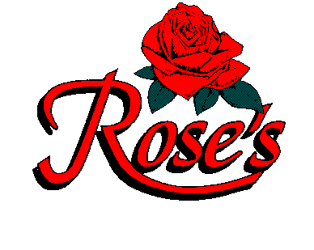
WELCOME TO ROSE’S
IN CELEBRATION OF
KRISTEN’S
BRIDAL SHOWER
PARTY #1

“BON APPETIT”

LASAGNA
Mama Rose’s homemade lasagna, stacked high
with homemade noodles

GRILLED CHICKEN SALAD
Sliced grilled chicken breast, crisp greens with fresh fruit,
julienned vegetable, tossed with homemade honey mustard vinaigrette and topped with almonds

FETTUCCINE ALFREDO
Romano and Parmesan cheeses blended in a light cream sauce,
served over fettuccine

CHICKEN MILANO
Sautéed chicken breast with mushrooms and garlic
in a sherry cream sauce

ANGEL HAIR PROVENCALE
A light sauce of diced tomatoes, wine and herbs
with artichokes over angel hair

