**AIM proposal: Field trial assessment of biosolarization using almond residue amendments to improve soil health and manage pests in almond orchards**

*Principal investigator*: Christopher Simmons, PhD; Department of Food Science and Technology, UC Davis

*Co-principal investigators*: Jean VanderGheynst, PhD; Department of Biological and Agricultural Engineering, UC Davis

James Stapleton, PhD; Statewide Integrated Pest Management Program, UC Division of Agricultural and Natural Resources

Amanda Hodson, PhD; Department of Entomology and Nematology, UC Davis

*Industry collaborator:* Rory P. Crowley, Director of Business and Research Development & Assistant Operations Manager, Nicolaus Nut Company, Chico, CA

*Project duration*: July 1, 2017 through June 30, 2018

*Total budget*: $107,552

***Objective****:* The goal of this work is to perform and assess biosolarization in a commercial almond orchard prior to planting. Specifically, biosolarization using residual material from almond processing (hulls and shells) as soil amendments will be used to demonstrate the dual benefits of recycling almond processing wastes in orchards while improving soil quality and inactivating soil pests. This project will utilize biosolarization conditions that were previously optimized in a simulated biosolarization system under a prior AIM award. Soil health, microbiome, nematode infestation, and tree growth responses will be tracked over time after biosolarization.

Specifically, the following hypotheses will be tested in this project:

1. Biosolarization with almond hull and shell soil amendments results in decreased nematode and microbial pests in the soil and increased soil fertility compared to untreated soils.
2. Combining solar heating and soil fermentation (biosolarization) for soil disinfestation results in more rapid growth of Nonpareil trees compared to solar heating alone (solarization).
3. Biosolarization with almond hull and shell soil amendments enhances the growth and reduces disease instance compared to untreated soils when cultivating Nonpareil, Aldrich, and Monterey almond varieties.

To the investigators’ knowledge, this project will represent the largest deployment of biosolarization (or anaerobic soil disinfestation, a similar technology) in a commercial orchard and the first to use almond processing residues as biosolarization soil amendments.

***Concept***: Biosolarization is a soil disinfestation technology that can be used as an alternative to soil fumigation and other pesticides. Biosolarization utilizes a combination of passive solar heating and soil fermentation to temporarily create soil conditions that are hostile to many pests (Figure 1). Biosolarization differs from anaerobic soil disinfestation, another fumigation alternative, in two primary ways. While both practices involve eventual generation of anaerobic conditions in the soil through tarping, irrigation, and microbial fermentation, biosolarization selects tarp, soil, and amendment properties to maximize solar heating of the soil. The solar heating acts as an additional stress on soil pests to complement the anoxic and fermentative soil stresses. Additionally, biosolarization conditions are selected to capitalize on aerobic microbial activity in the soil that occurs early on in the process in addition to the anaerobic conditions that eventually occur in the soil. This aerobic activity can lead to substantial biological heating of the soil that can increase the soil temperature beyond that achieved through solar heating alone.

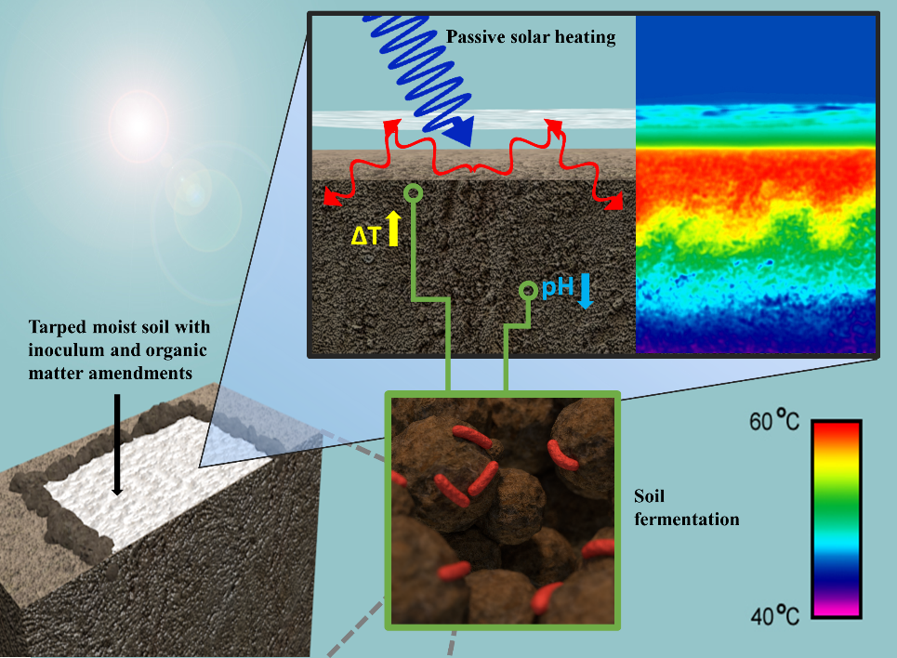

*Figure 1. The pest inactivation mechanisms of biosolarization. Soil is amended with organic matter, irrigated, a covered with clear tarp. The tarp creates a greenhouse effect that heats the soil to high temperatures. Additionally, microorganisms in the soil digest the amended organic matter and produce organic acids that lower the pH. This activity also removes much of the oxygen from the soil. Together, these stresses are lethal to many soil borne pests.*

Our team has previously studied and optimized biosolarization using several different soil amendments (Simmons et al., 2013; Achmon et al., 2016A; Achmon et al., 2016B). We will apply similar methods to gauge the biosolarization potential of almond hulls and shells when used as soil amendments.

***Experimental******design and rationale***:

Field site:

The field trial will be conducted at Kittyhawk Ranch in Chico, CA, which is owned by the Nicolaus Nut Co. A roughly 8.9 acre area has been dedicated to this study. This space is located within a larger 50 acre plot that is currently fallow. Previously, the field contained a walnut orchard. The orchard was removed in 2016 including ripping of the roots from the soil. The field is slated to be planted with almond trees in early 2018. Nonpareil, Aldrich, and Monterey varieties on Krymsk 86 (K86) rootstock will be planted. In December of 2016, this field tested positive for the presence of root lesion nematodes.

Biosolarization treatments:

Two biosolarization treatments will be examined. These treatments differ based on the type of almond processing residue used as soil amendment for biosolarization. The amendments will include a hull-rich residue stream, a hull and shell mixture, and worm castings (as an inoculum added to either almond biomass type). The hull-rich and hull/shell residues will be sourced from the Nicolaus Nut Co.’s hulling and shelling facility, North State Hulling Co-Op, INC. Prior work by the investigators has shown that these materials are compatible with biosolarization. The almond residues and worm castings will be amended to achieve concentrations of 1.25% and 0.5% (by dry weight), respectively, in the amended layer. To separate the effects of solar heating from those of soil amendment and fermentation, a subset of plots will not be amended but will be covered with plastic film to induce solar heating (i.e., solarization). Non-biosolarized soil will serve as a negative control.

Plots will serve as the experimental unit for this study. Each plot will measure 10 ft by 950 ft and there will be a 12 ft buffer between each plot. Biosolarized plots will be established in July 2017. Prior to establishment, the field will be disced, laser leveled, and processed with a land plane and float. Soil amendments will homogenized in a tub grinder to create mixtures of almond biomass and worm castings. Plots will be established by spreading the amendments on the field rows via a tractor mounted spreader, tilling the amendments into the soil down to at least 7 inches to achieve the target amendment concentration, leveling the soil, laying drip tape on the rows and then laying clear plastic tarp (clear totally impermeable film from Trical). The amendment steps will be omitted for the solarized plots. The biosolarization and solarization processes will be initiated by using the drip lines to irrigate the soil to field capacity down to 2 ft depth. Each treatment and control will have 9 replicate plots except for the solarization treatment, which will have 3 replicate plots.

The biosolarized plots will be randomly arranged according to the amendment treatment and variety of almond that will ultimately be grown (Figure 2). Untreated plots will serve as negative controls.

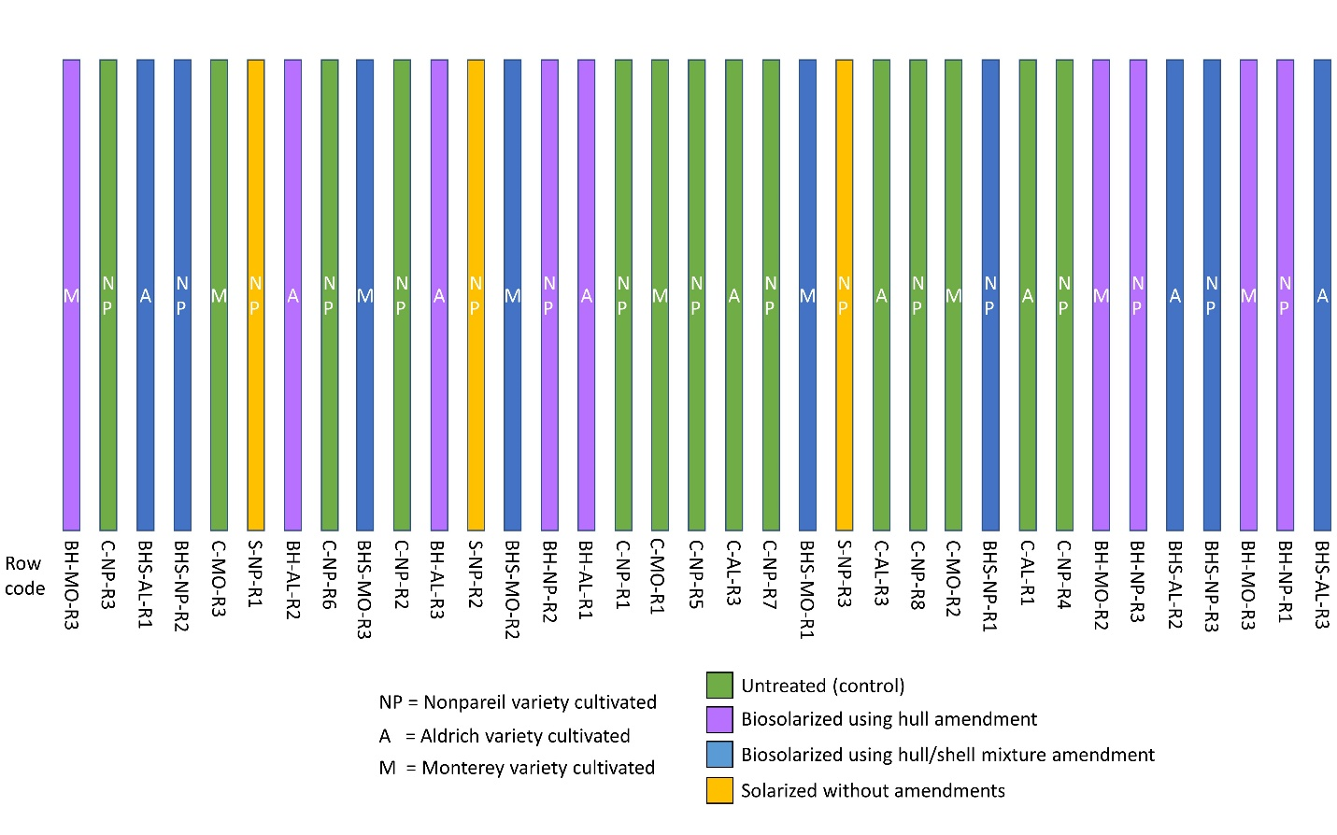

Figure 2. Layout of field trial plots showing disinfestation and almond cultivation treatments. Plots are not to scale.

Biosolarization will last for at least 30 days after which the tarps will be removed. After biosolarization, the rows will be prepared for tree planting by discing, mounding and berming planting sites, installing drip irrigation systems, planting a cover crop, and installing weather station and moisture monitoring equipment. In January 2018, the plots will each be planted with one of three almond varieties according to Figure 2: Nonpareil, Aldrich, and Monterey on K86 rootstock. Each row will be planted with 58 trees.

Data collection and analysis:

The following soil responses will be measured prior to, during, and at several timepoints following biosolarization:

1. Nematode community composition-including free living species
2. Soil microbiome composition (including pathogenic taxa)
3. Soil temperature during biosolarization
4. Soil volatile fatty acid concentration
5. Soil phytonutrient content (mineral nitrogen, extractable phosphorus and potassium)

After planting, the following tree responses will be measured periodically over the first 6 months of growth:

1. Tree diameter
2. Visual evidence of disease

The soil responses will measure pest control in terms of plant parasitic nematode reduction and changes in the relative abundance of pathogenic microorganisms in the soil, such as *Pseudomonas syringae* (bacterial canker), *Verticillium* spp., and *Armillaria mellea* (root rot). Volatile fatty acids, major fermentation products in the soil that contribute to pest inactivation during biosolarization, will be measured in the soil to confirm successful implementation of biosolarization and to monitor remediation of soil after biosolarization. Soil temperature will be measured to determine if pest inactivating temperatures were achieved in the soil. Beyond disinfestation, benefits to soil quality via addition of almond biomass to the soil will be measured by quantifying plant macronutrients and the roles of microorganisms and nematodes in plant nutrient cycling. Following planting, tree growth will be monitored and any trees exhibiting signs of disease will be counted to determine the effects of biosolarization on tree health.

Soil sampling and analysis will occur at five time points: immediately prior to biosolarization, 7 days after the start of biosolarization, after 30 days of biosolarization once the tarp is removed, immediately before tree planting (roughly 6 months after biosolarization), and 6 months after tree planting. Tree responses will be measured monthly.

For soil samples, soil cores will be obtained from the upper 12 inches of soil. From each half of every plot, 6 cores will be obtained in a zig-zag pattern and pooled (for a total of two sets of pooled cores for each plot representing each half of the plot). An additional set of core samples will be obtained spanning 12-24 inches depth to examine soil within the root zone that was not amended during biosolarization. The previously listed soil responses will be measured on each pooled sample.

Nematodes will be extracted from soil samples using a sieving and decanting technique followed by sugar centrifugation (Barker 1985). The total number of nematodes in each sample will be counted and the first 200 encountered on a slide will be identified. When possible, nematodes will be identified to the genus level (according to Bongers 1999). For further analysis of nematode communities, the abundance of nematode groups identified from the sites will be used to calculate indices of ecosystem function (Ferris et al. 2001).

Nematode metabolic footprints will also be calculated, which estimate the contribution of different functional guilds of nematodes to carbon and nutrient cycling based on their size-dependent metabolic activity (Ferris, 2010). For example, the bacterial and fungal metabolic footprints will be calculated from the bacterivore and fungivore nematode groups, to indicate the C entering the soil food webs through those respective channels. The structure metabolic footprint will quantify the trophic complexity of the nematode food web and its contribution to pest suppression, while the enrichment footprint measures nematodes involved in nutrient processing. Calculations of indices and metabolic footprints will be completed using the online platform, NINJA: 'Nematode INdicator Joint Analysis' (Sieriebriennikov et al. 2014).

Soil temperature data during biosolarization will be obtained at 5 and 15 cm depth using miniature temperature sensors and data loggers (iButtons).

Water extracts of soils will undergo HPLC analysis to determine volatile fatty acid levels. Mineral nitrogen and extractable phosphorus and potassium will be determined using previously described colorimetric assays (see UC Davis Analytical Laboratory methods 312, 340, and 355). Microbial genomic DNA will be extracted from the soil and bacterial and fungal phylogenetic markers will be sequenced using the Illumina MiSeq platform as previously described (Simmons et al., 2016C). Sequencing data will be processed using the R vegan software package to assess differences in soil microbiome structure (diversity, relative abundance of taxa including known pathogenic taxa) in biosolarized soils compared to untreated controls and to screen for pathogenic microorganisms (Simmons et al., 2016C).

Following planting, trees will be visually inspected for signs of disease such as stunting, canopy thinning, and yellowing. Trunk diameter will be measured with calipers.

Multi-way Analysis of variance (ANOVA) will be used to determine the significant main and interaction effects of biosolarization with each almond biomass amendment and the variety of almond grown following treatment. Separate ANOVA analyses will be conducted for each of the soil and tree responses described previously.

References

Achmon, Y., Harrold, D. R., Claypool, J. T., Stapleton, J. J., VanderGheynst, J. S., & Simmons, C. W. (2016A). Assessment of tomato and wine processing solid wastes as soil amendments for biosolarization. Waste Management, 48, 156-164.

Achmon, Y., Fernández‐Bayo, J. D., Hernandez, K., McCurry, D. G., Harrold, D. R., Su, J., ... & Simmons, C. W. (2016B). Weed seed inactivation in soil mesocosms via biosolarization with mature compost and tomato processing waste amendments. Pest management science.

Barker, K.R., (1985). Nematode extraction and bioassays. In: Barker, K.R., Carter, C.C., Sasser, J.N. (Eds.), An advanced treatise on Meloidogyne. Methodology, vol. 2. North CarolinaState University Graphics, pp. 19–35.

Bongers, T., Ferris, H., (1999). Nematode community structure as a bioindicator in environmentalmonitoring. Trends in Ecology & Evolution 14 (6), 224–228.

Ferris, H., Bongers, T., de Goede, R.G.M., (2001). A framework for soil food web diagnostics:extension of the nematode faunal analysis concept. Applied Soil Ecology 18(1), 13–29.

Ferris, H., (2010). Form and function: metabolic footprints of nematodes in the soil foodweb. European Journal of Soil Biology 46 (2), 97–104.

Sieriebriennikov, B., Ferris, H., & De Goede, R.G. (2014). NINJA: An automated calculation system for nematode-based biological monitoring. European Journal of Soil Biology, 61, 90-93.

Simmons, C. W., Higgins, B., Staley, S., Joh, L. D., Simmons, B. A., Singer, S. W., ... & VanderGheynst, J. S. (2016C). The role of organic matter amendment level on soil heating, organic acid accumulation, and development of bacterial communities in solarized soil. Applied Soil Ecology, 106, 37-46.

Simmons, C. W., Guo, H., Claypool, J. T., Marshall, M. N., Perano, K. M., Stapleton, J. J., & VanderGheynst, J. S. (2013). Managing compost stability and amendment to soil to enhance soil heating during soil solarization. Waste management, 33(5), 1090-1096.

UC Davis Analytical Laboratory Method 312, Soil Nitrate And Extractable Ammonium By Flow Injection Analyzer Method, http://anlab.ucdavis.edu/using-the-lab/analysis/soils/312

UC Davis Analytical Laboratory Method 340, Extractable Phosphorus - Olsen Method, http://anlab.ucdavis.edu/using-the-lab/analysis/soils/340

UC Davis Analytical Laboratory Method 355, Extractable Phosphorus - Bray Method, http://anlab.ucdavis.edu/using-the-lab/analysis/soils/355

***Budget***:

Senior investigators (salary and benefits)

Christopher Simmons (PI) $3,601

Jean VanderGheynst (Co-PI) $4,637

Amanda Hodson (Co-PI) $1,966

Key personnel (salary, benefits, tuition/fees)

Postdoctoral scholar (1.5 months) $7,858

Graduate student researcher (3 quarters) $36,038

Subaward to UC Division of Agricultural and Natural Resources

James Stapleton (Co-PI) $3,473

Subaward to Nicolaus Nut Co.

Field preparation and biosolarization supplies $34,781

Supplies and services

Soil quality analysis $5,000

Nematode profiling $500

Soil DNA extraction $700

Microbiome sequencing $8,000

Travel

$1000

Total budget $107,552

***Budget*** ***justification***:

Senior investigators: Drs Simmons and VanderGheynst have worked to develop the biosolarization program at UC Davis since 2011. Dr. Hodson is a project scientist and nematologist within the Department of Entomology and Nematology at UC Davis. Dr. Hodson is an expert in nematode sampling, identification, and control strategies. The complimentary capabilities of their laboratories will be used to conduct the proposed work. The budget reflects 2% effort for each investigator, which is comparable to the effort dedicated to other successful projects of similar scope. The compensations for the investigators was calculated from their current salary and benefits.

Key personnel: Funds will support a postdoctoral scholar (1.5 months effort) and a graduate student researcher (3 quarters effort) during the project period. The postdoctoral scholar will work within the Department of Entomology and Nematology under the guidance of Dr. Hodson and will be responsible for nematode extraction and classification in soil samples. The graduate student researcher will work within the Departments of Food Science & Technology and Biological & Agricultural Engineering under the guidance of Drs. Simmons and VanderGheynst. The graduate student researcher will be responsible for conducting soil quality and microbiome analyses. The listed salaries and benefits are proportional to the standard rates effort for these titles at UC Davis.

Subawards: As Dr. Stapleton is employed by the UC Division of Agricultural and Natural Resources, a subaward must be issued by UC Davis to support his participation as a co-investigator. Dr. Stapleton is an expert in the field of soil fumigant alternatives, with a focus on solarization and related technologies. Dr. Stapleton will advise on the design of experiments, guide interpretation of data, and provide advice on translating laboratory data to field application of solarization. Funds will support 2% of Dr. Stapleton’s effort based on his current salary and benefits. This is commensurate with the contributions that Dr. Stapleton will make to the project.

An additional subaward will be issued to the Nicolaus Nut Co. to acquire materials needed to implement biosolarization in their demonstration orchard. Specifically, the funds will be used to purchase drip hose and irrigation supplies ($16,828), acquire and transport hull, shell, and worm castings amendments ($8,223), purchase plastic film for covering soil ($3,500), supply fuel and water for field operations ($430), and compensate labor needed to perform biosolarization field operations and install the irrigation system ($3,300). Additionally, recording supplies to support drone videography will be used to document the field trial and regularly scan the trees for signs of disease ($2,500).

Supplies: Soil quality analysis funds will be used to conduct the previously described volatile fatty acid (VFA) and plant nutrient assays in soil samples. VFA measurement supplies will include HPLC consumables. Plant nutrient assay expenses were quoted by the UC Davis Analytical Lab, which will perform the assays. Together, the VFA and plant nutrient assays total $4000. Nematode quantification and identification supplies will include extraction tubes and reagents and microscopy supplies ($500). Soil DNA extraction supplies include PowerSoil DNA extraction kits to accommodate 80 samples ($500). Funds for sequencing will cover sequencing of 16S rRNA and ITS rRNA phylogenetic markers to profile soil bacteria and fungi in approximately 80 samples spanning all treatments and time points ($8000). A commercial sequencing service will be used.

Travel: Funds will support travel to the orchard by UC Davis personnel to advise on biosolarization implementation, retrieve soil samples, and collect tree data.