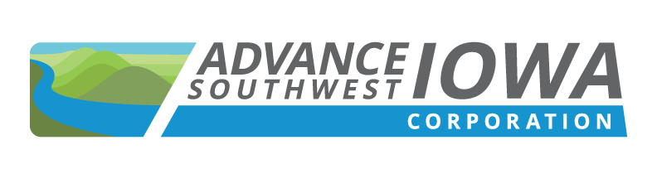 | 149 W. Broadway, Council Bluffs, IA 51503

2021 MEETING SCHEDULE

Note:
Please note that the Board meetings will start at 8:30 AM and are scheduled for the 4th Friday of each month with the exception of July and November (by-months) and the 3rd Friday in December due to the Christmas holiday. Meeting notices will be sent in January 2021 for the full year keeping in mind that we will conduct our Q1 meetings via the virtual platform Zoom. The location of future meetings will be based on the current COVID-19 data.

January 22, 2021 – Via Zoom

February 26, 2021 – Via Zoom

March 26, 2021 – Via Zoom

April 23, 2021 – TBD

May 28, 2021 – TBD

June 25, 2021 – TBD

July – No Meeting

August 27, 2021 – TBD

September 24, 2021 – TBD

October 22, 2021 – TBD

November – No Meeting

December 17, 2021 – *3rd Friday – TBD

