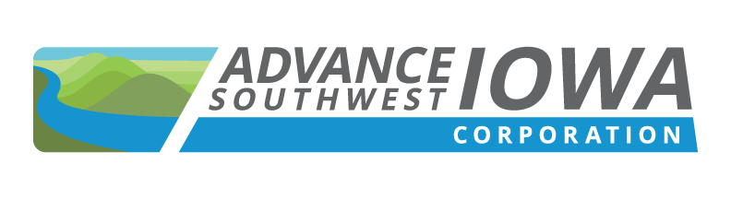 | 149 W. Broadway, Council Bluffs, IA 51503

2022 MEETING SCHEDULE

Note:
Please note that the Board meetings will start at 9:30 AM and are scheduled for the last Friday of each month with the exception of July and December (by-months) and the 3rd Friday in November due to the Thanksgiving holiday. Meeting notices will be sent in January 2022 for the full year and the location of future meetings will be updated month to month.

January 28, 2022

February 25, 2022

March 25, 2022

April 29, 2022

May 27, 2022

June 24, 2022

July – No Meeting

August 26, 2022

September 30, 2022

October 28, 2022

November 18, 2022

December – No Meeting

