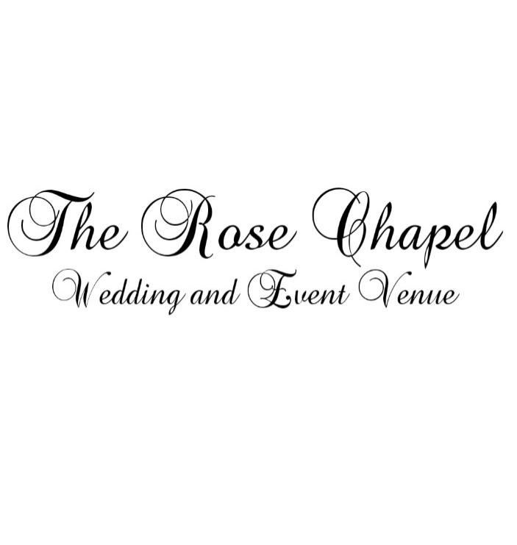
The Rose Chapel – 4000 sqft. Rustic venue can be rented for your wedding, anniversary, birthday, business meeting, etc. which includes indoor facility and w/ potential outdoor use. The floors are made with stained knotty pine and rough sewn pine walls. The foyer has brick and rough sewn pine walls.
- Beautiful lighting throughout
- Features a professional stage for DJ or Band
- Central Heat and Air
- Accommodates up to 125 guests.
- Alcohol permitted – BYOB – Licensed Bartender required – additional cost for security and liability insurance which is required with Alcohol.

$2500 for Friday or Saturday Rental - 8 hour minimum
$3000 for Friday and Saturday
$2000 for Sunday through Thursday = 4 hour minimum
$250 Refundable damage fee
$250 cleaning fee

Tables, chairs, and linen at additional cost depending on number of guests.
Planning services available by S&S Events. Please contact for more details.
www.eventsbyss.com
Planningeventsbys.s@gmail.com

