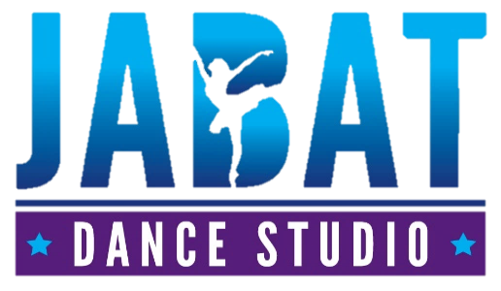
IMPORTANT DATES
Term 1: 31 Jan – 8 April 2022
Term 2: 26 April – 1 July 2022
Term 3: 18 July – 23 Sep 20212
Term 4: 10 Oct – 15 Dec 2022
Elevate Dance Eisteddfod – 8-10th July 2022
Star Struck Dance Challenge – 16th Oct 2022
Starlight Festival of Dance – 17 Sep 2022
Dance Exams – September 2022 TBC
2022 Concert Dates: November 18/19 (TBC)
VENUE
AMC: 45 Keesing St, Port Hedland
Postal Address – PO Box 654
Port Hedland WA 6721

2022 Term 3 Timetable
nbbvKo9snippin

DAY | CLASS | AGE | TIME | VENUE | TEACHER
Monday | Tiny Tots | 2-5 | 2:00-2:45pm | Studio 1 | Miss Dana
 | Pre-Primary Ballet | 5-6 | 3:15-4:00pm | Studio 1
 | Primary Ballet | 7-8 | 4:00-4:45pm | Studio 1
 | Grade 1 Ballet | 8-10 | 5:00-6:00pm | Studio 1
 | Grade 2 Ballet | 10+ | 6:00-7:00pm | Studio 1
Tuesday | Acro 1 (Group A) | 5+ | 3:00-3:45pm | Studio 1 | Miss Katherine
 | Acro 1 (Group B) | 5+ | 3:45-4:30pm | Studio 1
 | Cheer | 5+ | 4:30-5:30pm | Studio 1
 | Grade 5 Ballet | 14+ | 5:00-6:00pm | Studio 2 | Miss Zoe
Wednesday
 | Leaps and Turns Technique | 8+ | 3:00-3:45pm | Studio 1 | Miss Dana
 | Combined 4,5 Ballet | 11+ | 3:45-4:45pm | Studio 1
 | Senior Hip Hop | 10+ | 4:45-5:45pm | Studio 1
 | Senior Tap | 9+ | 5:45-6:45pm | Studio 1 | Miss Zoe
 | Adults | 18+ | 6:45-7:30pm | Studio 1 | Miss Dana
Thursday | Junior Jazz | 5-8 | 3:00-4:00pm | Studio 1 | Miss Dana
 | Junior and Intermediate Lyrical/Contemp | 5-10 | 4:00-5:00pm | Studio 1
 | Intermediate Jazz | 9+ | 5:00-6:00pm | Studio 1
 | Acro 2+3 | By Audition | 6:00-7:00 pm | Studio 1
Friday | Junior Tap | 5-8 | 3:15-4:00pm | Studio 1 | Miss Jacinta
 | Junior Hip Hop | 5-9 | 4:00-4:45pm | Studio 1
 | Advanced Jazz | 12+ | 4:45-5:45pm | Studio 1 | Miss Dana
 | Advanced Contemporary | 12+ | 5:45-6:45pm | Studio 1
Saturday | Tiny Tots | 2-5 | 8:00-8:45am | Studio 1 | Miss Emmy
 | Junior Troupe | By Audition | 9:00-10:00am | Studio 1 | Miss Dana/Miss Zoe
 | Intermediate Troupe | By Audition | 10:00-11:00am | Studio 1
 | Senior Troupe | By Audition | 11:00-12:00am | Studio 1
 | Grade 4 Ballet | 12+ | 12:00-1:00pm | Studio 1
 | PRIVATES | By Booking | 12:00pm onwards | Studio 2 OR 1

Contact us at - jabatdance@live.com.au
Contact us at jabatdance@live.com.au

