**JABAT DANCE INC**

INFORMATION AND UNIFORM GUIDE

2022

Jabat Dance Inc is a not-for-profit dance school in Port Hedland, run by a committee made up of volunteer parents and community members. JaBat Dance Inc has been running in the Pilbara for over 25 years. We offer tuition in the CSTD exam syllabus, with students participating in examinations annually.

Our committee and teachers are passionate about inspiring our students to reach their full potential; building confidence, grace, balance and coordination.

We are happy to announce that our NEW JaBaT Dance Uniform has finally arrived with all uniform pieces in stock. As the shop will be manned by volunteers and staff, we do not have set opening times and will advise opening dates and times via email. Eftpos facilities are available. Please note uniform will only be available for purchase during shop opening times.

**ALL** shoes and tights are available online from:

Energetiks (https://www.energetiks.com.au) or

Bloch (https://[www.bloch.com.au/pages/dance)](http://www.bloch.com.au/pages/dance))

**JaBaT Leotard**

**$50.00**

**JaBaT Top (available in Purple and Blue)**

**$45.00**

**Laura Leggings**

**$50.00**

**Tiny Tot Tutu**

**$45.00**

**Hot Shorts**

**$40.00**

**Punk Rock Singlet**

**$30.00**

**Crop Top**

**$40.00**

**Boys Drawcord Short**

**$45.00**

JaBaT Dance Inc Uniform Pieces and Prices

# Ballet

We offer ballet from ages 5+, each year level learning the fundamentals of classical ballet. CSTD exam syllabus is taught for students from Primary + with exams available for students wishing to participate.

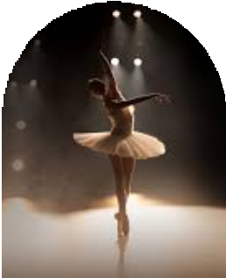

# Uniform

***All Grades (Pre-Primary - Grade 5) – JaBaT Leotard and black chiffon skirt (available from energetiks, link below)*** <https://www.energetiks.com.au/wrap-skirt>

***Stockings -*** Salmon Pink Tights can be purchased online from Energetiks. <https://www.energetiks.com.au/classic-dance-tight-convertible_20>

***Shoes -*** Split sole ballet flats can be purchased from Bloch or Energetics. All ballet shoes for exams will require ribbons. <https://www.energetiks.com.au/ballet-shoe-canvas-split-sole>

<https://www.energetiks.com.au/ballet-shoe-split-sole>

***Hair – Ballet bun (Students must not have loose hair around the face) If hair is too short for a ballet bun hair must be secured off the face.***

# JAZZ

Jazz is an upbeat style of dance that involves strong technique and fast-moving actions. We offer exams for students from 5yrs +.

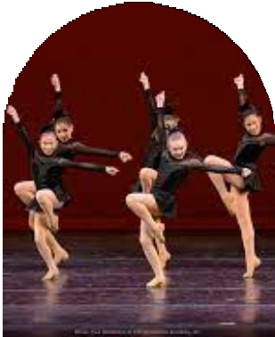

# Uniform

***Junior Jazz -*** Any combination of JaBaT uniform. Tan Jazz Shoes with elastic. <https://www.energetiks.com.au/jazz-boot-neoprene>

***Intermediate and Senior Jazz –*** Any combination of JaBaT uniform. Black Jazz shoes with elastic. <https://www.energetiks.com.au/jazz-boot-neoprene_27>

***Stockings -*** Tan Tights available online from Energetiks.

<https://www.energetiks.com.au/classic-dance-tight-convertible_20>

***Hair – Either in a bun, ponytail or braid. Hair must be secured off the face with no loose hair hanging onto the face.***

# Tap

Tap is a style of dance that is recognised by the sound generated from metal plates on the bottom of specially designed shoes to create a musical effect like no other. We offer tap exams for all ages.

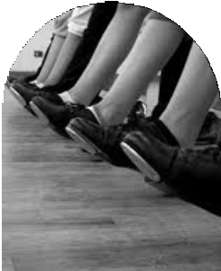

# Uniform

***Junior Tap-*** Any combination of JaBaT uniform. Tan buckle tap shoe. <https://www.energetiks.com.au/debut-tap-shoe-low-heel>

***Senior Tap -*** Any combination of JaBaT uniform. Black tap shoe either buckle or laces depending on students choice. <https://www.energetiks.com.au/women/dance-shoes/tap-shoes>

# *Stockings -* Tan Tights available online from Energetiks

# <https://www.energetiks.com.au/classic-dance-tight-convertible_20>

# *Hair – Either in a bun, ponytail or braid. Hair must be secured off the face with no loose hair hanging onto the face.*

# Lyrical / Contemporary

This style of dance combines classical ballet technique, modern and hints of jazz. A style of dance where music and dance combine to tell a story. CSTD exams coming soon.

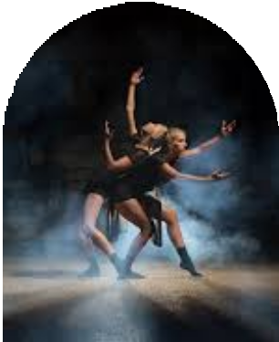

# Uniform

***Junior Lyrical –*** JaBat leotard with either Jabat shorts or leggings and a long sleeve black shirt. No shoes required.

***Intermediate and Senior Lyrical/Contemporary-*** ***–*** JaBat leotard with either Jabat shorts or leggings and a long sleeve black shirt. Knee pads if required. Plain black socks required for exams.

***Stockings -*** Tan Tights available online from Energetiks.

# <https://www.energetiks.com.au/classic-dance-tight-convertible_20>

# *Hair – Either in a bun, ponytail or braid. Hair must be secured off the face with no loose hair hanging onto the face.*

# Hip Hop

Hip Hop is a fun upbeat class working on the core units of street dancing with an emphasis on fun and freedom. No exams are offered for hip hop.



**Uniform**

***Junior Hip Hop-*** Any combinations of JaBaT uniform. Black sneakers and socks.

***Senior Hip Hop –*** Any Combination of JaBaT uniform. Black sneakers and socks.

***Hair – Either in a bun, ponytail or braid.*** *Hair must be secured off the face with no loose hair hanging onto the face.*

# Acro

Acro dance is a combination of core gymnastic and jazz style dance. No exams are offered for Acro. Acro level 2+ require audition. If you believe your child is ready for acro 2 please email us and we can do an assessment.

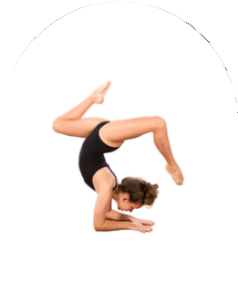

**Uniform**

***Junior Acro-*** Either the JaBat leotard or crop top and either pant options. No shoes required.

***Senior Acro-*** Either the JaBat leotard or crop top and either pant options. No shoes required.

***Stockings -*** Tan Tights available online from Energetiks.

# <https://www.energetiks.com.au/classic-dance-tight-convertible_20>

***Hair*** *– Either in a ponytail or braid. Hair must be secured off the face with no loose hair hanging onto the face.*

# *.*

# Tiny Tots

# Tiny Tots is an introduction into the world of dance for our tiny students. We teach all three main styles of dance - ballet, jazz and tap to ensure that students can fully understand the introductory movements for their age. This genre is great to introduce small students to dance and assist them to decide on their preferences as they grow and move into the older classes.

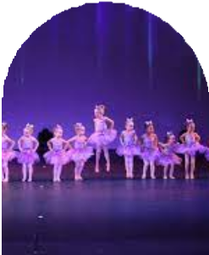

# Uniform:

***JaBaT Tiny tot leo***

***Shoes: Ballet flats AND Tan tap shoes*** [***https://www.energetiks.com.au/girls/girls-dance-shoes***](https://www.energetiks.com.au/girls/girls-dance-shoes)

***Stockings: Salmon pink tights*** [***https://www.energetiks.com.au/premier-convertible-tight***](https://www.energetiks.com.au/premier-convertible-tight)

# Cheer

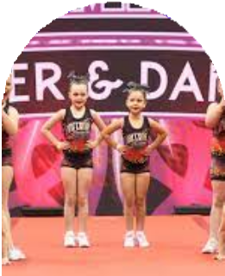

# Cheer dance incorporates fundamentals of cheerleading and dance into one. Learning fun stunts and tricks

# Uniform

***Cheer –*** Any combination of JaBaT uniform. No shoes required.

# *Stockings –* Tan Tights available online from Energetiks.

# <https://www.energetiks.com.au/classic-dance-tight-convertible_20>

***Hair*** *– Either in a ponytail or braid. Hair must be secured off the face with no loose hair hanging onto the face.*

# Calisthenics

Calisthenics combines the elements of rhythmic gymnastics and ballet a strong emphasis on elegance and theatre.

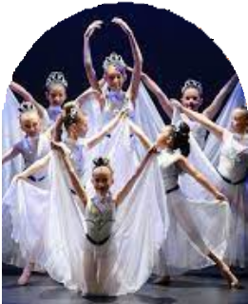

**Uniform**

***Calisthenics- JaBaT le***otard and shorts or tights. No shoes required.

***Stockings –*** FootlessTan Tights can be purchased online from Energetiks.

<https://www.energetiks.com.au/classic-dance-tight-footless_18>

***Hair – Either in a bun,******ponytail or braid.*** *Hair must be secured off the face with no loose hair hanging onto the face.*

# Adults

# Adults is a fun dance class aimed at maintaining fitness whilst learning

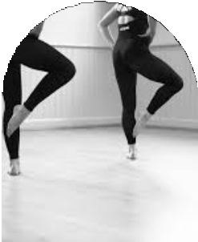

# basic dance to stay active, make friends and have fun.

# Uniform

***Adults -*** Fitness clothing, leggings and any top. Also can wear JaBaT items.

***Stockings -*** Tan Tights can be purchased online from Energetiks. (Only for concert).

# Leaps and Turns Technique

A new class starting this year with a focus on strength and technique development. Highly recommended for all students 9+. This class will help develop skills core strength for further development in class.

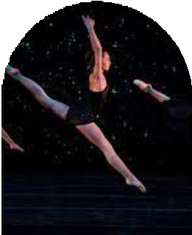

# Uniform

***Leaps & Turns*** – Any combination of JaBaT uniform. No shoes.

***Stockings -*** Tan Tights can be purchased online from

Energetiks.

# Troupe

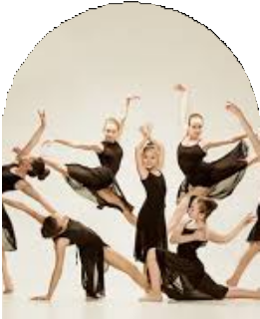

.

# Troupe

Troupe students are required to commit to additional classes each week and provided with opportunities to compete in local competitions and perform at local events. Troupe students perform all genres of dance.

## **Uniform**

Any combination of the JaBaT uniform, must have a JaBaT shirt for travel and performances. Jazz shoes required. There may also be a requirement to purchase costumes for competitions.

***Stockings -*** Tan Tights can be purchased online from Energetiks. <https://www.energetiks.com.au/classic-dance-tight-footless_18>

***Hair –*** *Either in a bun, ponytail or braid. No loose hair on the face.*

**Important Dates for 2022:**

* **Term 2**: 26 April – 1 July 2022
* **Term 3**: 18 July – 23 Sep 20212
* **Term 4**: 10 Oct – 15 Dec 2022
* **Starlight Festival of Dance** – 17 Sep 2022
* **CSTD Dance Examinations** – 12/13 September 2022 (TBC)
* **Proposed 2022 Concert Dates**: November 18/19 (TBC)

**Other Information:**

No student is to attend class if they are unwell.

Please contact us as soon as possible via email or messenger to advise if your child will not be attending their enrolled class.

**COVID 19 Requirements:**

* We have a responsibility to the community to follow all COVID 19 instructions and mandates issued by the WA Department of Health.
* We will advise via email when any changes to instructions from WA Health are received with regard to vaccination and mask mandate requirements for our studio.
* We will be updating our COVID 19 Plan at the entrance to the studio as we receive further advice. Please continue to monitor this information each time you come to the studio as the requirements in this space are changing rapidly.
* We continue to monitor the WA Health website daily for updates and our teachers have confirmed that they are fully vaccinated and ready to commence the dance year.

Dance classes commence on the first day of each school term with the final class for each term held on the Saturday of the final week of each term. Dance classes are not held on Public Holidays or any Saturday during a long weekend.