**JaBaT Dance Inc.**

**UNIFORM REQUIREMENTS**

**Items Available at www.energetiks.com.au unless otherwise specified.**

**BOYS T-SHIRT SIZES KIDS: Size 4 - 14 ADULTS: XS - L**

**JaBaT Merchandise -** Order forms are available on the JaBat website.

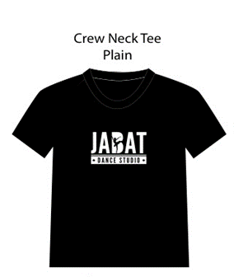

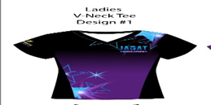

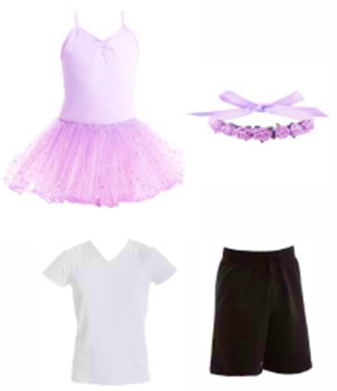

**Tiny Tots and Junior Boys**

**GIRLS LEOTARD:** CD05 Sparkle Tutu – Lilac

**TIGHTS:** DCT38C Debut Tight Convertible – Salmon Pink

**SHOES:** Ballet Pumps (Pink), Tap Shoe (Tan)

**HAIR:** H019 Hair Blossom - Lilac

**BOYS WEAR:** White Shirt / Black Shorts / White Socks

**BOYS SHOES:** Sneaker (Black) and Tap Shoes (Lace up, Black)

** For Exams only leather ballet shoes are allowed, if intending on child to participate in exams please purchase leather shoes to avoid having to purchase a new pair.

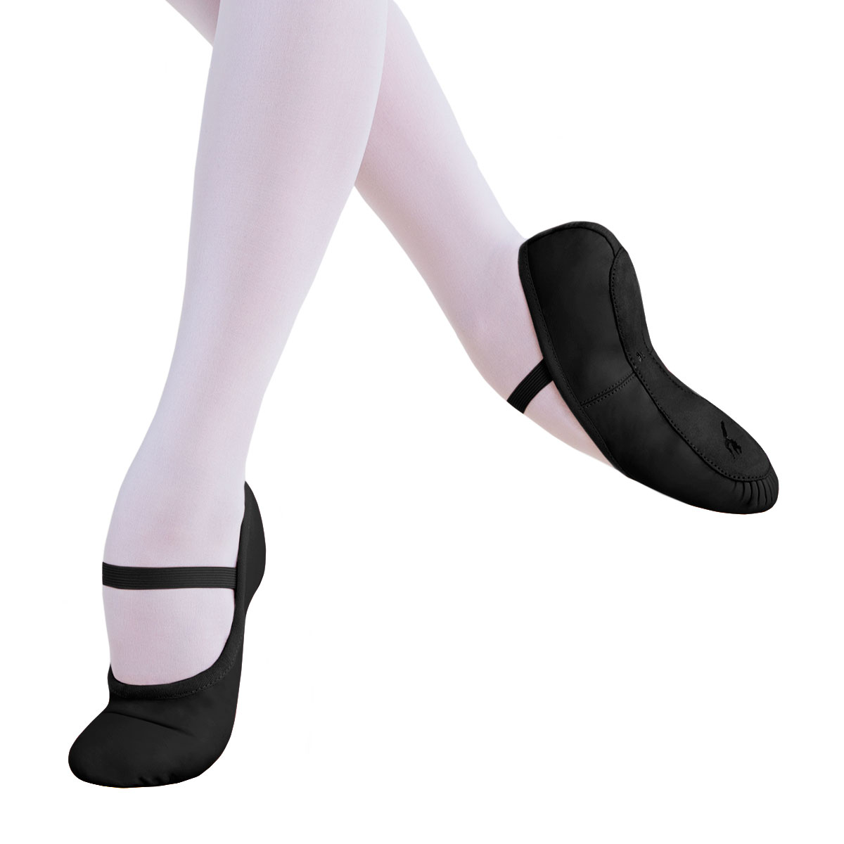

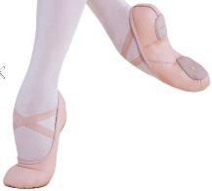





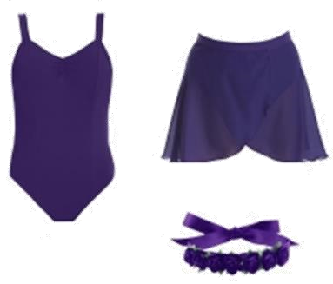

**Pre-Primary – Grade 1 Ballet**

**LEOTARD:** CL11 Wide Strap Camisole – Deep Purple

**SKIRT:** CS01 Wrap Skirt – Deep Purple

**TIGHTS:** DCT38C Debut Tight – Convertible, Salmon Pink

**SHOES:** Split Sole Ballet Shoe – Pink

**HAIR:** HO19 Hair Blossom – Purple

**BOYS WEAR:** White Shirt / Black Shorts / White Socks

**BOYS SHOES:** BSC01 Ballet Shoe – Full Sole, Black

**Grade 2+ Ballet**

**LEOTARD:** AL11 Wide Strap Camisole – Black

**SKIRT:** AS01 Wrap Skirt – Black

**TIGHTS:** DAT38C Debut Tight – Convertible, Salmon Pink

**SHOES:** Split Sole Ballet Shoe – Pink

**HAIR:** HO19 Hair Blossom – Black

** Leather slit sole ballet shoes are the only style allowed for exams

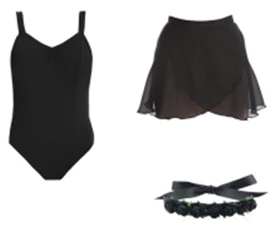



**Jazz/Tap – Junior, Intermediate and Senior**

**LEOTARD:** CL11 Wide Strap Camisole

* Juniors - Deep purple
* Intermediate and senior - Black

**SHORTS:** CT08 Cross Band Shorts

**TIGHTS:** DCT38C Debut Tight – Convertible, Natural Tan

**SHOES:**

Jazz: Jazz Shoe (Elastic, No laces)

* Junior – Tan
* Intermediate and Senior – Black

Tap : Tap Shoe (Buckle)

* Junior – Tan
* Intermediate and Senior – Black

**HAIR:** HO19 Hair Blossom

* Junior – Deep Purple
* Intermediate and Senior – Black

**BOYS TOP:** Plain T-Shirt – Black or White

**PANTS:** CAP44 Track Pant – Black

**SHOES:** Jazz: Classic Black Jazz Shoe, Tap: Black Lace up Tap Shoe







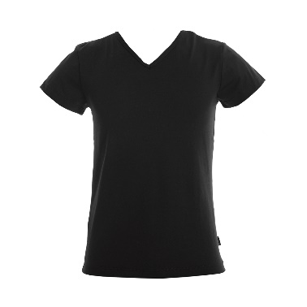

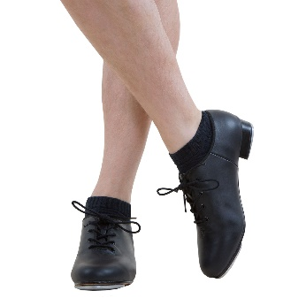

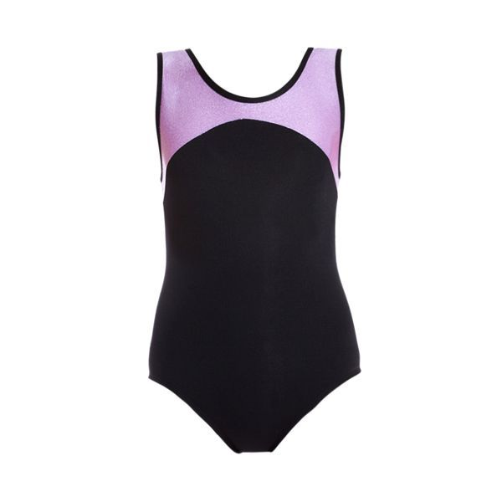 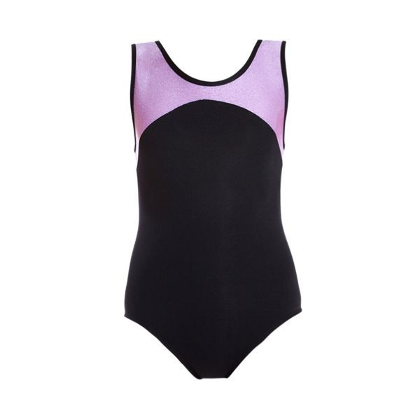   



**GIRLS LEOTARD:** Meg Leotard SKU SCL120 – Lilac

**BOYS TOP:** Plain Black or White T-Shirt

**GIRLS SHORTS:** GCAS11 Shattered Glass Shorts – Deep Purple

**BOYS SHORTS:** Black Shorts/Pants

**HAIR:** H019 Hair Blossom – Purple or Black

**Acro and Calisthenics – All Levels**





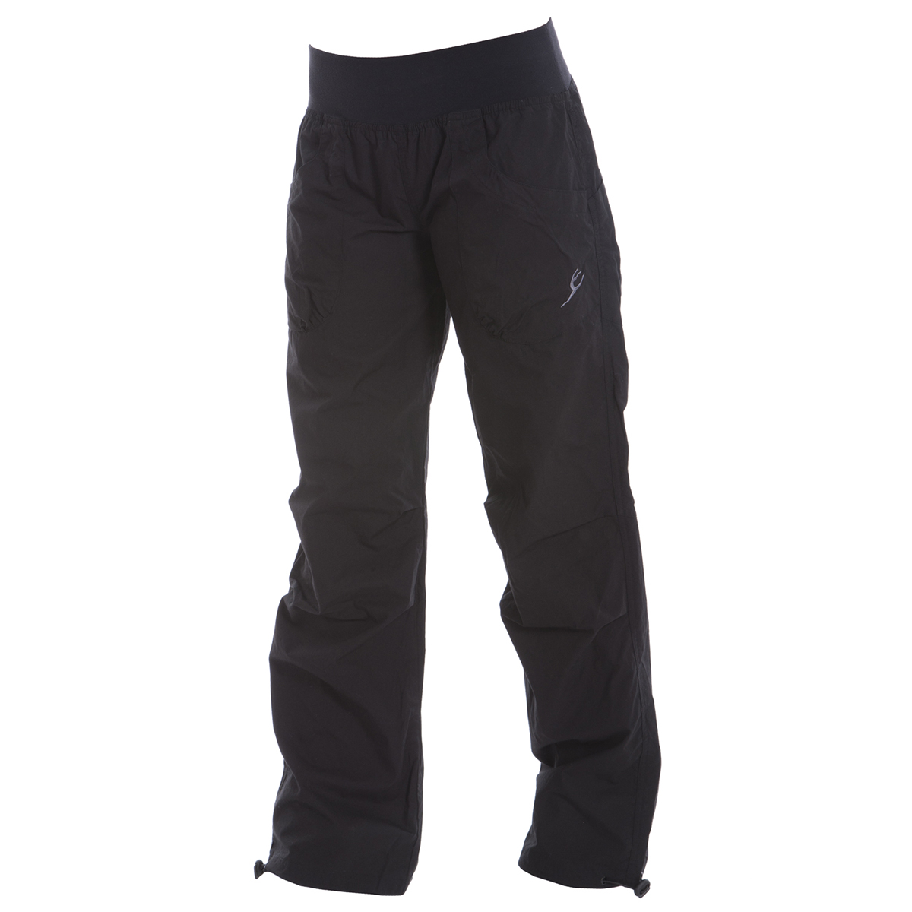



**Hip Hop**

**GIRLS LEOTARD:** CL11 Wide Strap Camisole – Deep Purple or Black

**BOYS TOP:** Black T-Shirt or Singlet

**UNISEX PANT:** CAP17 Kenzie Cotton Pant

**SHOES:** Black Dance Sneaker or Plain Black non-Branded Sneaker

**HAIR:** H019 Hair Blossom – Purple or Black



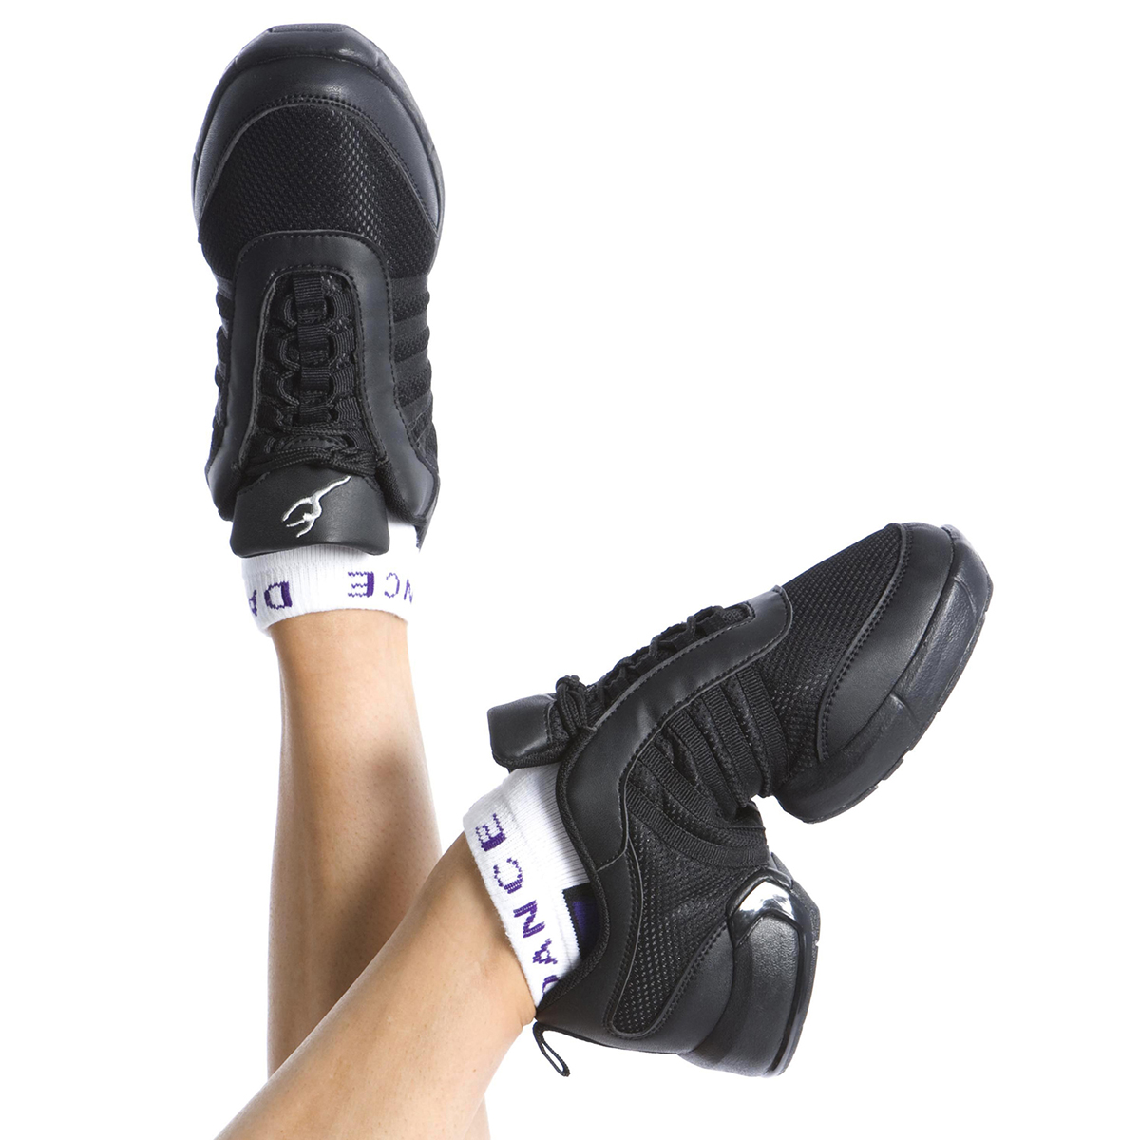













**GIRLS:** JaBat T-Shirt

**BOYS TOP:** Black T-Shirt or Singlet

**UNISEX PANT:** CAP17 Kenzie Cotton Pant

**SHOE:** Black Dance Sneaker or Plain Black non-Branded Sneaker

**TIGHTS:** Plain black tights (Kmart)

**Cheerleading**

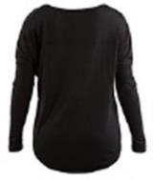

**Lyrical / Contemporary**

**LEOTARD:** CL11 Wide Strap Camisole OR CC33 Cross Band Crop Top (optional) WITH Plain long sleeve Shirt – Black

**SHORTS:** CT08 Cross Band Shorts or Plain Leggings – Black

**TIGHTS:** DCT38C Debut Tight – Convertible, Natural Tan

**SHOES:** EXO Compression Foot Glove – Available from www.mdmdance.com

**HAIR:** H019 Hair Blossom – Black or Purple





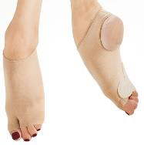

**Adult**

**TOP:** Exercise Shirt

**BOTTOM:** Exercise Pants

**SHOE:** Comfortable Sneaker or another shoe

**Open Ballet & Stretching and Conditioning**





**LEOTARD:** Any Leotard – Black or Purple

**SHORTS:** CS01 Wrap Skirt or Black Shorts

**TIGHTS:** DCT38C Debut Tight – Convertible, Salmon Pink

**SHOES:** Ballet Shoe and Sneakers

**Open Ballet and Stretching & Conditioning**