Mount Hebron – Orchards Community Association General Meeting
Date: October 14, 2025
Location: Mount Hebron Presbyterian Church
Board Members Present: Roger Knight; Donna Liston; Erin Mossberger; Tina Owens; Eric Ulanowicz; Carl Utt
Other Attendees: Guest Speaker Lila Boor and 16 community members
Call to Order: Occurred at 7:04 pm. The meeting was adjourned at 8:32pm
Treasurer’s Report: Donna Liston provided the following summary, and dues received so far this year represent approximately 110 residents participating
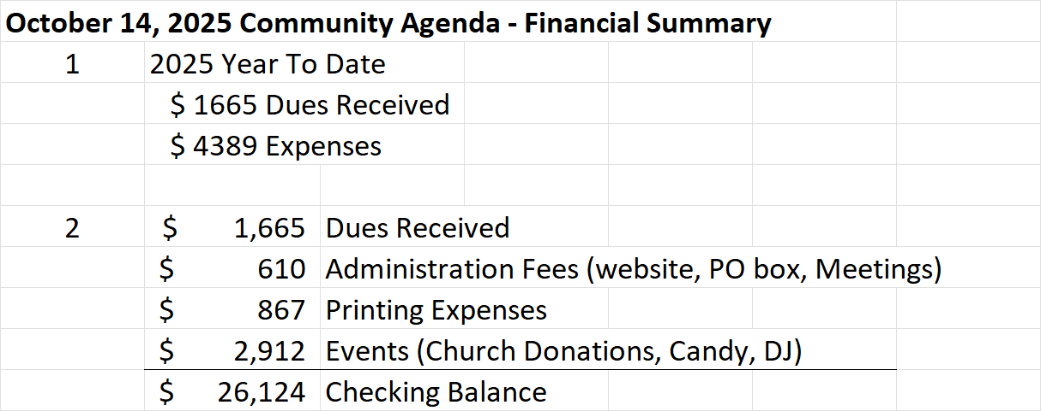
Approval of past minutes: Eric Ulanowicz presented a summary of the minutes from the April 8, 2025 Community Association Meeting.
Guest Speaker: Lila Boor, a Senior Investigator from the Howard County Office of Consumer Protection presented “How to Pick Your Contractor, Set Up Your Project, & Avoid Scams”.
* She emphasized the importance of properly preparing a project determining budget, timeline and priorities, and thoroughly researching materials.
* She recommended getting at least 3 estimates, and verifying contractors are licensed by the Maryland Home Improvement Commission, and not just trusting license information in advertisements or business cards. The Commission can be reached by telephone 410-230-6309 or the web via https://labor.maryland.gov/license/mhic/ and select “License Search”. [Note: the website listed in Lila’s presentation (www.dllr.state.md.us/mhic/) lands on an invalid page]
* Lila discussed the importance of making any written contract as comprehensive as possible, including detailed descriptions of work to be performed, approximate start and substantial completion dates, all verbal promises, special materials, and “must haves”, how the money will be collected and when (max 1/3 deposit), that the contractor will obtain all necessary permits, and list any potential mortgage or lien interests. A 5-7 day right of cancellation clause should also be included.
Things to watch out for regarding contractor fraud:
* Uninvited solicitations, “leftover materials” from a previous job, no solicitor/peddler’s or MHIC license, only accepts cash payments, high pressure sales tactics, fails to provide a written contract, or requesting full payment before completing work. Be aware of potential distractions from 2-party solicitors that could lead to theft.
* Common Fraud examples include Tree Service and Driveway Paving scams
* All solicitors selling products or services need to be licensed by the Howard County Office of Consumer Affairs. Soliciting is only allowed between the hours of 9am – 8pm.
* If you are the potential victim of a scam contact the Howard County Police, Office of Consumer Affairs (410-313-6420, consumer@howardcountymd.gov, www.howardcountymd.gov/consumer), or the Office on Aging for assistance
New & Ongoing Business:
* Roger invited all attendees to become board members or volunteer.
* The current slate of board officers was re-elected to their positions for the next year
* The next Community Meeting is planned for 4/21/2026
* Positive feedback from the attendees was received for both the yard sale and movie night events

