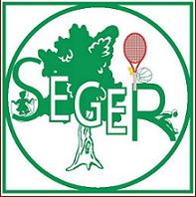
SEGER PARK TENNIS CLUB
1218 Walnut Street
Suite 804
Philadelphia, PA 19107
(215) 284-8103

www.segerparktennis.com

MISSION STATEMENT

Beginnings Founded in 2007 by Brian Villa & John Sharp as a non-profit (PA) and tax-free 501(c)(4) organization, our mission is to promote and nurture the game of tennis In Center City Philadelphia specifically via the tennis courts located at Seger Playground.

Cost to Participate $0

Funding We are funded by USTA grants, matching contributions
from the Seger Playground Advisory Council, and money raised
via donation requests & low cost clinics.

Programs/Events/ Seger Match Page – Assist discovery of same level players
Services Challenge Ladder – Singles match play for all level players

Collaborative Partners USTA Middle States PATD
Seger Playground Advisory Council
Everyone’s Racquet

Logistics Court Location – Seger Playground -10th & Lombard Sts.
Office Location – 1218 Walnut Street, #804, Phila, PA 19107

Staff Director Brian M. Villa
Administrator John Sharp

