The Adventure Within
April 20th - April 25th, Sedona, Arizona
SO HERE IT IS! Sedona's Beautiful Energies…

In addition to being a beautiful and serene place, I find that Sedona has long been known as a spiritual power center. This is because the power that emanates from the vortexes produces some of the most remarkable energy on the planet.
This energy is the reason Sedona is full of people that are "on the path", that is, people who have made a commitment to grow and become as much as they can be spiritually.Known as the Spiritual Disneyland, Sedona is a place one must visit!
The energy centers at Sedona are both exciting and growth inspiring. If you are at all sensitive to the more subtle things, the experience of standing at one of these vortexes, and letting the energy flow into you and through you, can be almost overwhelming. People come from all over the world to experience this.

My personal experience in Sedona was unforgettable, thus propelling me in such a way that I could never have imagined.

On these 5 days we will visit the main vortexes in Sedona and other sacred sites...
HOWEVER, AS SOME OF YOU ALREADY KNOW, THE UNIVERSE SPEAKS TO US IN VARIOUS FORMS AND THINGS CAN ALWAYS SURPRISE US FOR THE BETTER. I HAVE FOUND THAT ON THESE JOURNEYS, MOTHER EARTH, GREAT SPIRIT, THE UNIVERSE, ADDS MORE TO OUR JOURNEY THAN EXPECTED SURPRISING US WITH PURE MAGIC. SO REMEMBER, THE BELOW IS OUR COMPASS BUT WE ARE OPEN TO RECEIVING MORE... :)

THE ADVENTURE WITHIN
Sedona, Arizona Itinerary
April 20th^{rd}-25th 2019

Day 1– Saturday, April 20rd
Arrive in Sedona, AZ. Check into our accommodations and relax.
4:00 pm - Group gathering. Circle gathering at the local labyrinth - smudging and sacred walking ceremony. Four directions opening prayer. Welcome dinner.
Day 2 – Sunday, April 21st
After breakfast we will head out to our 1st Vortex, The Cathedral Rock Vortex, where we will do our Opening Heart Meditation, Sufi Dance, and Unity Breath Meditation connecting to the Earth element and invite our inner child to accompany us in this journey.

With reverence, we ask Mother Earth to guide us on our journey together and show us what is not seen with the two eyes.

TheRed Rocks/Cathedral Rock Vortex

Spiritual Attributes:The Native Americans referred to Cathedral Rock as a physical manifestation of the Sun God. It’s a name befitting this formation for it shines especially beautifully at sunrise and sunset. The energy here is subtle but very powerful and deep. It soaks inward so that just by sitting quietly, your mind will start to become more calm and at ease. Deep meditation here will help you to access earth energy as well as the deeper knowledge within you – which might be communicated through your spirit guides. The energies here are known to help release negative emotions or memories. Don’t be surprised if you start to recall past lives.It is said that the energy at this vortex is supremely powerful and strengthens the feminine side.

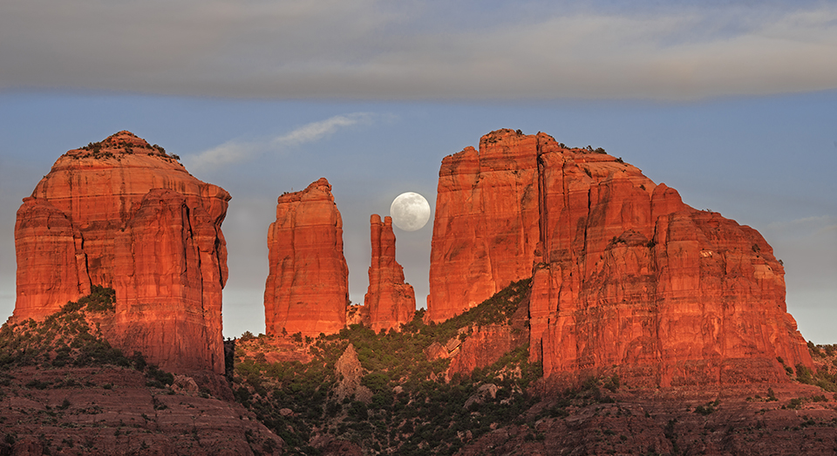
Cathedral Rock

Following our journey to Cathedral Rock we will then head out to The Chapel of The Holy Cross... I have heard interesting stories about this chapel and it definitely is a must see...
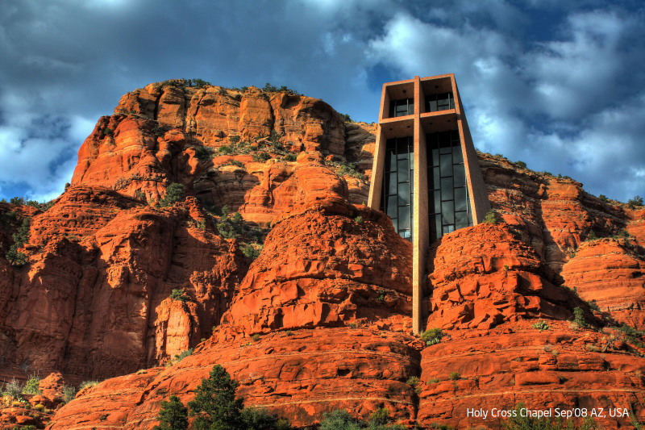
Chapel of The Holy Cross

After visiting the Chapel we will head out to lunch to Sedona City Center where there are a myriad of restaurants where we can relax, rest, eat and laugh a little. More importantly, we will take time to integrate the energies of all the vortexes.

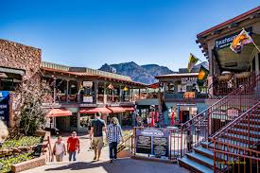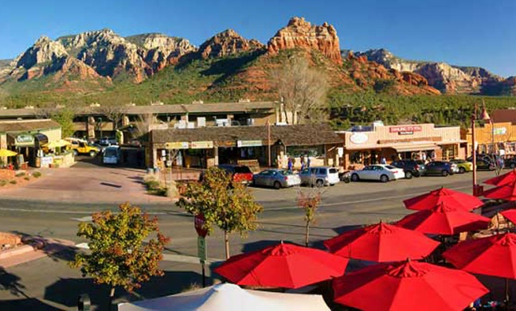
Sedona's City Center

After lunch we will head out to a beautiful spot where we can see the sunset and continue harnessing the beautiful vortex energy at AIRPORT MESA. It is said that Airport Mesa Vortex carries the masculine side of the vortexes.In this vortex we will do a fun meditation, flying in our merkabas,our light bodies.

Spiritual Attributes: Airport Mesa is the closest vortex to the center of Sedona. The “upflow” energy charges physical power and creative inspiration, and as with all electric vortexes, facilitates access to higher mental planes and helps with thought projection, which is especially useful for prayer.
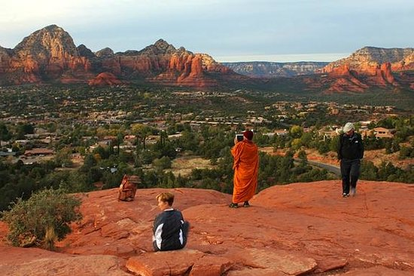
Airport Mesa
Day 3 –Monday, April 22nd

After Breakfast we will head out to our 3rd Vortex, Bell Rock Vortex, where we will do our Sufi Dance, Inner Guardian Meditations (The Female Guardian & The Male), &The Forgiveness Meditation...
With its distinctive bell shape, Bell Rock,is an electrical vortex most renowned out of the four major vortexes, and considered to have the strongest flow of energy in the area.
Spiritual Attributes:The energy here will breathe inspiration into your soul and help you gain new perspectives, perceive new levels of awareness, stimulate new thoughts and ideas, and even increase psychic abilities. It is known for helping to uncover one’s life dream and purpose and envisioning one’s future. It covers the whole area around the rock formation, so you do not have to do any climbing to experience the energy.
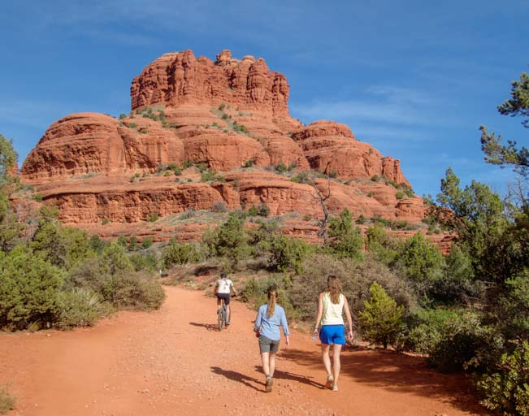
Bell Rock

After Bell Rock we will head over to the beautiful Amitabha Stupa and Peace Park.

"The stupa is one of the oldest forms of sacred architecture on earth, dating back to the time of the Buddha, 2600 years ago. Stupas are mostly found in the East, where Buddhism first took root and flourished. They are indeed rare in the West. A stupa is considered to be the living presence of the Buddha and as such represents the Mind of Enlightenment. Stupas have been built to avert war, end famine, and promote prosperity and well-being. Their sole purpose is to bring benefit for all living beings, and the mystical accounts of the healing powers of stupas are well documented.”

It is custom to find a quiet place alone to meditate, and afterwards walk around the Stupa with a prayer in mind, and then to close your circle gving love to self and others.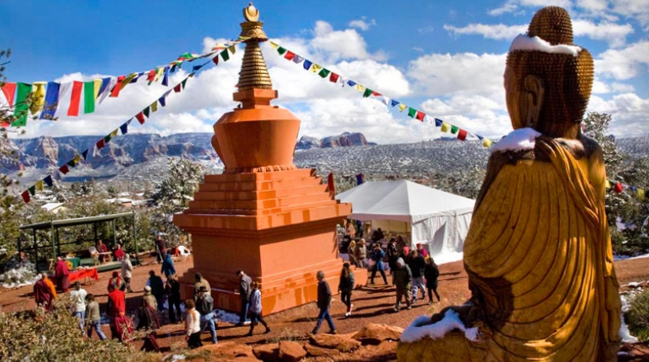
Amithaba Stupa, Sedona

LUNCH- Afterwards we will head out to lunch to Sedona City Center to continue exploring the restaurants and share over lunch our experiences and messages received from the morning meditations.

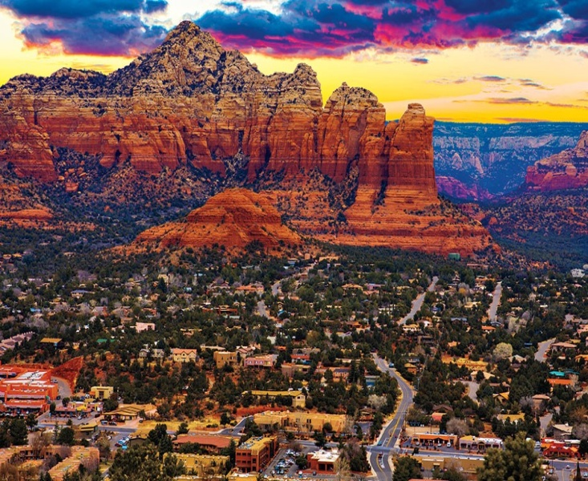
After lunch, we will continue our journey towards Red Rock Crossing near the Crescent Moon Circle, to rest and watch the sunset. Here we will do a beautiful sound healing meditation.

This is part of the Cathedral Rock Vortex, 2nd most powerful energy portal.
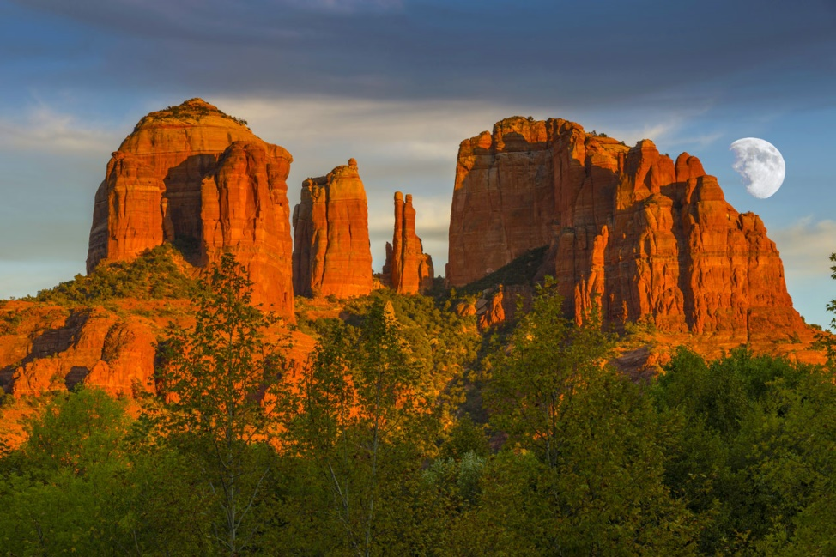

Day 4–Tuesday, April 23rd
After Breakfast we will head out to Boynton Canyon. This place is beautiful and powerful and I hold it very dear to my heart. We will spend most of our morning here.

Boynton Canyon, an electromagnetic vortex of balanced energies, is the most mysterious and sacred of the four main vortexes of Sedona.The hiking trails of Boynton Canyon are generally flat and surrounded by many tall trees that emit fresh energy, making it ideal for walking meditation.

At Boynton,we will do our Sufi Dance, Pineal Gland Activation,& Light Body Activation Meditations.

Spiritual Attributes: It is said that the native Yavapai-Apache would not dare enter this area without first purifying their body and mind through fasting or deep meditation. The Apache believed there was a powerful feminine spirit that lived in this canyon. Even today, native tribes hold private sacred ceremonies here that are far from the public eye.The energy here is very balanced and quietly peaceful. Walk in deep meditation here and clear your mind of thought and concerns. It is important to listen very carefully to your intuition – and then follow it! Let it be your guide, especially if you feel you should stop at a particularplace.
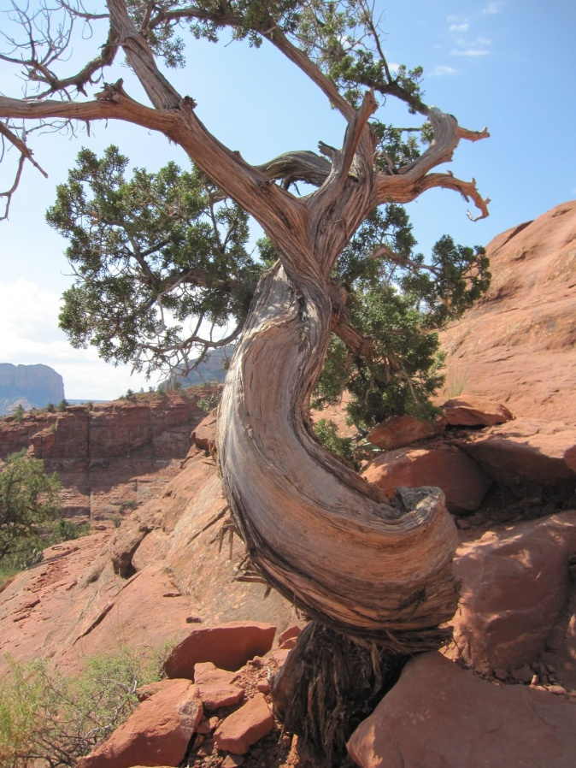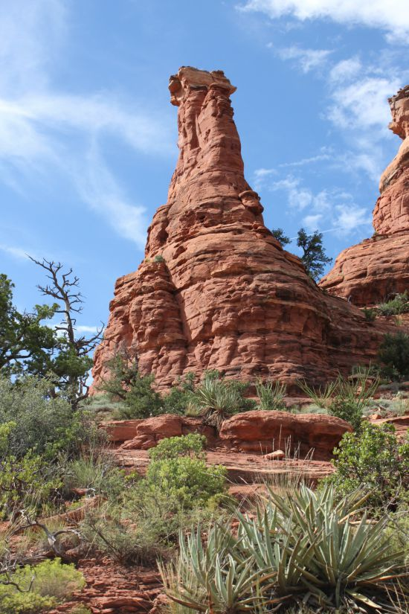

After trekking this beautiful and powerful mountain we will head out to lunch.
Afterlunch we will continue our adventure towards Soldiers Pass Trail,Devils Kitchen,and The Seven Sacred Pools.

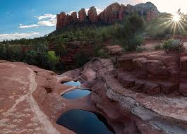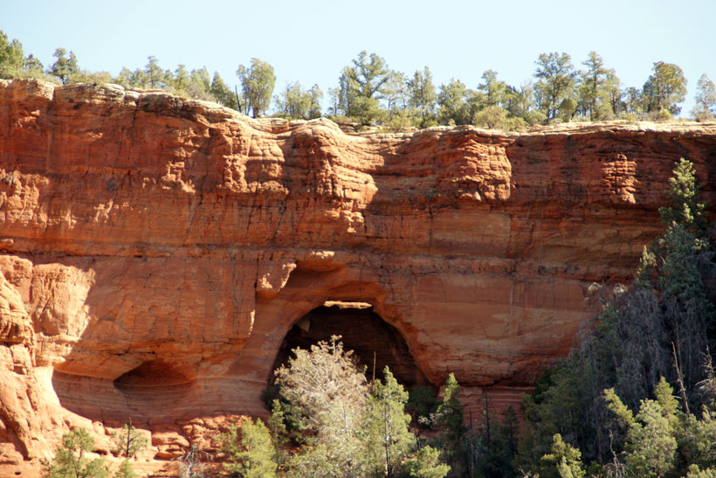

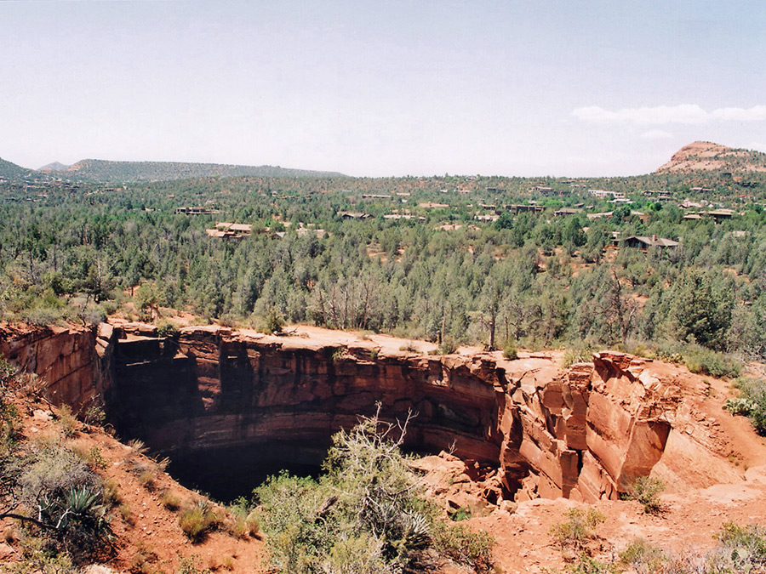

This day, after our long hike, we will be able to enjoy a sweat lodge in the evening at Rahelio's property. Rahelio is a Toltec native, shaman, and mystic whohas lived in Sedona for most of his life.

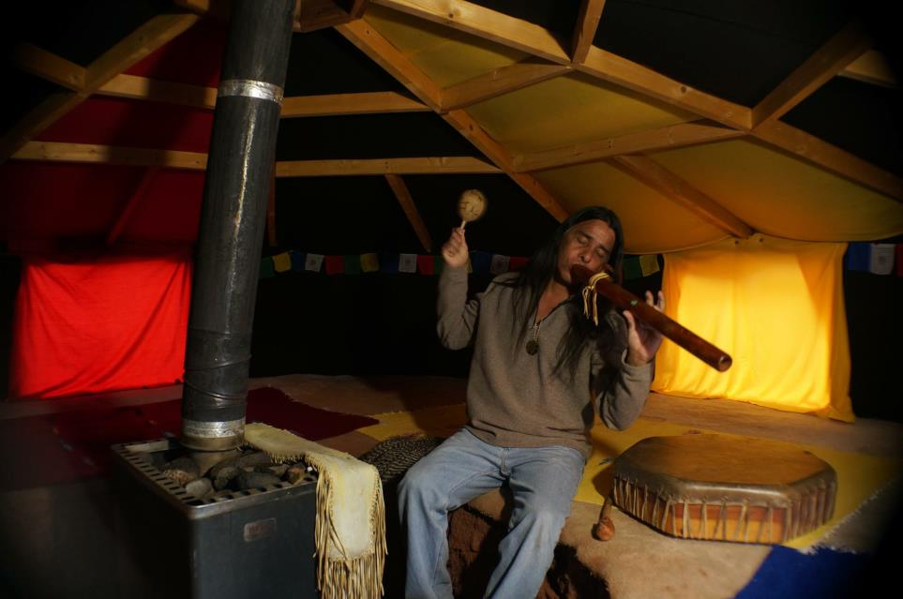
Sweat Lodge

Day 5 – Wednesday, April 24th

Today is our last day together and we will try to take it easy.

After breakfast we will head out to Oak Creek Canyon. Oak Creek Canyon is a place where you can not only enjoy the area’s red fantastically-shaped cliffs and varied evergreens, but where deciduous trees show their jewel-toned colors in autumn.

The invigorating forest fragrance is the first thing that welcomes you as you enter the canyon from either direction. Streams of water gurgle and shout robustly, effortlessly making your mind comfortable and calm. They symbolize an aspect of life that always has hope and is willing to take on all challenges.

Spiritual Attributes:This riparian area is bursting with the energy of nature and its gifts of water, flora, and fauna. The energy here is highly energizing, and at the same time, very relaxing and balancing. Your breath becomes smoother, you feel yourself smiling, and you either let out an audible “ah-h-h-h” or you just feel a deep inner relief. Some people feel, or have seen, fairies and sprites dancing about. It is no wonder some call it an enchanted forest.
This day we will bring our bathing suits.
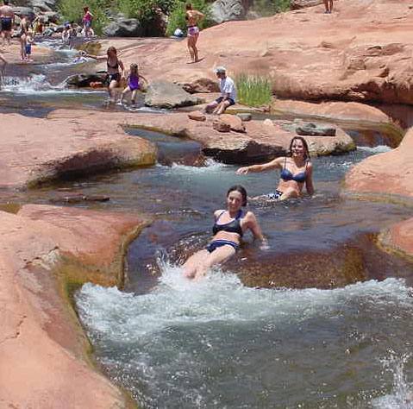
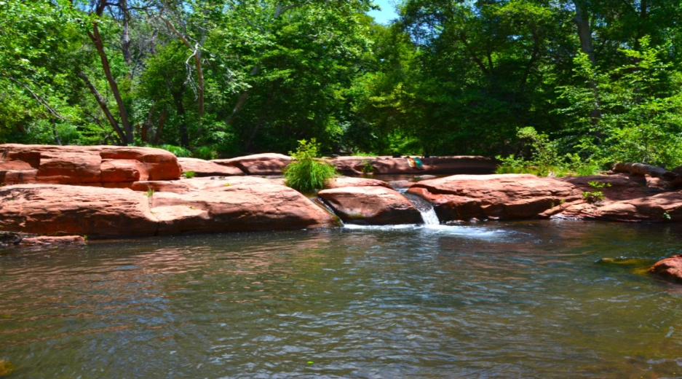

Afterwards, we will head back home and freshen up before going into town for last minute shopping and lunch.

In the evening we will head back to where we started, for our closing ceremony at the labyrinth.

Afterwards we will go out to town for our goodbye dinner.

Day 6 – Thursday, April 25th

Today we will say goodbye, as everyone checks out and heads to the airport to go back home.

Special Note
I would also like to announce that we will have Mariella, a Q’ero initiate from Peru, with us and she will be doing a despacho ceremony for wealth, love, prosperity, wisdom, and connection to the Apus & Pachamama.
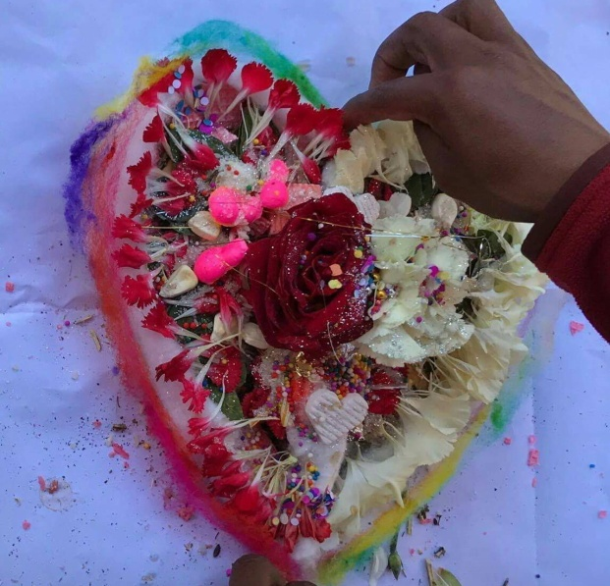

THE ADVENTURE WITHIN
Sedona, Arizona
April 20rd–25th 2019

PRICE: $1,222.00

INCLUDED:

*LODGING
*TRANSPORTATION TO SACRED SITES
*BREAKFAST
*Q'ERO SHAMAN CEREMONY
*SWEAT LODGE
*GUIDED MEDITATIONS (EMOTIONAL TRAUMA HEALING)
*TAROT CARD READING
*SHAMANIC BREATHWORK
*VORTEX EXPEDITIONS

NOT INCLUDED:

*AIRFARE
*TRANSPORTATION TO OR FROM AIRPORT (Unless pre-arranged)
*LUNCH & DINNER

WHAT TO BRING:

SUNSCREEN
HIKING GEAR
FLASHLIGHTS
SLEEPING BAGS
SMALL BACK PACK
BATHING SUITS
CAMERA

Soul Tribe! We only have availability for 10 –First come first serve, and spots are already filling up fast! This is going to be an unforgettable experience!

Full Payment of $1,222.00
*Non-refundable due to travel limitations. Serious inquiries only.

DEPOSIT PAYMENT
$611

You can make payments to:
https://www.paypal.me/EvelynOneHeart

Full Payments due by April 5th, 2019

I LOVE YOU ALL AND HOPE TO SEE YOU THERE

What is a Vortex?
A vortex is the funnel shape created by a whirling fluid or by the motion of spiraling energy. Familiar examples of vortex shapes are whirlwinds, tornadoes, and water going down a drain. A vortex can be made up of anything that flows, such as wind, water, or electricity.

The vortexes in Sedona are swirling centers of subtle energy coming out from the surface of the earth. The vortex energy is not exactly electricity or magnetism, although it does leave a slight measurable residual magnetism in the places where it is strongest.

The subtle energy that exists at these locations interacts with who a person is inside. The energy resonates with and strengthens the Inner Being of each person that comes within about a quarter to a half mile of it. This resonance happens because the vortex energy is very similar to the subtle energy operating in the energy centers inside each person. If you are at all a sensitive person, it is easy to feel the energy at these vortexes.

Here is a map to help you easily locate the four main energy vortexes. On the map, a diamond indicates the location of a vortex. Although the Sedona area has many hiking trails that only a vigorous hiker can enjoy, the vortexes are all easy to get to, and no strenuous hiking is required to get to any of them.

