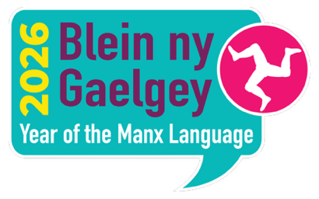

Oie Voaldyn Veg Fancy Dress Parade 4pm Sunday 3rd May 2026

Parent information
All participating children must be accompanied by a responsible adult at the start and finish of the parade. You can take part in the parade with your children (hopefully you’ll be in fancy dress too) there will be a prize for the best fancy dress family.

Any children wanting to take part need to be outside
Black Dog Pizza Restaurant Peel Quay by 3.45pm.

The parade will start at 4pm the event will finish by 5pm on the beach.

The parade will be celebrating the Year of the Manx Language with a Manx language sing off and dance off Summer versus Winter. There is an information pack with music, lyrics for any children wanting to practice before the event. All information via link https://oievoaldyn.com/oie-voaldyn-veg

The fancy dress theme is: Sourey (Summer) and Geurey (Winter): prizes for best overall family and ……..

Winter: best themed pram/buggy; best 5 and under; best 8 and under; best 12 and under.
Summer: best themed pram/buggy; best 5 and under; best 8 and under; best 12 and under.

The fancy dress competition will be judged by the visiting Jarl Squad visiting from the Shetlands.

If parents would like any further information regarding this event, please contact Cathy Clucas: cathy.clucas@sch.im

