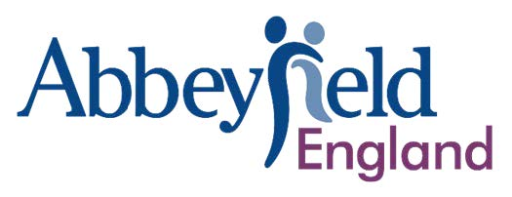
Policy Title | Marketing, PR, Advertising & Digital Media Policy
Version | 1.0
Date of Issue | 16 July 2025
Next Review Date | 16 July 2025

Marketing, PR, Advertising & Digital Media Policy

Section 1: Policy Framework

1.1 Purpose
This policy sets out the Abbeyfield Dulwich Society Limited (The) approach to using marketing, PR, social media and digital platforms in a way that is ethical, safe, legally compliant, and aligned with the Abbeyfield brand.

1.2 Scope
This policy applies to all online and offline promotional content created by or on behalf of the society. It includes websites, social media, advertising, event promotion, email marketing, and branded materials.

1.3 Branding and Reputation
The Abbeyfield brand must be used consistently and with care. Logos, templates, and style guidance must follow materials available via Abbeyfield Connect. All use of the brand reflects on the national Abbeyfield family.

1.4 Legal and Regulatory Compliance
All digital media activity must comply with relevant laws (e.g., GDPR, copyright, fundraising regulations) and policies such as safeguarding, privacy, and equality.

1.5 Risk Management and Escalation
If any post, content or digital activity might generate significant media, reputational or safeguarding risk, it must be escalated to Abbeyfield England immediately for coordinated response planning.

1.6 Policy Review
This policy is reviewed annually or in response to major incidents, regulatory updates, or changes in national Abbeyfield England digital strategy.

