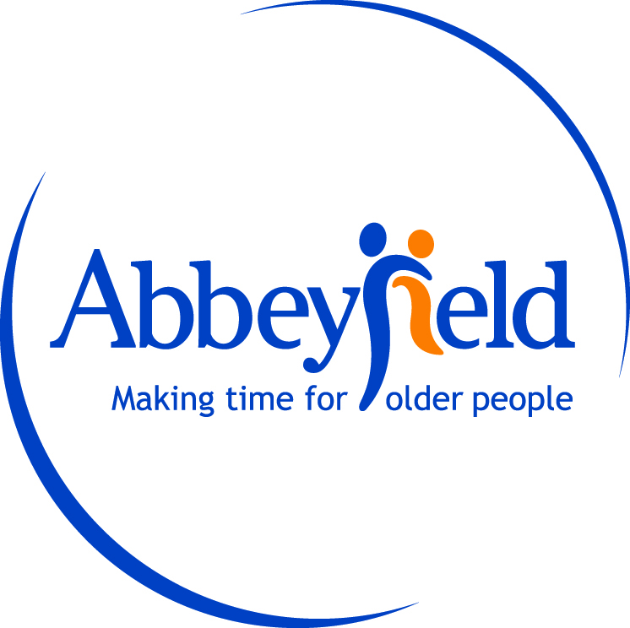

Governing Body Response
To the 2024 Self-Assessment, Complaints Performance and Service Improvement Report
Date: 16 April 2025
Dear Residents, Families, and Stakeholders,
The Governing Body, as the Trustees of Abbeyfield Dulwich, has reviewed the 2024 Self-Assessment, Complaints Performance and Service Improvement Report and wishes to express its appreciation for the transparency and diligence demonstrated throughout.
We are pleased to note that only one formal complaint was received during the reporting period. The concern, relating to a heating issue, was promptly addressed and resolved to the resident’s satisfaction. The Trustees commend the staff team for their swift and effective response, which reflects a strong commitment to resident wellbeing and care.
We welcome the proactive service improvements made following the complaint, including the introduction of a Maintenance Response Log and strengthened out-of-hours escalation procedures. These measures demonstrate a positive learning culture and an ongoing commitment to continuous improvement, even in the context of a low number of formal complaints.
The Trustees fully support the service development plans for 2025, particularly the proposed review of the heating system and enhanced resident engagement initiatives. We believe these steps will further strengthen the quality of care and the lived experience of residents at Abbeyfield Dulwich.
On behalf of the Governing Body, we extend our sincere thanks to the management and staff team for their continued dedication and compassion. We remain committed to providing strategic oversight and support in the delivery of high-quality, person-centred care.
Yours faithfully,
The Trustees
Abbeyfield Dulwich

