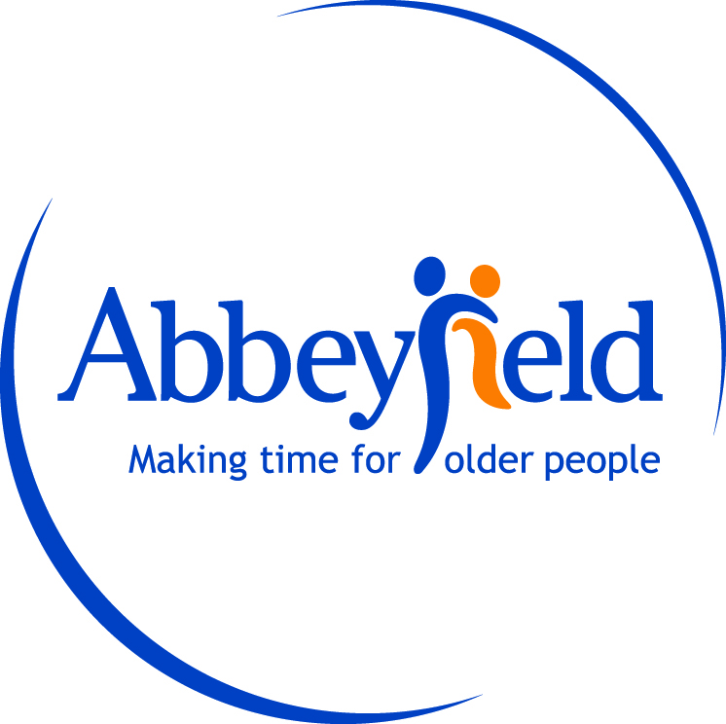

Governing Body Response
For the October 2024-Sept 2025 Self-Assessment, Complaints Performance and Service Improvement Report
Date: 20 June 2026
Dear Residents, Families and Stakeholders,
On behalf of the Governing Body, we are pleased to endorse Abbeyfield Dulwich Society’s October 2024-Sept 2025 Self-Assessment and Complaints Performance and Service Improvement Report.
The Trustees are encouraged that only one formal complaint was received during the reporting period. The issue, relating to heating, was addressed promptly and resolved to the resident’s satisfaction. We commend the management and staff team for their timely response and continued commitment to providing high-quality, person-centred care.
We also welcome the positive improvements implemented as a result of the complaint, including the introduction of a Maintenance Response Log and enhanced out-of-hours escalation procedures. These actions demonstrate a strong commitment to learning from feedback and continually improving the services we provide.
The Trustees fully support the planned service improvements for the year ahead, including the proposed review of the emergency warden call system, and are confident these initiatives will further enhance the safety, wellbeing and experience of our residents.
We thank our residents, their families and our staff for their continued support, feedback and dedication. The Governing Body remains committed to providing effective oversight and supporting the delivery of safe, responsive and high-quality services for everyone at Abbeyfield Dulwich.
Yours faithfully,
The Trustees
Abbeyfield Dulwich Society

