**Attic Insulation**

**Heat flows naturally from a warmer to a cooler space. In the winter, this heat flow moves directly from all heated living spaces to adjacent unheated attics, garages, and basements, or to the outdoors; or indirectly through interior ceilings, walls, and floors--wherever there is a difference in temperature. During the cooling season, heat flows from outdoors to the house interior. To maintain comfort, the heat lost in winter must be replaced by your heating system and the heat gained in summer must be removed by your air conditioner. Insulating ceilings, walls, and floors decreases this heat flow by providing an effective resistance to the flow of heat.**

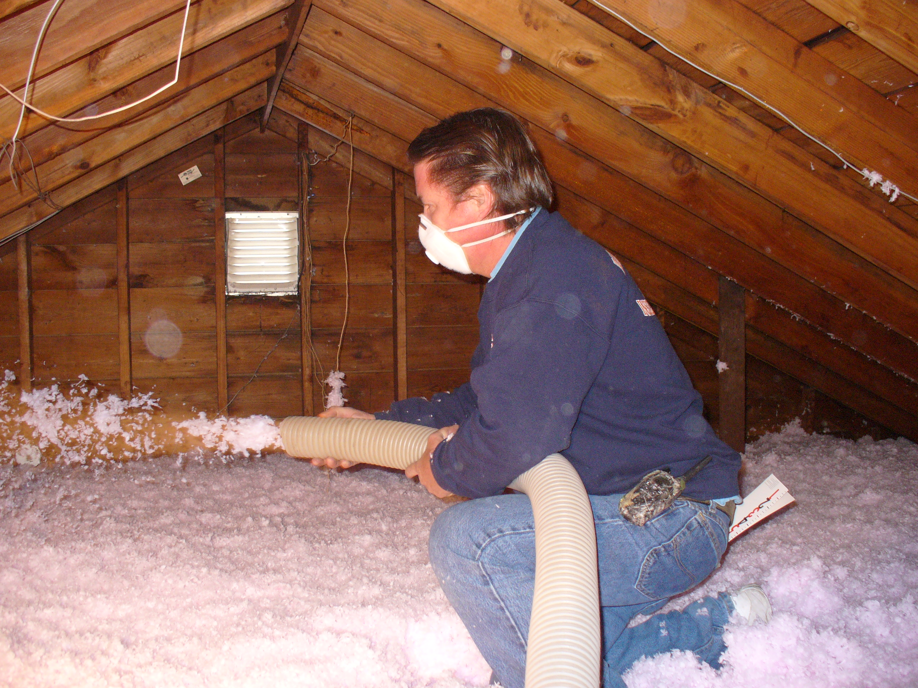



After

**WHY ATTIC INSULATION?**

Insulation is just as important in the summer as it is in the winter. A well-insulated house will be **cool in summer and warm in winter.** Most homes absorb heat through the roof, so insulating the attic floor stops heat from reaching the rest of the house.

Properly insulated homes can use 30 to 50 less energy than homes without insulation. Lining your "thermal envelope" - adding materials that don't readily allow heat to leak through your walls, ceilings, floors, from around your home's foundations and its ductwork - saves energy by keeping heat in during the winter and keeping heat out during the summer.

The effectiveness of a piece of insulation is measured by its [R-value](http://www.consumerenergycenter.org/glossary/r.html#r-value). The R-value in insulation designates its resistance to heat flow. **The higher the R-value, the greater the insulating ability - the more effective it is.** Generally speaking, each time you double the R-value of insulation, you cut your conduction heat loss in that area in half.

Adding insulation to an **un-insulated** attic is the most cost-effective, energy-saving measure you can do. Most older houses were built with little or no insulation. In Kentucky', the minimum recommended R-value is R-49 for an **un-insulated** attic, R-5 to R-6 for **un-insulated** wood frame walls, R-19 for **un-insulated** raised floors. See: <http://www.reca-codes.org/codes2012/Kentucky.pdf>



**CELLULOSE INSULATION**

Cellulose insulation is treated for fire retardancy. If a fire occurs, the blown in cellulose insulation, combined with its fire retardants, can slow the fire from spreading and can create a "2-hour firewall". Scientists at the National Research Council report that, blown in cellulose insulation increases fire resistance by 22%-55%. When Blown in Cellulose insulation does burn, it generally doesn't emit toxic chemicals. **Densely packed cellulose** limits air movement and prevents drafts much better than **fiberglass insulation**. This is well documented by the [University of Colorado](http://www.advancedfiber.com/Colorado%20Study.pdf) in their 1990 evaluation of identical homes insulated with fiberglass and cellulose. The results of their study showed cellulose reduced air leakage by 38% and required 26% less money to heat and cool than the fiberglass home. Fiberglass can naturally break down after its useful life unlike Cellulose which does not. Six inches of blown in Cellulose is all it takes to prevent the loss of heat due to air convection versus Fiberglass alone.



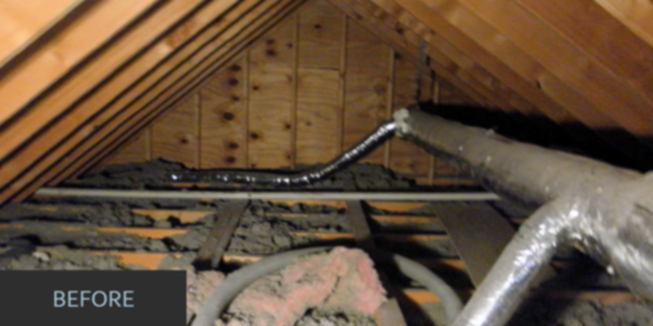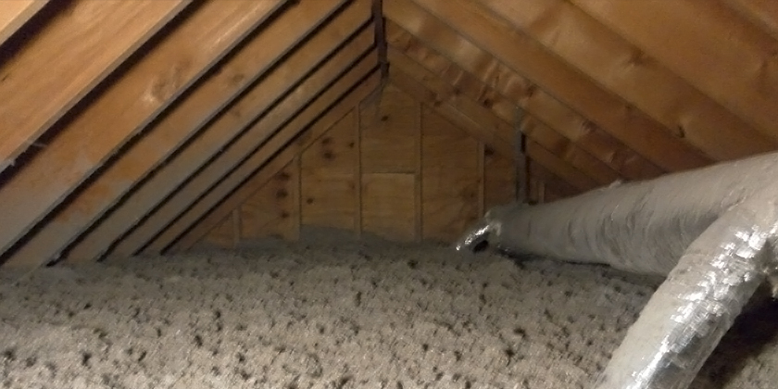

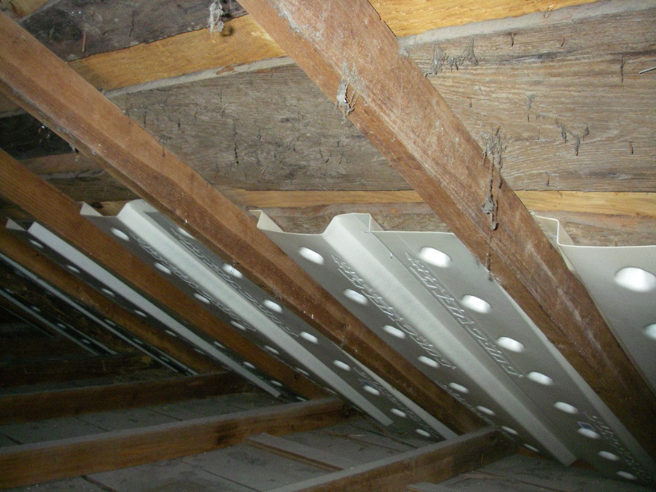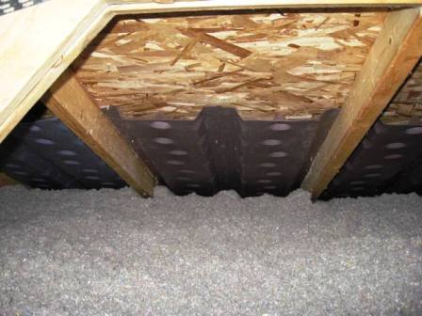

**Even if you have existing fiberglass installed in your attic, you can improve its performance by providing a "blanket" of cellulose insulation.**

If your attic has enough insulation and proper air sealing, and your home still feels drafty and cold in the winter or too warm in the summer, chances are you need to add insulation to the exterior walls. You may also need to add insulation to your crawlspace or basement.

Contact **HOMETOWN INSULATION** for a **FREE ESTIMATE**!

**BEFORE AFTER BAFFLES = (Ventilation)**

**COOLER IN THE SUMMER * WARMER IN THE WINTER**