The crawlspace is one of the most forgotten, yet crucially important areas of your home. **Mold, energy loss, and poor indoor air quality** can all be drastically improved after encapsulation. Let us transform this damp, dark, pest infested space into a clean, almost pleasant space.

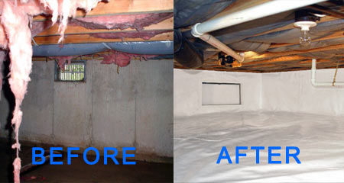

**Crawlspace Encapsulation**



After

**What is Crawl Space Encapsulation?**

Crawlspace Encapsulation is a method of sealing the crawlspace

from outside air and ground moisture. This process can provide many important benefits, including **improving air quality. It stops moisture and condensation from deteriorating your home** and **causing other problems such as mold, mildew, fungus, and other airborne toxins** from entering your crawlspace and home.



***Hometown Insulation & Home Improvements*** *has trained professionals that can help you make your crawlspace DRY and HEALTHY. We offer Encapsulations that seal out moisture, which can be used on your crawlspace or basement. The liner is sealed to the wall to stop any escape of moisture from under the liner.  The liner is seamed with a moisture proof tape and sealed around all piers, interior walls, and other structures.  At that point, the final step is to seal all foundation vents.* *We also have polyurethane solutions to fill cracks and keep that moisture away from your crawlspace. These vapor barriers are the first line of defense against high humidity and poor indoor air quality. Crawlspace encapsulation barriers are 10 to 20 mil thick, puncture resistant and made of a high tensile strength material that stops soil moisture from entering the space from the soil. These swimming pool type liners encapsulate the crawlspace so that moisture cannot attack exposed wood and create mold and mildew, you will even gain valuable storage space in your home!*

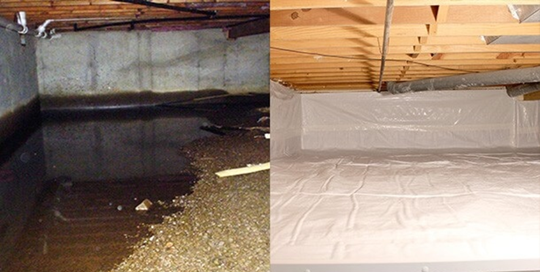

**Before After**

**Benefits to Encapsulate your Crawlspace:**

* Improved indoor air quality in home/odor elimination (50% of the air in your home comes from the crawlspace)
* More efficient heating and air since the duct work is now in conditioned air space (Save up to 18% on heating and cooling costs)
* Air leakage is reduced in the home, lowering heating and cooling costs
* Reduce flex and buckling of floors
* Dramatically reduce presence of pests, including termites
* Warmer floors in the winter
* Gain valuable storage space
* Creates a clean and conditioned space instead of a bug infested dungeon