*The last thing you want to do is add insulation to your attic without*[*air sealing*](http://howtohomeinsulation.com/insulation_basics_losing_money_sealing_air_leaks.html)*first. Up to 30% of your heating and air conditioning escapes through gaps, cracks, and holes in your walls and ceilings. Even if you have insulation properly installed.*

**Why Seal & Insulate?**

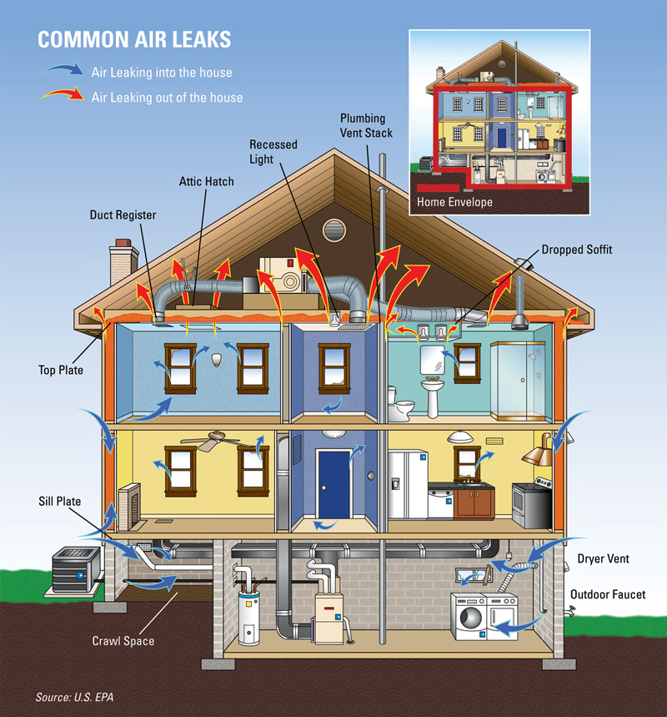



After

INFRARED CAMERA

AUDITS & SCANS

Our Infrared Camera Offers Detection and Visualization of Infiltration and Exfiltration & Guarantees our Customers a Flawless Job.

**With our Infrared Camera you can actually see your energy heat loss**

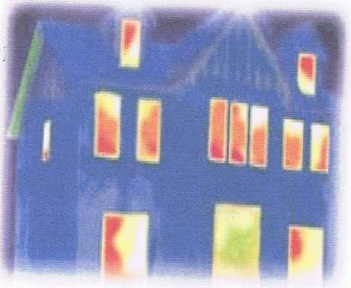

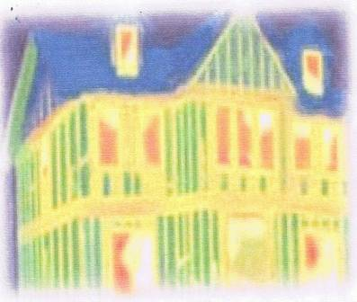



Sources of Air Leaks in Your Home

After

**BENEFITS** (**Tightening a home through air leakage and duct work sealing can provide a number of benefits)**

• Lower utility bills

• Improved comfort, especially during summer and winter

• Reduced noise from outside

• Less pollen, dust, and insects entering your home

* Improved Durability
* Better humidity control

• Fewer Drafts

• Less Chance of Mold Because of Trapped Moisture

• Enhanced Indoor Air Quality

• Better Performance of The Home's Ventilation System

* Possibility to Reduce Size of Heating and Cooling Equipment Capacities

Air leakage occurs when outside air enters, and conditioned air leaves your house uncontrollably through cracks and openings. It is unwise to rely on air leakage for [**ventilation**](http://energy.gov/node/367519). During cold or windy weather, too much air may enter the house. When it's warmer and less windy, not enough air may enter, which can result in poor indoor air quality. Air leakage also contributes to [**moisture**](http://energy.gov/node/369181) **& mold** problems that can affect occupants’ health and the structure’s durability. An added benefit is that sealing cracks and openings reduces drafts and cold spots, improving comfort.

**We also offer a comprehensive** [**home energy audit**](http://www.dodrillheating.com/home-energy-audit.html)**, which we use to fully diagnose the causes of your home's energy issues.**

* Door & Window Frames
* All Ducts
* Baseboards
* Chimney Flashing
* Vents & Fans
* Rim Joists
* Porch Roofs
* Common Walls
* Water and Furnace Flues
* Electrical Outlets
* Electrical Switches
* Plumbing & Utility Access
* Dropped Ceiling
* Recessed Light
* Attic Entrance
* Sill Plates

Before

**Reduced Air Leakage = Increased Energy Efficiency**