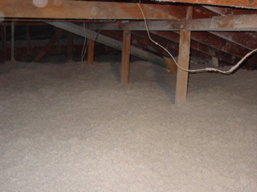

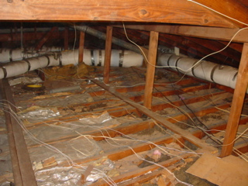

ATTIC

BEFORE & AFTER

Over 50 Years - 5 Generations!