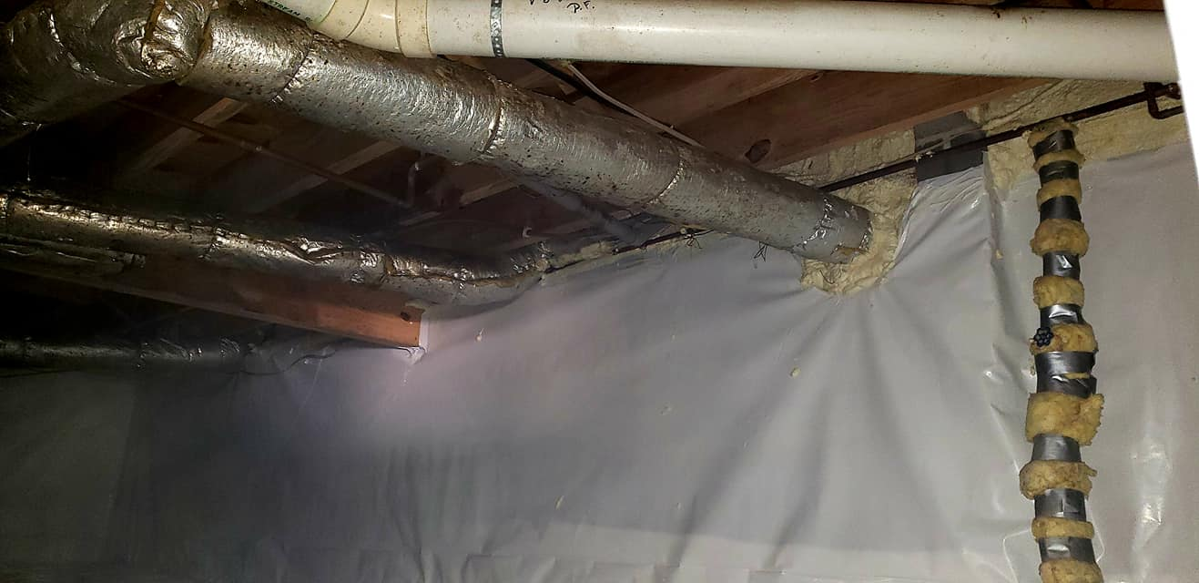

Over 50 Years - 5 Generations!

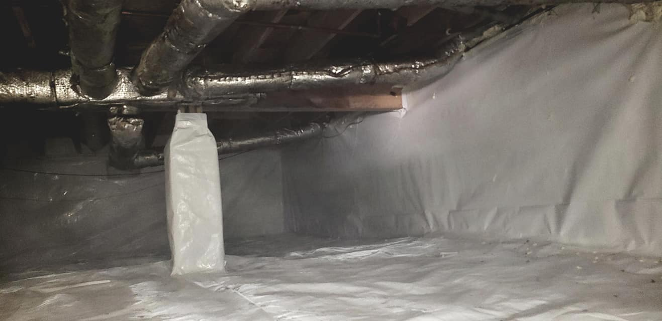

CRAWLSPACE

ENCAPSULATION