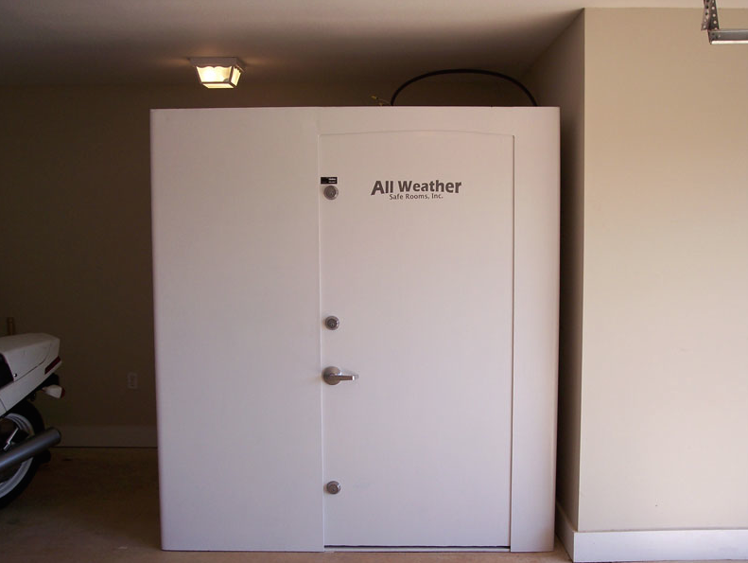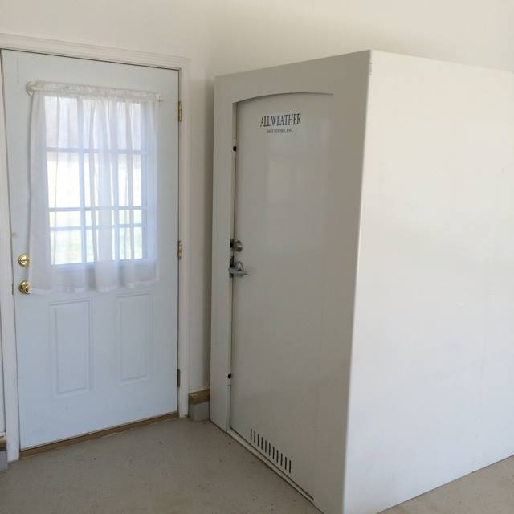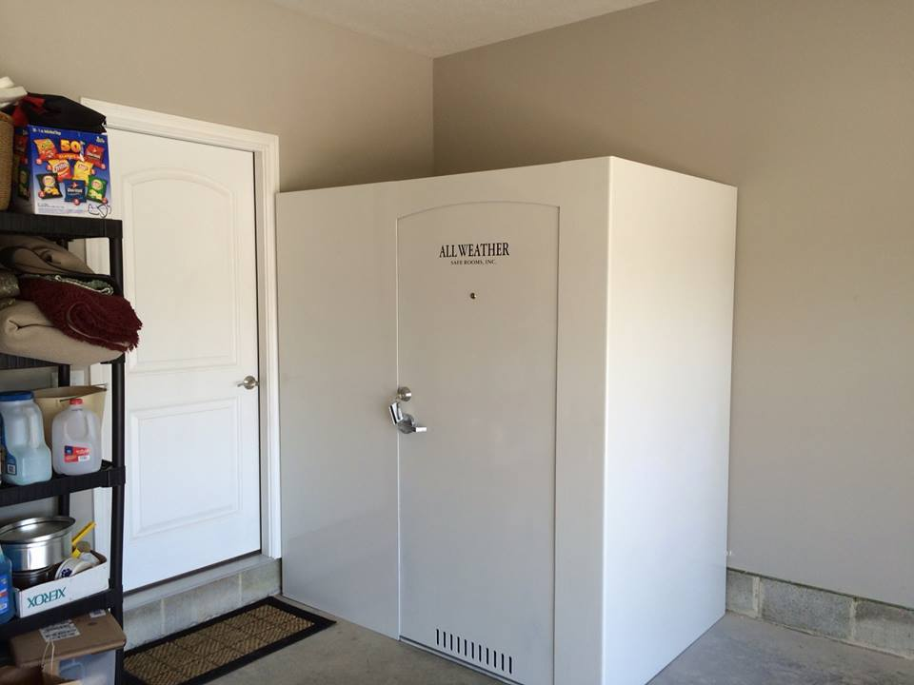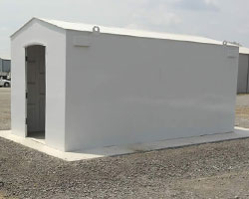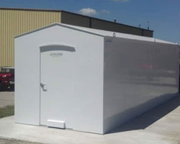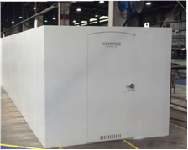

SAFE ROOMS

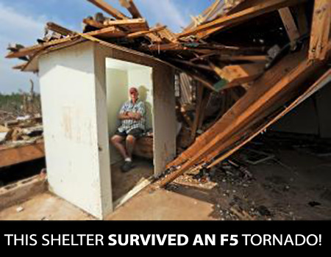

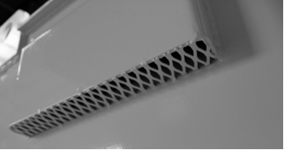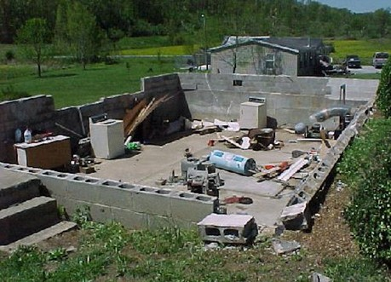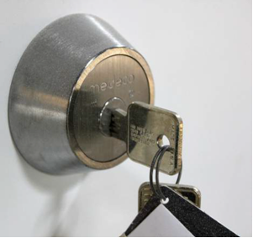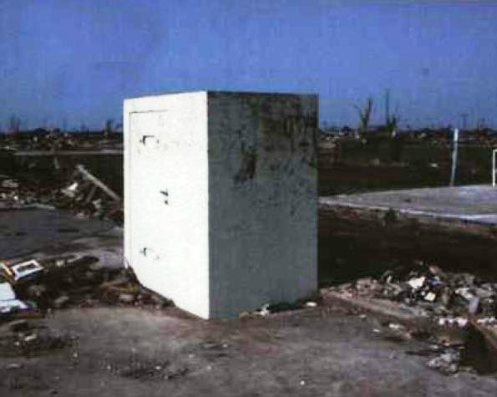

217-352-9770

**4-PERSON**

**INSTALLED!**

No-Leak

Air Vents

**$4995.00**

No cracks - No leaks - No rust - No pests

Basements are not Storm Shelters

Stainless Steel Class-One Dead Bolt

**All shelters and components are fully engineered, exceed FEMA 320 and the National Storm Shelter Association performance criteria for storm shelters and have been successfully tested by the Texas Tech Wind Science & Engineering Center and a member of the American Tornado Shelter Association.**

**Shelters and Safe Houses** are perfect for your:

*Residential Homes * Manufactured Home or Mobile Home * Small Business *Day Care Center * Retirement Home * RV Parks & Campsites * US Government & Military Facilities * Local & City Government Facilities * Restaurants * Churches *Convenient Stores *Schools *Corporations

**Standard Features Include:**

-Engineered to withstand an F5 Tornado

-Bullet resistant to most handguns

-Undergone extensive testing

-Can withstand 50 tons of weight

-Available in many different sizes

-Easy entry with optional dead bolt

-Easily installed in as little as an hour

-Manufactured in the USA