STORM SHELTERS

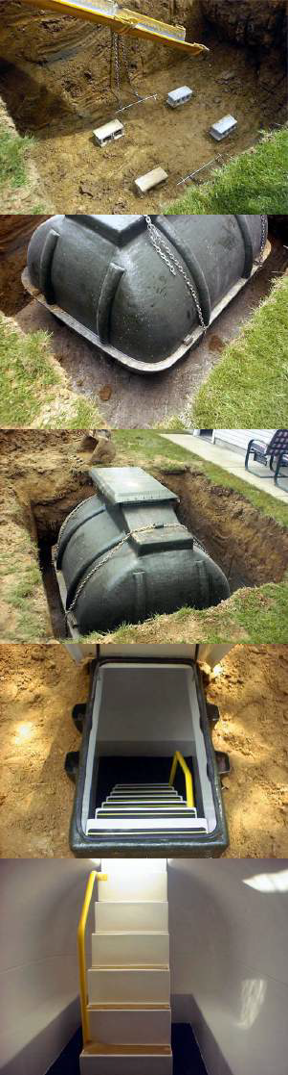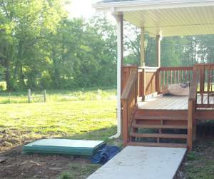



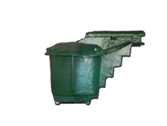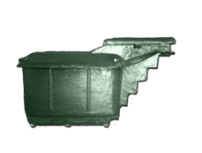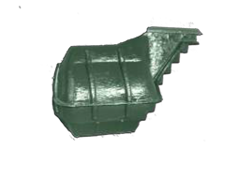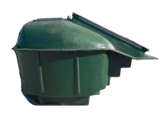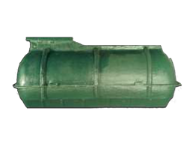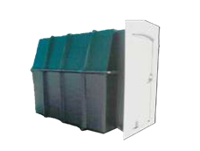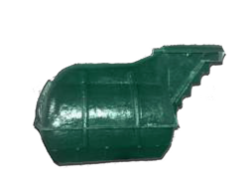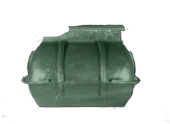

270-366-1105

## **Storm-Tek LS20**

**(178”L X 79”W X 70”H Seats 20)**

## **Hillside 12 person**

**(6'L X 8'W X 6.5')**

**Storm-Tek LS12**

**(98"L X 79"W x 72"H Seats 12)**

**Storm-Tek LS10**

**(102"L X 78"W X 70"H Seats 10)**

**Slope 8 Person**

**(9.5'L X 6'W X 6.5'H)**

**Storm-Tek LS8**

**(80"L X 65"W X 73"H Seats 8)**

**Storm-Tek LS4**

**(48"L X 60"W X 62"H Seats 4)**

**Storm-Tek LS6**

**(81"L X 60"W X 58"H Seats 6)**

**Standard Features Include:**

-Heavy Duty Fiberglass Construction

-Multi-Point Door Locking System

-Gas-Assist Struts for Easy Door Opening

-Water-Tight Door Seal and Screened Vents

-Non-Skid Steps / Handrail & Carpeting

-**LIFETIME WARRANTY**

**TORNADO STANDARD FEATURES INCLUDE:**

**Impact Tested Door Design, Fully Weather Sealed Door, Screened In Ventilation, 6 Point Lock System, Easy Open Door System, Molded In Seating, White Gel Coat Interior, Green Epoxy Coated Exterior, Full Limited Warranty.**

1

3

2

4

5

6