Washington Home Mortgage, Inc.  
Executive Residential Mortgage & Equity Advisors

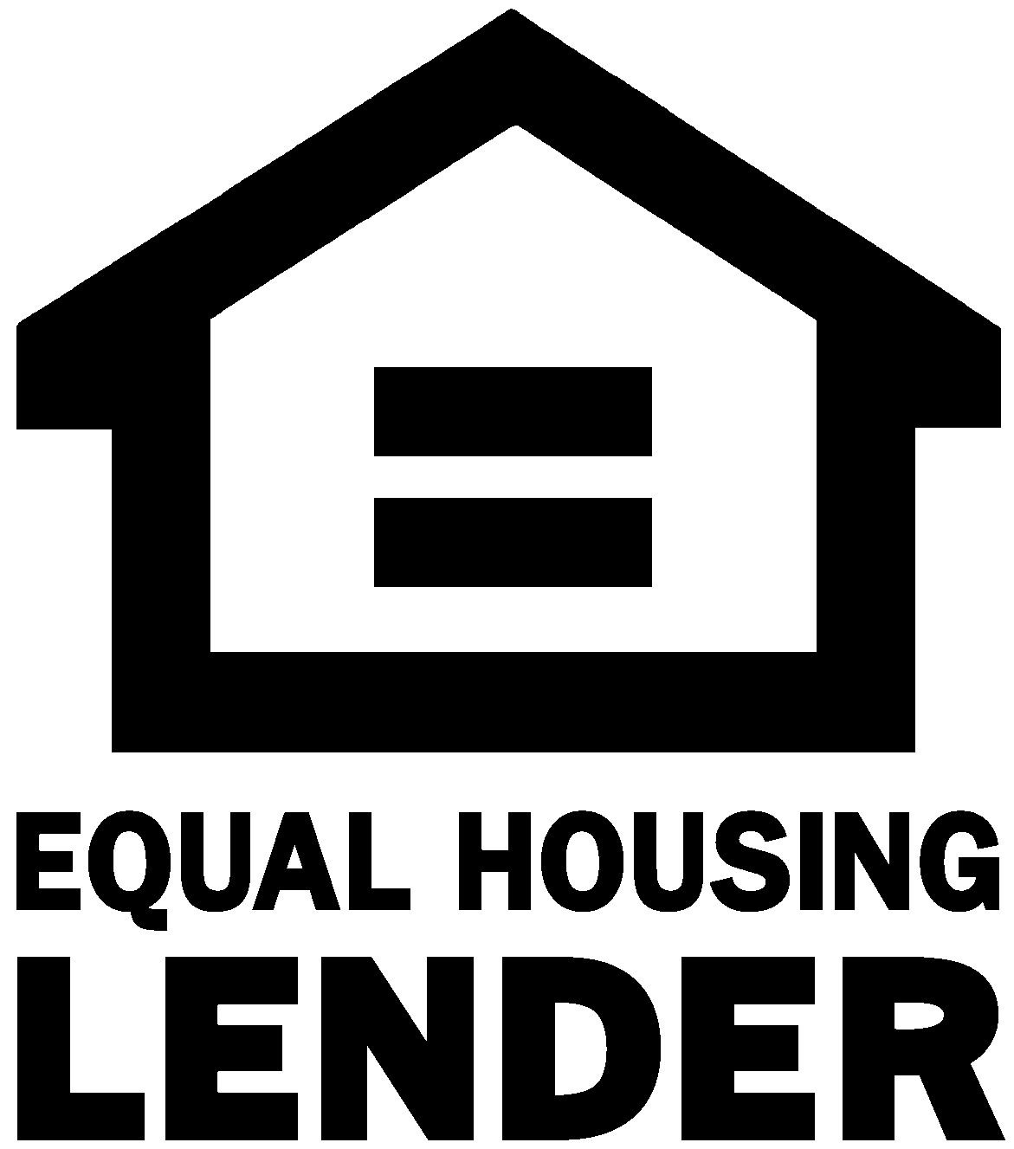



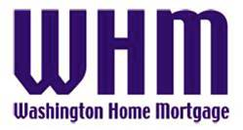

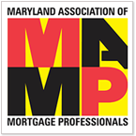

**J o s e p h C h i l d**

Director – Private Clients Sr. Executive  
NMLS# 214118

**Washington Home Mortgage, Inc.**

7101 Wisconsin Ave. Bethesda MD 20814  
**Mobile/Text: 443-336-7000 Office: 301-215-7310 FAX: 301-215-7311**  
**E-Mail: jchild@whmortgage.com / Web: www.whmortgage.com**

Washington Home Mortgage, Inc. partners with you, your financial professionals and property representatives to advise & navigate today’s complex requirements. We consult exclusively for Washington DC, Maryland and Virginia clients looking to buy, sell or otherwise reposition   
their real estate equity in those markets.  
  
***Competitive?*** After over 15 years working with the best providers, in one of the most competitive markets in the country … and with the flexibility of private ownership – ***You bet we are!***

We represent over two dozen local and national institutions to facilitate a broad view of available options, *including* primary residence financing, income producing property, 2nd Home, vacation & non-agency warrantable property financing, new construction & project approvals, renovation financing, 2nd position lines of credit as well as several portfolio programs for self-employed and executive clients … in addition to our select government agency product solutions.

***What are your best options? Schedule a Private Appointment for your review with:***

**When the preparation of Personal Financial Information on today’s Financial Applications requires such serious expertise.**

***Who Do You Consult With?***

