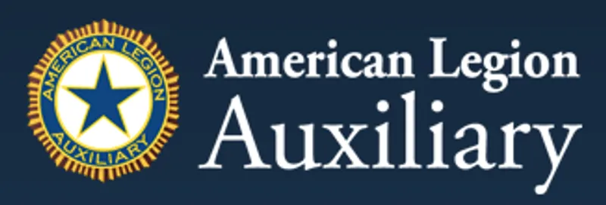

# Department of Oklahoma

# 2025–2026 Plan of Action

# Americanism Program

Department Chair **STATE PRESIDENT**

Sherrie Nida Kim McInnis

E-mail: [sherrienida@yahoo.com](mailto:sherrienida@yahoo.com) Email: [ALAOKPRESIDENT@GMAIL.COM](mailto:ALAOKPRESIDENT@GMAIL.COM)

Phone : 620-762-0419 Phone: 918-807-4680

## What is the Americanism Program?

The Americanism Program of the American Legion Auxiliary exists to promote patriotism, provide care and comfort to our veterans, and support the families and communities who give so much for our great nation

This program ensures that we do all we can to:  
- Inspire respect for our flag, Constitution, and freedoms.  
- Instill in youth a love of country and civic responsibility.  
- Encourage active participation in patriotic activities and education.  
- Partner with veterans and their families to strengthen our communities

Americanism is not just a program — it is a responsibility to uphold the values of democracy and freedom that our service members and women fought to defend.

## Department Goals for 2025–2026

1. Promote patriotism and respect for the U.S. Flag and Constitution.  
2. Educate youth on American history, citizenship, and civic duty.  
3. Provide opportunities for veterans and military members to share their stories.  
4. Strengthen community engagement through visible and impactful programs.

## Program Participation Ideas

### 1. Star Spangled Kids

Encourages youth to learn about the history and values of our nation.  
- Partner with schools for flag etiquette and Constitution education.  
- Distribute patriotic coloring books and activity pages.  
- Celebrate Constitution Day (Sept 17).  
- Encourage students to test their knowledge of the Constitution.  
- Publish newsletters or bulletins with Constitution facts.

### 2. Education & Youth Engagement

- United Citizen Award recognizing youth who embody constitutional ideals.  
- Invite veterans and service members into classrooms.  
- Share financial/civic facts about the U.S. Constitution.  
- Promote Americanism Essay Contest and Oratorical Contest.

### 3. Veteran & Military Involvement

- Invite veterans to speak at events.  
- Recognize Gold and Blue Star Families.  
- Deliver programs to VA hospitals.  
- Constitution activities: skits, scavenger hunts, dress-up events.  
- Encourage high school participation in Oratorical Contest.

## Americanism Essay Contest

Theme 2025–2026: "Celebrating America’s 250th Birthday and the Veterans who fought for Our Freedom

- Deadlines: Submissions to Department Chair by March 20, 2026.  
- Resources: www.legion-auxiliary.org  
- Questions: Americanism@ALAforVeterans.org

## What to include in your year end report.

Reports should include:  
1. Promotion of Star-Spangled Kids.  
2. Education of youth on Constitution and patriotism.  
3. Use of Star-Spangled Kids Kit.  
4. Flag history and disposal training provided.  
5. Methods used to increase Essay Contest participation  
6. Contributions to Legion Americanism Programs.  
7. Photos (300 dpi, actual size when emailing).

## Award Submission Guidelines

- Deadlines: Essay Contest March 20, 2026; **Outstanding Unit Award**  **April 15th, 2026.**  
-- Confirmation email will be sent upon submission.

## National Award: Dorothy Pearl Most Outstanding Unit Americanism Program

- Presented to one Unit per Division.  
- Narrative not to exceed 1,000 words with specific examples.  
- Submissions may include portions of Department Chair report.  
- Include high-resolution photos, news scans, or links.  
- Submit online at: www.legion-aux.org/nationalawards-form

## Final Statement

The Americanism Program is at the core of the Auxiliary’s mission. By fostering patriotism, encouraging youth, supporting veterans, and promoting civic engagement, we preserve the values that define America

Together, we ensure the flag continues to wave, the Constitution is honored, and future generations thrive in the spirit of Americanism.