**1921**

**1st American Legion Auxiliary**

**Department of Oklahoma**

**President**

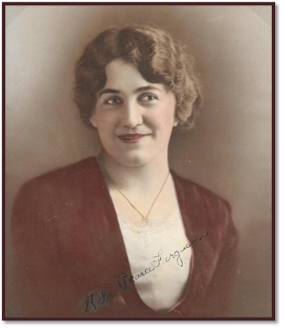

Mrs. Ada D. Pierce

Admore, OK