2022-2023 American Legion Auxiliary Programs Action Plan

Gold Star Mother Committee

Contact information for questions:
Nanci Galatian — 918-729-2431
ngalatian@yahoo.com

Background Summary Information
When the United States entered WW I in 1917, George Vaughn Seibold, 23, volunteered, requesting aviation. He was sent to Canada where he learned to fly British planes, since the United States had neither an air force nor planes. Deployed to England, he was assigned to the British Royal Flying Corps. He left for duty in France. He corresponded with his family regularly. His mother, Grace Darling Seibold, did community service by visiting returning servicemen in hospitals. The mail from George stopped. All aviators were under British control & authority, the United States could not help the Seibold family with information about their son. Grace continued to visit hospitalized veterans, clinging to the hope that her son might have been injured & returned to the United States without any identification. But on October 11, 1918, George's wife in Chicago received a box marked "Effects of deceased Officer 1st Lt. George Vaughn Seibold". George's body was never identified. Grace, realizing that self-contained grief is self-destructive, devoted her time & efforts to not only working in the hospital but extending the hand of friendship to other mothers whose sons had lost their lives in military service. She organized a group consisting solely of these special mothers, with the purpose of not only comforting each other, but giving loving care to hospitalized veterans. The organization was named after the Gold Star that families hung in their windows in honor of the deceased veteran. After years of planning, June 4, 1928, twenty-five mothers met in Washington, DC to establish the national organization, American Gold Star Mothers, Inc. The success of this organization continues because of the bond of mutual love, sympathy, & support of the many loyal, capable, and patriotic mothers who while sharing their grief & their pride, have channeled their time, efforts and gifts to lessening the pain of others.¹

What can individuals and Units do?

- Know your members, so you know if they have sons or daughters that are or could be deployed.
- Upon deployment, keep in touch with your members. This will let them know they have someone to call at anytime, not just if something bad happens.
- Should that Mother get that gut wrenching notification and contact you; reach out to your quickest contact to the Gold Star Mother Committee Person

Support for Mother’s

- Luncheons/Dinners
  - The last Sunday of September is Gold Star Mother’s/Family Day. Units could have a special luncheon or dinner in honor of the Mother’s or Families of fallen soldiers.

- Special Plaque
  - A special award or plaque in honor of their soldier at a Memorial Day Remembrance

What can Department do?

- Present the Mother with a Gold Star Pin and Banner
- Have a memorial service to honor her fallen soldier

Additional information and resources:

¹ https://www.goldstarmoms.com/our-history.html
https://www.goldstarmoms.com/
https://www.legion-aux.org/Blog/%E2%80%98Behind-every-fallen-is-a-family%E2%80%99

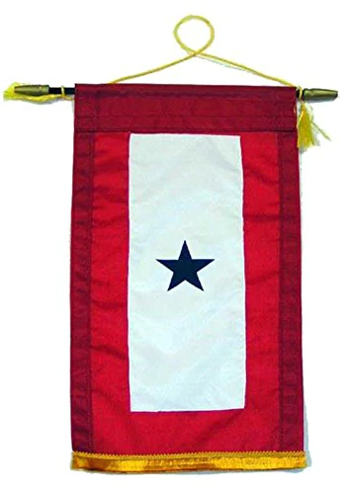
Please use this form to send me Gold Star Mother’s information so that I can include that number in my report to National or you can email the information to me at the address shown below.

Unit Number ________________________ District _______________________

Location ____________________________________________________________

Name of Gold Star Mother(s)

__________________________________________________________________

__________________________________________________________________

__________________________________________________________________

Nanci Galatian, Gold Star Chairwoman
519 E 6th Ave
Bristow, OK 74010
ngalatian@yahoo.com
918-729-2431

