## 

**Ilene M West**

**Department of Oklahoma Historian**

**1597 S Elm Ave, Bartlesville OK 74003**

**918-852-8085**

[Impwest67@gmail.com](mailto:Impwest67@gmail.com)

## The purpose of the program is to….

## **Maintaining and Preserving ALA History**

* The heart of any organization’s history is in its records – items that officers, members, directors, staff, and volunteers have produced and compiled over the years. They provide unique testimony to the achievements of an organization.
* Maintaining and preserving our records are invaluable to society by serving as informative and educational resources to a variety of potential users. In other words, an organization benefits itself and the public by preserving its records and making them available for use by everyone inside and outside the organization.
* Members are able to look back and learn what efforts were successful, or unsuccessful, and why. Understanding the missteps as well as the achievements can assist in determining a stronger future strategy.

## [**Looking for ideas?**](https://www.facebook.com/groups/ALAHistorians/)

ALA Facebook Groups are spaces on the social media network for ALA members to discuss or share about broad or narrow topics. Groups provide an arena for organic discussion about your local programs or services and present the opportunity to cultivate brand awareness.

This is a place to share service activities and events, ask questions, obtain information, and network for those interested in the American Legion Auxiliary Historians

<https://www.facebook.com/groups/ALAHistorians/>

**How to Record and Post to “Members Remember “**

**Objective:** Record the ALA’s history through the eyes of its members

**Background Information**  
The history of the American Legion Auxiliary begins back in November 1919, and continues with you. The organization’s history, like any other history, is more than names and dates. It is about its membership and how it developed the ALA’s programs and projects to fulfill our mission of serving the veterans, servicemembers, and their families who sacrifice much for this country of ours.  
  
A written history can only tell so much. However, when an organization’s history is told through the eyes of its membership, everyone learns a great deal more about who we are, what we do, and why we matter.

**Step-by-Step Instructions**

Here are some tips:

* This is a two-person project so find someone to assist. This is a good time to enlist the help of your 9th-12th grade Junior members as it is a required activity in earning the History Patch. If your unit does not have Junior members, enlist the assistance of college students.
* Find longtime members of the Auxiliary and ask them to share their stories in a video.
  + These stories can be about:
    - A special project,
    - A particular highlight during her membership
    - How many generations of her family have been members and why
    - If a chartered member, her experience in starting the unit
* Find a location where it is quiet and where there will be no interruptions.
* Record with iPhones/Smartphones. Please keep in mind that your video file must be either a .mov; .avi; .mpeg; or a .wmv file extension.
* Each recording should be no longer than five (5) minutes long. You may make more than one. Cover one topic in each video.
* Post the video on YouTube. An instructional video on how to upload is located at [www.youtube.com/watch?v=_O7iUiftbKU](https://www.youtube.com/watch?v=_O7iUiftbKU).
  + Go to YouTube at [https://www.youtube.com](https://www.youtube.com/)
  + Give the video the following title: ALA Dept. of __ (two letter abbreviation for your state) Unit ____ Members Remember.
  + Provide a description and tags that will help people locate the video easily.
  + Under Category, click on Nonprofits & Activism.
  + Under Privacy, click on Share your video with the world.
  + Click Save Changes.

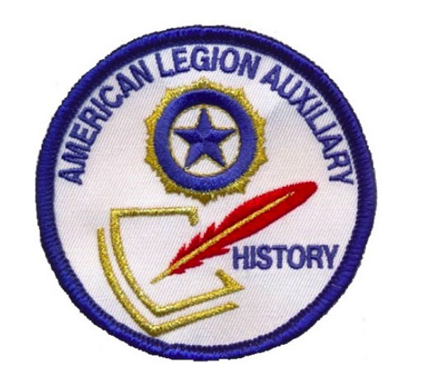**How to involve A Junior Member**

**Objective:**  
Help a Junior member (9th – 12th grades) earn the new History Patch

**Background Information**  
In a joint effort with the National Junior Activities Committee, we have developed a History Patch for our high school (9th – 12th grades) Junior members. These young ladies have an opportunity to work with, learn from, and take ownership of the American Legion Auxiliary history. It is important for them to understand that they are a part of the Auxiliary’s history. By earning this patch, they may become interested not only in the history itself, but in preserving it as well, and become a unit’s or department’s History/Cavalcade chairman.

**Step-by-Step Instructions**

What can we do?

* Contact the department Junior Activities chairman and ask her to help promote this new patch. Make joint announcements at your fall/winter/spring meetings, division/district meetings, etc.
* Write an article about the patch for the department newsletter.
* Make a poster to promote the patch for meetings. Include the patch and activities list (see below).
* Encourage the unit History/Cavalcade chairmen to promote this patch and work with their unit Junior Activities committee chairman.
* Find a high school aged Junior member and be a mentor to her as she works the activities to earn the patch.

**How to Celebrate Women’s History Month.**

**Objective:** Celebrate the special women of our organization

**Background Information**  
The month of March is dedicated to the celebration of women’s history. It corresponds with International Women’s Day on March 8th. What could be better for a women’s organization to do than celebrate their own history? Our Auxiliary members have accomplished a great deal all around the world. Now it’s time to celebrate what makes them so special!

**Step-by-Step Instructions**

What can we do?

* Learn more about Auxiliary members who made history within your department or unit. This could include girls sponsored to ALA Girls State who have gone on to do great things or those members who have improved their communities, state or country.
* Celebrate the women in your life – mom, grandma, even your sister.
* Donate money to the ALA Cavalcade of Memories budget at the unit, department, or national level in honor of a special woman.
* Set up a display in honor of those members who have gone above and beyond the ALA’s mission.
* Write an article for your unit/department newsletter about Women’s History Month or about the woman you are honoring.
* Check out how women’s fashion has changed over time in the Auxiliary, as well as women’s hair fashion. There has been a great deal of change from 1919 to today!
* Research and write about how the former and present members make a difference in the community and share with others.
* Put up a display at your local library, historical society, or storefront, celebrating the work that the women of the ALA have done and still do every day.

Remember – these activities can be shared with the Junior members. Honoring our members provides them with a role model. Sharing our history with our Junior members allows them to know that they, too, are valuable members of this great organization. Hopefully, they will begin to own this history and remain members throughout their lifetimes

**Note to all Historians of Oklahoma District and Units Please send me all pictures of actives by Text at 918-852-8085 or email at** [**impwest67@gmail.com**](mailto:impwest67@gmail.com) **so I can add them to our Department History Book for 2022-2023.**

This year in July 2023 All Units and Districts please bring your Memory books and/or Memory videos and we will award 1st, 2nd, and 3rd place in Books and in video. There will also be a special award for social media accounts so send me your Face book, Instagram, YouTube, or other to follow online. You can text me with unit #, what kind of account, and what the name of your account is.