|  |  |
| --- | --- |
| **2nd**  **annual** | **American Legion Auxiliary Unit 60** |
| **CHILI DINNER** |
| **POKER RUN** |

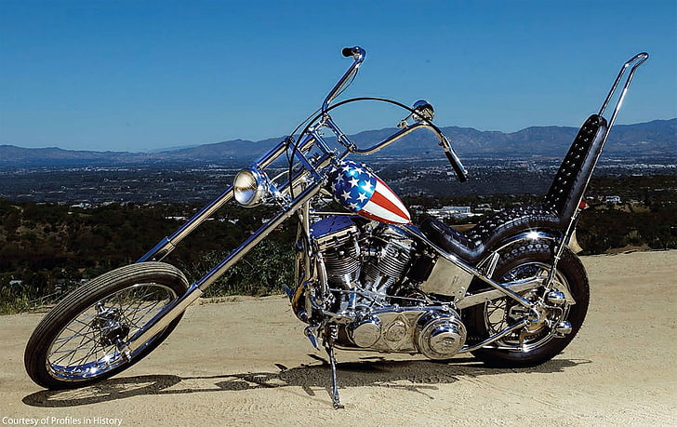

|  |  |
| --- | --- |
| 1st Stop Vinita Caesar’s Place 414 E Illinois Ave  2nd Stop Pickles at the Lake  3rd Stop Claremore VFW  4th Stop Claremore American Legion Post 141  5th Last Stop Winganon Bait Shop | **Benefitting the ALA Poppy Fund**  **for**  **Veterans & their families**  **Saturday Veterans Day**  **October 5th**  **Pancake Breakfast 08-10a**  **Registration: 11a**  **American Legion Post 60**  **431 West 7th**  **Chelsea, OK 74016**  **KICKSTANDS UP @ NOON**  **$20 FIRST HAND**  **$5 EACH ADDITIONAL HAND**  **CHILI DINNER FREE FOR VETS**  **ALL OTHERS $10 DONATION** |

**We start serving Chili @ 11a all day long till we run out**

**● 50/50 ● SILENT & LIVE AUCTION, RAFFLES●**