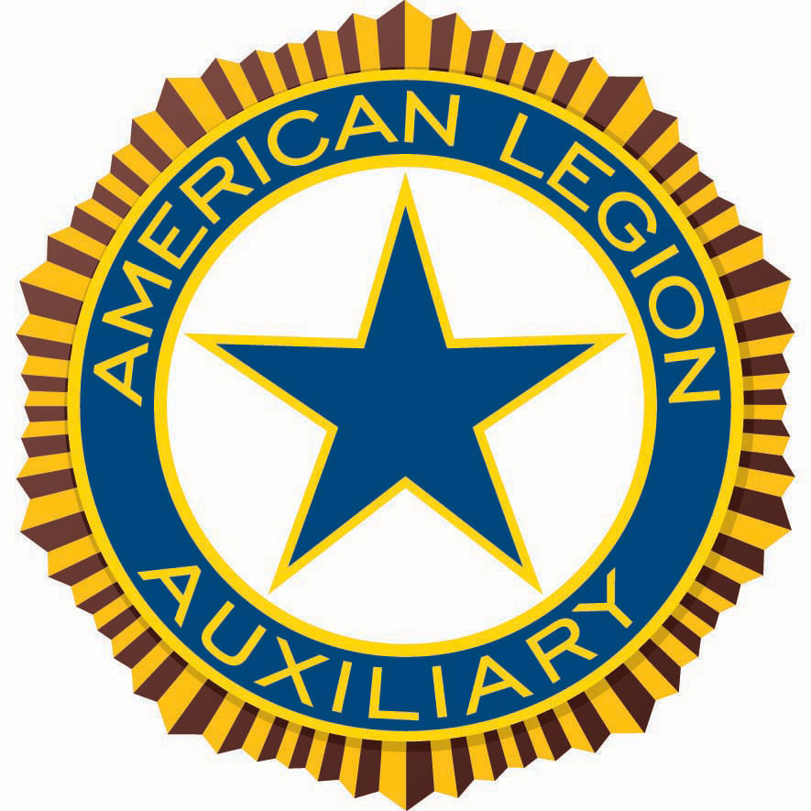

Americanism Program Action Plan
2022-2023

As members of the American Legion Auxiliary we know what it means to be an American and a Patriot - we know that “Freedom is not Free – But it is worth fighting For”. Many Americans throughout the Nation are unaware of what it takes to aid and support our veterans. They do not realize the sacrifices made by military families. One of the responsibilities of the American Legion Auxiliary is to teach others about our organization and our goals. The National President’s focus this year is to honor our veterans every day.

Remember Department of Oklahoma President Gayle Keene’s theme “Strength Thru Unity”. We must all do what we can to promote patriotism, provide care and comfort not only for our veterans, but to the families and communities who do so much for our great nation as well.

Americanism includes many things such as: Independence Day, Memorial Day, and Veterans Day. Other things are not so widely known such as Flag Day (why do we call her “Old Glory?); Constitution Day (when is it?); what is the symbolism of the 13 folds of the United States Flag?; what star represents Oklahoma? Answers to these questions are available online at our National website ALAforVeterans.org, or you can contact me.

Americanism Essay Contest
Essay Title: “What Does Patriotism Mean To You?”

Each year, the American Legion Auxiliary sponsors an Americanism Essay Contest for students in grades 3-12, including students with special needs. Grade levels are divided into six classes. One award in each of the six classes will be presented in each division. Information on grade levels and number of words per essay can be found on the Essay Contest Cover Sheet. Winners will receive $50 and a $50 donation in the student’s name will be made to the Children of Warriors National Presidents’ Scholarship fund. National winners will be posted at www.ALAforVeterans.org after convention.

In order to qualify, the Americanism Essay must be received on or before APRIL 15, 2023.

An Essay Contest Award Cover Sheet must accompany each essay and be signed by the Unit. They can be obtained online at our Department website www.OKAmLegionAux.org or the National website at www.ALAforVeterans.org. If you need a hard copy mailed to you, just call me and I will send one.

Star Spangled Kids
Educating our children about American history is extremely important to our country’s civic health. “Star Spangled Kids” is the American Legion Auxiliary’s initiative to educate our youth about United States history, Americanism, and the U.S. Constitution. ALA Units sponsor Star Spangled Kids activities in conjunction with local schools and youth groups. Some activities include:
- Americanism Essay Contest
- Unit Citizenship Awards presented to children and youth who have demonstrated the ideals of the U.S. Constitution.
- Bringing Veterans or service members to local schools and youth groups to talk about what their service means to defend the ideals of the Constitution.
- Distributing patriotic coloring books for children in primary grades.
- Celebrating Constitution Day (also known as Citizenship Day) on September 17, the day set aside each year to commemorate the signing of the U.S. Constitution.
- Distributing pocket copies of the U.S. Constitution for school children and/or ALA Junior Members.
- Encouraging high school-aged students to use their knowledge of the U.S. Constitution by participating in The American Legion Oratorical Contest. Details for this contest can be found at www.legion-aux.org.

2022-2023 Americanism Program Awards Deadlines and Submission Requirements
Unit Award: Dorothy Pearl Most Outstanding Unit Americanism Program (per division)

- Due to Department Chairman By MAY 19, 2023
- All unit and individual entries must be sent to the Department Americanism Chairman

Awards for both individuals and units will be awarded by National. If there is an individual who has dedicated themselves to the Americanism program throughout the year, please write a narrative report and forward to me so that I can, in turn, submit it to National. Likewise your unit’s year-end Americanism report will be considered for submission to National.

National is only asking for end-of-year reports this year. They are asking that all units share the story and pictures of their events as they happen. When details are fresh in your mind it is much easier to present a clear picture of your event. Please send me photos and short reports on events as they occur (I will forward them to National and Southern Division). Sharing your projects and pictures encourages others to find new ways to promote the Americanism Program. Also, if units do this throughout the year, an end-of-year report will be easy to compile.

Please take the time to share a favorite story about the positive impact you or someone you know has had on our mission! Your story may inspire another member into service. It also helps us tell the world who we are, what we do, and why we matter.

As a reminder, remember to wear your Red, White and Blue, proudly display the American Flag, and support your local communities.

I am always available to help with information you may need to get the job done and really work the Americanism Program. Should you have any questions or need help with online websites, please contact me for assistance.

Department Americanism Chairman
Sherree Cagle
4805 East Avenue
Oklahoma City, OK 73129
Phone 405.889-1313
svbinmwc@att.net

