1941-1942

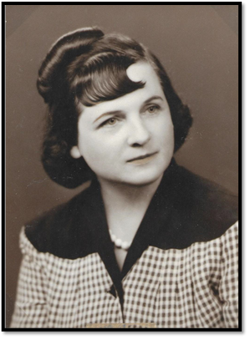

Mrs. Edward J, Box
Oklahoma City, OK

1942-1943

National VP Southern Division 1958-1959
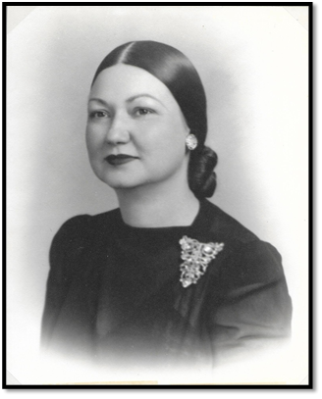

Mrs. E. B. (Zell) Benton
Tulsa, OK

1943-1944

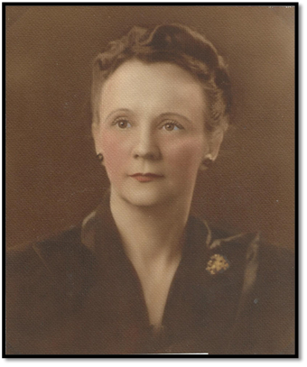

Mrs. H. H. Holliday
Anadarko, OK

1944-1945

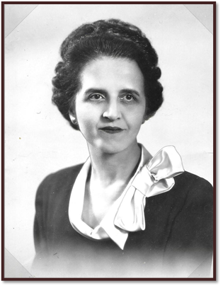

Mrs. D. A. Craig
Muskogee, OK

1945-1946

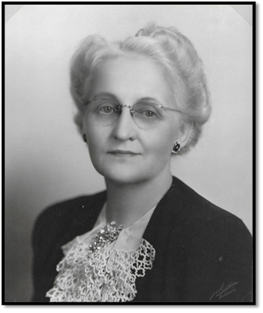

Mrs. Edwin S, Dunaway
Bartlesville, OK

1946-1947

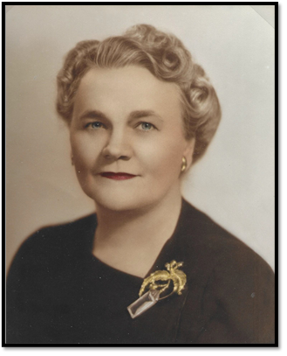

Mrs. O. B. Grimmett
Atlus, OK

1947-1948

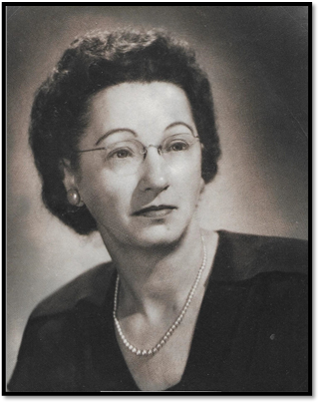

Mrs. George Redman
Alva, OK

1948-1949

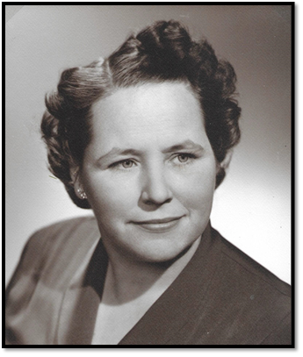

Mrs. J. Sam Johnson
Edmond, OK

1949-1950

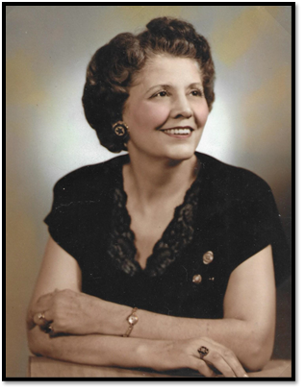

Mrs. W. Arthur Biggert
El Reno, OK

1950-1951

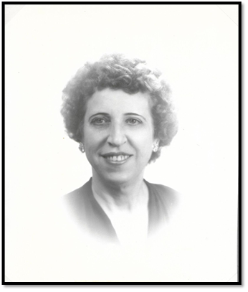

Mrs. John M. Martin
McAlester, OK

