**1961-1962**

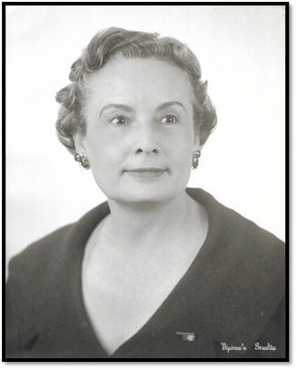

Mrs. E. L. (Louise) Crawford

Shawnee, OK

**1962-1963**

National President 1971-1972

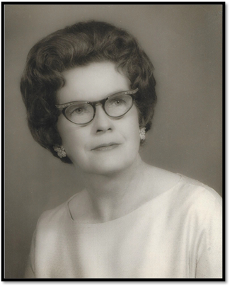

Mrs. L. R. Parker

Tahlequah, OK

**1963-1964**

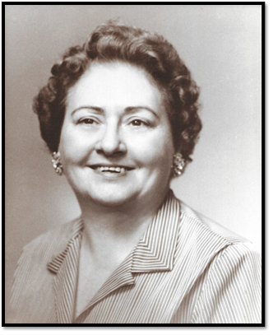

Mrs. W. E. Gilmore

El Reno, OK

**1964-1965**

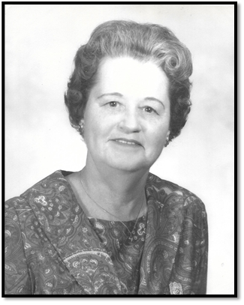

Mrs. J. T. (Ethel) Hobbs

Midwest City, OK

**1965-1966**

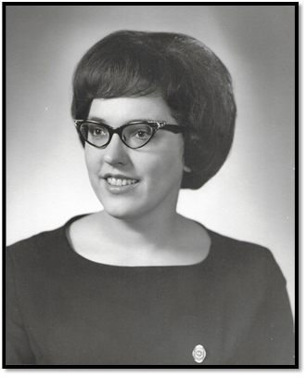

Mrs. Norville D. Johnson

Alva, OK

**1966-1967**

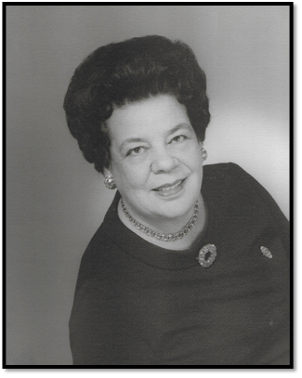

Mrs. J. Earl Simpson

Tulsa, OK

**1967-1968**

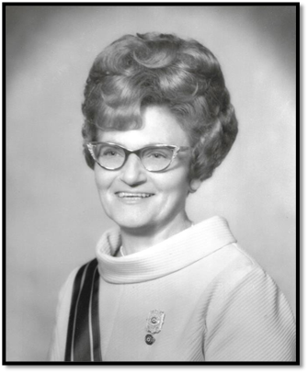

Mrs. Herman Reimink

Oklahoma City. OK

**1968-1969**

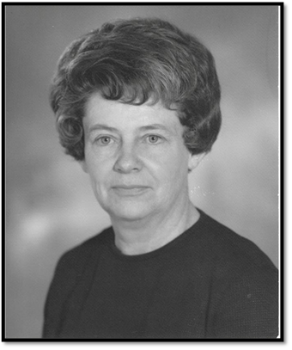

Mrs. Alvin Heidebrecht

Atlus, OK

**1969-1970**

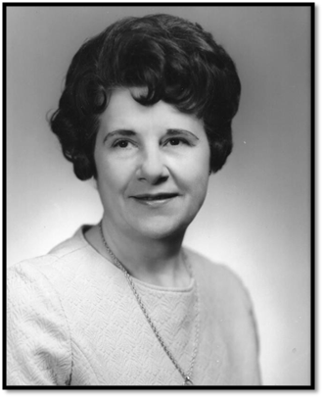

Mrs. Margaret Elgin Smith

Tahlequah, OK

**1970-1971**

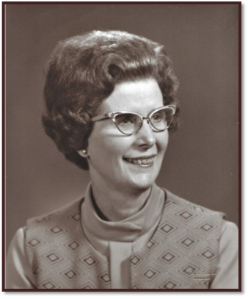

Mrs. Fred E. Frey

Chickasaw, OK